Bemidji State University

International
Student
Handbook
TABLE OF CONTENTS

Welcome

Campus Resources 1

• International Program Center 1
• Housing/Residential Life 1
• Learning Communities 2
• Campus Dining 2
• “Places to Visit” 3
• ID Cards 3
• Mail Services 3
• E-mail 4
• IT Help Desk 4
• Health Services 5
• Health Insurance 5
• Career Services 5
• Tax Services 5
• Student Organizations 5
• International Student Organization 6
• Gillett Wellness Center 6
• Outdoor Program Center 7

Academics 7

• FYE (First Year Experience) 7
• Academic American English Classes 8
• Advising Success Center 8
• Academic Advisors 8
• Warnings/Probation 9
• Graduation Plan 10

Immigration 11

• SEVIS 11
• Designated School Official (DSO) / Responsible Officer (RO) 11
• Maintaining Status 11
• When to Contact your DSO or RO 12
• Full Time Enrollment 12
• Extension of Stay 13
• Change of Program 13
• Transfer 13
• Employment/OPT/CPT and SSN 14
• Travel 16
• Renewing/Applying for Visa 16
• Returning to US 17
• Stays after Program Completion 17
• Out of Status 17

Cultural Awareness 17

• Be on Time 17
• Personal Space 17
• Addressing Others 17
• Ask Questions/Show Interest 18
• Use English 17
• Eye Contact 17
• Manners 18
• Office Hours/Visits 18
• Shopping 18
• Tipping 18
• Sharing a Ride with a Friend 18
• Roommates 19

Off-campus Resources 19

• Housing 19
• Stores/Restaurants/Places of Interest 20
• Banking Options 20
• Cell Phone (Mobile) Options 20
• Department of Motor Vehicles (DMV) 21
• Transportation 21

Staying Safe 22

• Student Alerts 22
• Weather 22
• Alcohol and Smoking 23
• The Department of Public Safety 23
• Sexual Violence 24
• Discrimination and Harassment 25

Acronyms and Building Codes 25

Important Contact Information 26

• Emergency 26
• Public Safety 26
• International Program Center (IPC) 26
• Records 26
• Student Health and Counseling Services 26
• Cashiers 26
• Residential life 26
• Career Services 26
• Family Friends Program 26

Campus Map 27
Tunnel Map 28

WELCOME!

On behalf of Bemidji State University (BSU), the International Program Center (IPC) warmly welcomes you to our campus. BSU is located in northern Minnesota. Bemidji, the first city on the Mississippi River, provides ample opportunities for shopping, education, medical care, technology, lodging, and government services. We offer the finest in outdoor recreation in Minnesota and the Upper Midwest. We are sure you will find that Bemidji is a beautiful place to visit and a great place to live and study.

You will have many occasions to interact with American students as well as with community members. Below is just a short list of those opportunities:

- The International Student Organization
- Other BSU Clubs and Organizations
- Open Borders Learning Community
- Family Friends Organization

BSU offers Academic American English (AAE) classes to assist students in improving their English proficiency in basic skills areas. An English language assessment is completed prior to your first semester of enrollment (during orientation) to determine proper placement in AAE classes.

You are required to purchase annual health/medical insurance through the insurance provider contracted by the Minnesota State Colleges and Universities System. Charges for health insurance will appear on your fee statement, with payment due no later than the Friday before classes begin. We hope you enjoy your time at Bemidji State University! If you have any questions, please contact the IPC.

We look forward to getting to know you!

Sincerely,

Cherish Hagen-Swanson
Director

Megan McLaughlin
International Recruiter

Mary Carlson
Office Manager

CAMPUS RESOURCES

International Program Center
The International Program Center, located in Deputy Hall 103, serves international students, conducts the international student orientation and serves as a resource throughout enrollment on matters related to F-1 and J-1 student visa status.

Regular Office Hours
M-F: 8am-4:30pm

Summer Office Hours
M-F: 7:30am-4pm

Phone: (218)755-4096

Mailing Address
International Program Center
Bemidji State University
1500 Birchmont Drive NE #13
Bemidji, MN 56601

Email: international@bemidjistate.edu

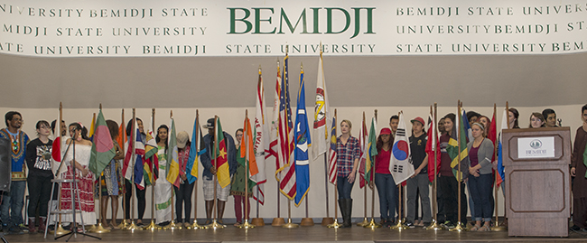

Housing/Residential Life
The BSU Office of Housing and Residential Life is committed to creating a caring environment that encourages academic success, individual respect, personal growth, and a sense of responsibility toward our community and a global society.

Residence hall services are provided as a part of the residence hall living experience and are included in the living cost of each resident. Please visit the Residential Life webpage at http://www.bemidjistate.edu/students/reslife/ for detailed information regarding our on-campus housing and meal options.

Housing is available in the BSU residence halls during all breaks. Students living on campus who wish to stay at BSU during breaks will need to discuss this option with the Residential Life office staff.

The Residential Life website also contains lots of helpful information regarding each residence hall, kitchen, internet, bathroom, other facilities, information about move in day, what is provided in each dorm room, and what can be rented or purchased. http://www.bemidjistate.edu/services/reslife/move-in-guide/
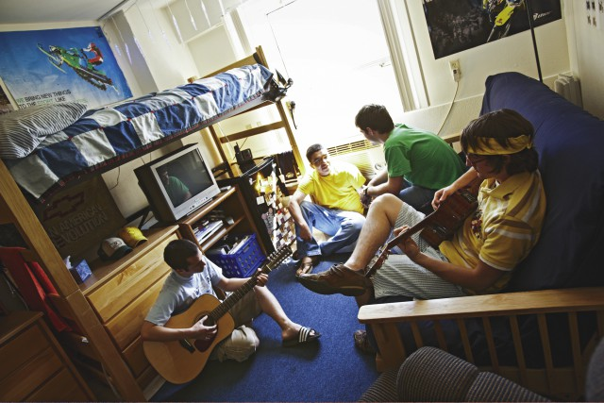
Learning Communities

First Year Residential Experience (FYRE)
New freshman students at BSU will participate in the First Year Residential Experience program. FYRE is a program which assigns all new, traditionally-aged freshman to a common living area in Oak Hall, Pine Hall, and Tamarack Hall where they live with only first year students. Living with other first year students allows participants to easily make new friends and share similar experiences with others who are also new to the University. Together you will explore BSU and help each other make the transition to college life. The FYRE program provides a unique academic and social experience specifically designed for first year students.

Open Borders Learning Community (OBLC)
The Open Borders Learning Community is a program where students from around the world, who share an interest in getting to know people from other cultures, live together on one floor. OBLC offers a dynamic living environment with an array of social and educational opportunities ranging from cultural exchange dinners to international movie nights to community involvement programs.

Campus Dining
A major part of living on campus is the dining experience. At BSU you’ll find high quality, nutritious options with a focus on variety, convenience and flexibility. Dining Services offers traditional American cuisine, ethnic dishes and national brands at our on-campus locations. Each location welcomes students, faculty, staff, and guests, and accepts cash, Beaver Bucks, VISA, and Master Card purchases.

Wally’s
Wally’s is located in Walnut Hall and provides a wide selection of menu choices in an all-you-care-to-eat cafeteria setting. Wally’s offers convenient hours of service and is open seven days a week, except during semester and holiday breaks.

Lakeside Food Court
Lakeside Food Court is located in the Lower Hobson Memorial Union. Lakeside features homemade bakery products, fresh soups, a selection of grilled sandwiches, fresh tossed salads, made-to-order wraps, Jump Asian Cuisine and Tortilla Express. Java City and Einstein Bros. are also located in the Lower Hobson Memorial Union. Both offer coffee, espresso, smoothies, fresh bagels, and sandwiches.

The Lodge
The Lodge is a convenience store and is located in lower Walnut Hall. Groceries, snacks, frozen foods, and school supplies are available at both stores.

The Upper Deck
The recently renovated Upper Deck is the new place on campus to hang out and have a great time with friends! This late night dining option offers flat screen TVs and a delicious menu. Hours: Sunday – Thursday: 8:00 pm – 11:00 pm; Friday & Saturday: Closed
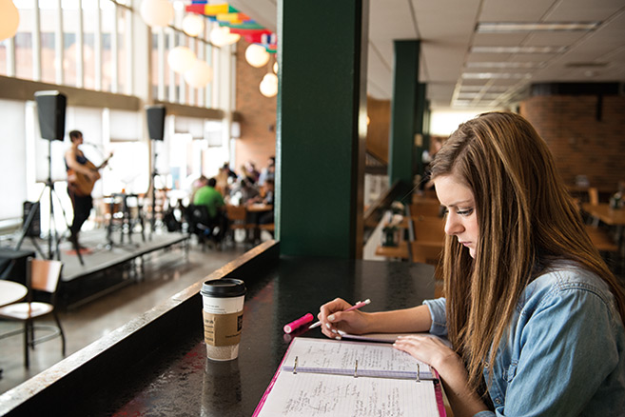
Meal Plan Choices
Meal plans allow you to enjoy all the great dining choices we have in store for you. With the wonders of technology, we transform your student ID card into a dining membership card packed with buying potential which provides you with dining flexibility.

Beaver Bucks
All meal plans include Beaver Bucks. Beaver Bucks are accepted like cash in all of our dining locations including the variety store in Walnut Hall and Hobson Memorial Union. It works on the same principle as a debit card. You can draw from your Beaver Bucks for beverages, snacks or full meals for you or your guests at any time. Whenever you make a purchase at any dining service location, the amount of your purchase is subtracted from your Beaver Bucks account. You can add additional Beaver Bucks to your account at any time. To view a list of current meal plan options, please visit: https://bemidji.campusdish.com/

You can change your Meal Plan during the first two weeks of each semester by completing a Meal Plan Change Form located in the Residential Life Office in Walnut Hall. However, we recommend that if you know you want to make a change to do so before the beginning of the semester.

For more information regarding dining options, meal plans, and Beaver Bucks, visit http://www.bemidjistate.edu/services/reslife/dining/

Places to Visit
Here is a list of places on campus that you should be sure to check out, while at BSU:

• International Program Center
• Library
• Bookstore
• Advising and Success Center
• Outdoor Program Center
• Campus Bank (Affinity)
• Campus Dining
• American Indian Resource Center
• Hobson Memorial Student Union
• Health and Counseling Center
• Campus Security
• Residential Halls
• Gillett Wellness Center
• Career Services

Student Identification (ID) Cards
BSU ID cards are prepared at the Student Union Information Desk which is located in the Upper Hobson Memorial Union. Keep in mind that while you are not charged for the first ID card, there is a $20 replacement fee.

Mail Services
Students living in the residence halls are assigned mailboxes. Mail services are available to all BSU students at the BSU Mailroom in the lower level of Memorial Hall, Room 001.
Dorm Address Information
Mail should be addressed to residents using the following information:

Name
Hall Name
Room Number, Wing
Street Address
Bemidji, MN 56601-xxxx

Hall Street Address Zip Code Front Desk Number
Birch (A wing) 1701 Birchmont Dr. NE 56601-1005 (218) 755-2601
Birch (B wing) 1703 Birchmont Dr. NE 56601-1005
Cedar Apartments 1925 Birchmont Dr. NE 56601-1003 (218) 755-3246
Linden (A wing) 1805 Birchmont Dr 56601-1004 (218) 755-2077
Linden (B wing) 1807 Birchmont Dr. NE 56601-1004
Oak (A wing) 314 23rd Street NE 56601-1801 (218) 755-2070
Oak (B wing) 316 23rd Street NE 56601-1801
Oak (C wing) 318 23rd Street NE 56601-1801
Pine 2005 Birchmont Dr. NE 56601-1801 (218) 755-3246
Tamarack 410 19th St NE 56601-2656 (218) 755-3400
University Heights 1725 Paul Bunyan Drive NW 56601

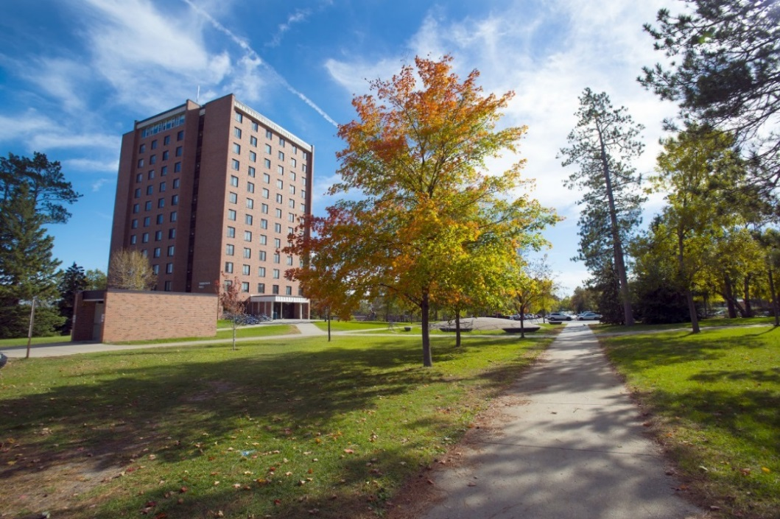

E-mail
You have been assigned a BSU student e-mail account. This account is used for all transmission of official information from BSU. Please check your email often. The IPC will use this email to send updates and information about your visa status. It is your responsibility to make sure you are receiving these emails.

Information Technology (IT) Help Desk
The IT Help Desk offers technical assistance for any BSU issued device or service. You can reach them at studenthelp@bemidjistate.edu or at 218-755-4207. You can also find lots of helpful information regarding technology at BSU at http://www.bemidjistate.edu/offices/its/support/knowledge-base/ .
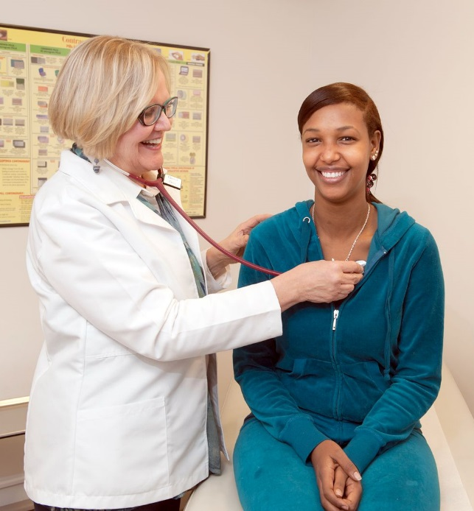
Health Services
BSU’s Center for Student Health and Counseling attends to the healthcare needs of all students. Please use this facility when needed. They provide a large range of medical, counseling, family planning, and immunization services. Please visit their website for more information: http://www.bemidjistate.edu/services/health-counseling/

Health Insurance
All international students at BSU are required to purchase health insurance through the Minnesota State contracted student insurance provider. This mandate exists for the protection of international students and helps prevent financial hardship resulting from the need for medical attention. Payment for the insurance premium is due no later than the Friday before class begins.

Career Services
The professional staff in BSU’s Career Services provides a comprehensive list of services designed to help students and alumni achieve their career goals, including:

• Career development guidance and job search services to students and alumni
• Services for employers who are interested in recruiting BSU students for employment or internships
• Information and guidance for parents seeking to assist their student through college
• Information for faculty and staff to aid them in helping students

For more information, please visit: https://www.bemidjistate.edu/students/services/career/

Tax Services
International Students are generally required to file taxes each year. Failure to do so can impact future applications for visas or residency status. Accounting majors at BSU offer free tax preparations for students from February to mid-April in Memorial Union.

Student Organizations
Get the most out of your experience at BSU by becoming involved in one or several student organizations! At BSU there are many types of student organizations ranging from student government and clubs related to your major, to faith based, sports & recreation, and special interest. There is something for everyone! If you don’t see something on the list of student organizations that appeals to you, grab a few friends and start your own group; BSU is always looking for new ideas and students to chart their own course. Visit this website for current student organizations: https://bemidjistate.collegiatelink.net/Organizations

International Student Organization (ISO)
One of the most relevant student organizations for international students is the International Student
Organization (ISO). The ISO has a membership of international students from over 40 countries. There is no process of signing up, since all admitted international students are automatically a part of this organization. The mission is to provide support TO international students FROM international students. Through various fun activities and events planned by the organization, international students get to experience life in Bemidji, as well as to share their culture with the University and the Bemidji community.

The largest cultural event at BSU, Festival of Nations, is held annually in the spring. Members of the ISO provide performances, exhibition, and dishes from different parts of the world which are presented to the BSU and Bemidji community to increase cultural sharing and understanding.

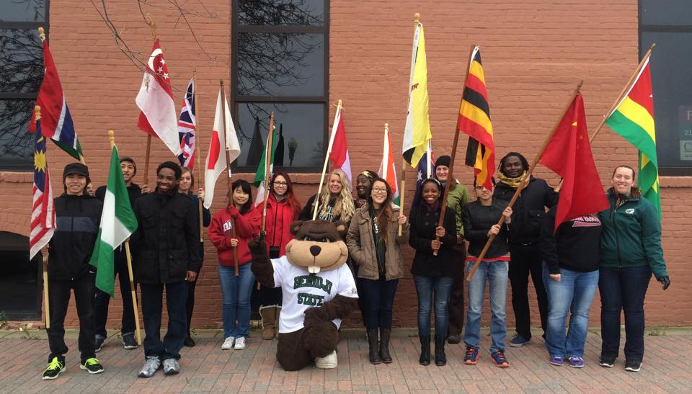

Gillett Wellness Center
The Gillett Wellness Center offers state of the art equipment and facilities that will help you slim down, tone up, de-stress, or just plain play. Located adjacent to residence halls on the BSU campus, the Gillett Wellness Center has four activity courts (adaptable for basketball, tennis, volleyball or badminton), a six lane 200-meter indoor track, both free and fixed weight rooms, five racquetball courts, a state of the art climbing wall, a spacious dance studio, numerous types of cardiovascular equipment (including several Cardio Theater Personal Viewing Systems) and a six lane 25-yard pool.
For facility hours and more information, please visit: http://www.bemidjistate.edu/services/campus-recreation/gillett-recreation-fitness-center/

Outdoor Program Center
The nationally recognized Outdoor Program Center provides you with the opportunity to be a part of the outside world around you. Imagine climbing the top of a mountain or kayaking through a canyon, ice fishing in the middle of winter, or taking a sailboat out on Lake Bemidji. The OPC makes it possible with trips to destinations throughout the United States, a climb on our state of the art indoor climbing wall, or with equipment rentals if you’re going on your own. Also consider Nice Ride, a program started by OPC and the Sustainability Office that allows you to rent a bicycle for the whole semester! For more information, visit http://www.bemidjistate.edu/offices/sustainability/

The OPC’s top notch facilities offer you a host of diverse recreational activities year round. From our state of the art indoor climbing wall housed at the Gillett Wellness Center, to our newly opened Boat House at Diamond Point Park on the shores of Lake Bemidji (open May-October), to the pristine 240 acre Hobson Memorial Forest, those seeking adventure are sure to find something that gets their heart beating.
For more information about the Outdoor Program Center, please visit: http://www.bemidjistate.edu/services/campus-recreation/outdoor-program-center/

ACADEMICS

FYE (First Year Experience)
As one of the state’s oldest teaching institutions, we understand the importance of establishing oneself early on campus. The students that make friends, join clubs and organizations, and find satisfying courses, are those that are most likely to succeed and earn a degree. To facilitate these bonds, BSU has developed a series of programs that help students make those first campus connections.

Weeks of Welcome
In the first weeks of classes, BSU hosts a series of campus-wide events that bring students out into the courtyards to socialize and interact. From movies on the lawn to free pancakes and prizes awarded to students who discover new things on campus, we make sure the first introduction to campus life is exciting and comfortable.

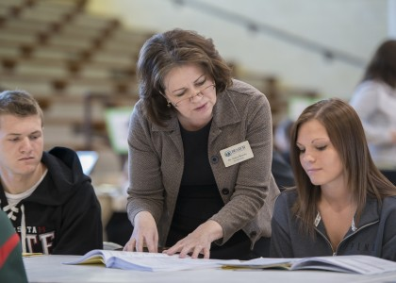
FYE Seminars
Few students arrive at school with all the skills they need to tackle college life, and coming from another country with a different culture and customs can make it even more challenging. The First Year Experience seminars are a recommended program for all new incoming students. Topics, such as study, responsible decisions, and practical introductions to student services, ensure that you know how to get the resources that you need to succeed.

FYRE (First Year Residential Program)
For most students, college is their first experience living away from home. Suddenly moving into a dorm, meeting a new roommate, and sharing space with lots of new people can be stressful. Our FYRE program helps ease students into campus living, building a bond with residential advisors and establishing patterns of study and socializing that are essential in the first year.

Academic American English Classes
During the international student orientation program prior to the beginning of your semester, all international students will undergo assessments to determine placement levels for Academic American English (AAE).

Students whose AAE assessment results indicate placement in the Intermediate AAE (II) or Advanced AAE (III) courses will be required to enroll in the applicable course their first semester. Post-test results at the end of the semester will determine the need for subsequent enrollment in AAE courses their 2nd term.

DEVL 0912 ACADEMIC AMERICAN ENGLISH II (3 credits)
Review and advancement of listening, speaking, reading, and writing of English. Focuses on perfecting English pronunciation through the use of Reading Week Seminar and improving English proficiency in the four basic skills areas. Extensive vocabulary development, understanding of American culture, accurate composition, and further practice in discussion and individual oral presentations. Prerequisite: International student with a score below 80 and above 70 on the Michigan College English Test or DEVL 0911 with a grade of A or B.

DEVL 0913 ACADEMIC AMERICAN ENGLISH III (2 credits)
Review and advancement of listening, speaking, reading, and writing of English. Extensive vocabulary development and more emphasis on composition accuracy. Prerequisite: International student with a score below 90 and above 80 on the Michigan College English Test or DEVL 0912 with a grade of A or B.

The Advising Success Center
The Advising Success Center is your first stop when you are seeking to improve your academic skills and excel in your classes. They offer free drop-in tutoring services in a number of academic areas at the center. They can also provide you with information and referrals to other campus tutoring services that may fit your needs. Assistance is available to you in most subject areas and additional support through faculty can be arranged on an individual basis.

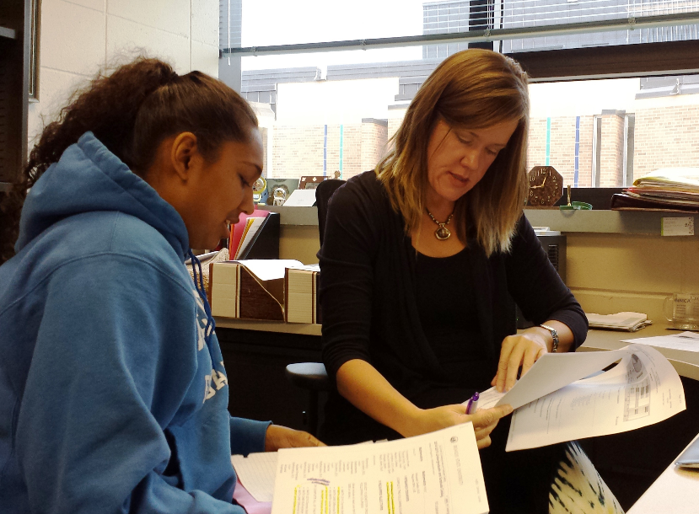
Academic Advisors
Faculty members serve as academic advisors to students, providing information on policies, procedures, and programs of the University, in addition to assisting with goal setting, degree planning, and course selection. Students with a declared major are assigned to a faculty member in their major department, with the exception of students in the Honors, and FYRE (First Year Residential Experience programs. These students are assigned to a faculty advisor involved with these programs. Students who have not yet decided on a major are assigned to their FYE (First Year Experience) instructor or an advisor serving undecided students for advising until a major is chosen. Students who do not have an assigned advisor or wish to change advisors may call or visit the Advising Success Center.

Warnings/Probation
The Bemidji State University Records and Registration Office provides this information regarding minimum GPA requirements, academic warnings, and suspension:

I. MINIMUM GRADE POINT AVERAGE REQUIREMENT
A student is required to obtain the following grade point average (GPA), based on attempted credits

Semester Hours Attempted* Minimum GPA Required**
0-15 1.50
16-30 1.75
31-59 1.90
60 & above 2.00

*Credits transferred from other institutions as well as credits attempted at BSU.
**Cumulated GPA at Bemidji State University (excludes grades earned at previously attended institutions).

II. MINIMUM PERCENT COMPLETION
A student is required to obtain a 66.67% course completion rate. Credits accepted in transfer are added to the BSU attempted credits and BSU earned credits, the calculated total earned credits is then divided by the calculated attempted credits to determine the percent completion rate.

III. PROCESS
Cumulative values are used in determining if academic progress has been met. Students not meeting the minimum grade point average or the minimum percent completion requirements will be notified of their academic progress status. Academic progress statuses include Academic Warning and Academic Suspension. See below for the criteria for each academic progress status.

IV. DETERMINATION of ACADEMIC PROGRESS STANDING

ACADEMIC WARNING
The first time a student fails the minimum cumulative grade point average requirement or the cumulative percent completion requirement during the semester, the student will be placed on Academic Warning. Students placed on academic warning are eligible for continued enrollment and are expected to make progress toward meeting the minimum cumulative grade point average requirement and minimum percent completion requirement.

REQUIREMENTS for ACADEMIC WARNING
Upon conclusion of the warning term, if the student has met BSU’s minimum cumulative grade point average and cumulative percent completion, the student’s warning status will be removed.

ACADEMIC SUSPENSION
At the conclusion of the warning term, those students not meeting the minimum cumulative GPA or minimum cumulative percent completion requirement will be suspended for the minimum time period indicated below.

# of Suspensions Period of Suspension
1 One semester
2 One calendar year
3 or more Two calendar years

V. REINSTATEMENT/APPEAL PROCESS
Students suspended from Bemidji State University who wish to return following the period of suspension must submit a petition to the Records & Registration Office. The petition should include information on the circumstances that affected past performance and a plan to be successful in achieving future academic progress goals. Readmission will be considered provided that certain conditions regarding academic deficiencies are agreed to in advance and reflected in the subsequent registration. Those students on suspension due to poor academic performance may submit a petition/appeal prior to sitting out the term of suspension if extenuating circumstances impeded their academic performance. All petitions are submitted to the Records & Registration Office to be reviewed by the Student Programs & Admissions (SPA) Committee. In order to allow sufficient time to review the petition, it is recommended that appeals are submitted at least two weeks prior to the start of the semester for which the appeal is being requested.

ACADEMIC PROBATION
Students with an approved petition for academic reinstatement will be placed on academic probation. While on probation, the student will be required to meet the terms that are set forth in the approved petition.
Note: Students returning to BSU after suspension shall always be subject to the minimum percent completion rate and GPA requirements stated above.

Graduation Plan

Undergraduate Students
Planning for graduation starts upon entry to BSU. Each semester you are getting closer to meeting the requirements needed for graduation. The DARS (Degree Audit Report) is a helpful tool in tracking your progress towards graduation. Students should apply for graduation up to 2 semesters before they expect to graduate. This allows time for the academic department and the Records and Registration Office to review your plans and determine if you will meet all of the graduation requirements. By submitting your graduation plans early, you ensure that if an error or omission is found, you have time to make changes to your class schedule, potentially avoiding the need to move your graduation term.

Graduate Students
Please visit this link for graduation requirements: http://www.bemidjistate.edu/academics/graduate-studies/

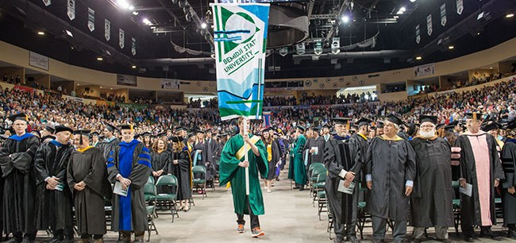

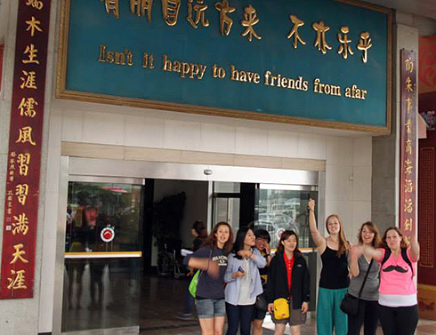
IMMIGRATION

SEVIS
SEVIS is the automated system for the overall Student and Exchange and Visitor Program. It is through SEVIS that I-20s and DS-2019s are issued.

It is critical that your information be correct in SEVIS. Please promptly report any changes in personal information (name, address, phone number, major, etc.) directly to the International Program Center.

Changes in your U.S. address must be reported within ten days of the change. To report changes, e-mail international@bemidjistate.edu.

Designated School Official (DSO) / Responsible Officer (RO)
A Designated School Official (DSO) is someone that has been approved to assist students with an F or M Visa. A person who is approved to help with J visa students is called a Responsible Officer (RO). Both can help you maintain your visa status. At BSU, we have people in the IPC with both designations that are authorized to help students.

Your DSO or RO can help you:
- Verify admission requirements, including review and evaluation of official transcripts, English skills, and evidence of financial support
- Issue/sign I-20s and DS 2019s of BSU sponsored students
- Verify/confirm the student’s enrollment and status maintenance information reported to SEVIS
- Advise on and authorize Curricular Practical Training (CPT) and Optional Practical Training (OPT)
- Authorize student transfer between U.S. institutions
- Authorize reduced course load
- Approve program extensions
- Recommend reinstatement
- Endorse applications for employment based on severe economic hardship, verifying that student is in status and meets all requirements, and submits information to SEVIS

Maintaining Status
Keep your I-20 (DS2019) valid by:
- Maintaining a full course load (12 credit hours for undergraduate students)
- Keeping your passport valid at all times
- Not working without authorization
- Limiting work hours to 20 hours per week while school is in session
- Making sure that the IPC always has your current address on file
- Following procedural requirements to continue from one education level to another
- Leaving the United States by the anticipated completion date or applying to the DSO for a program extension
- Abiding by rules requiring disclosure of information and prohibition on criminal activity
- Abiding by any special requirements of the U.S. Dept. of Homeland Security
When to contact your DSO or RO:
- Change of name
- Change of foreign address
- Change of U.S. address
- Change in major
- Change of enrollment status
- Termination/withdrawal from studies
- Completion of studies
- Changes in campus employment
- Changes in off-campus employment, such as OPT and CPT

Questions regarding status should be directed to the BSU International Program Center. You can e-mail
international@bemidjistate.edu, call (218)755-4096; or stop by the Center in Deputy Hall 103

Full-Time Enrollment
International students are required by U.S. immigration laws to be enrolled as full-time students. This means students must take a minimum of 12 hours of credit each semester (9 credits for graduate students). Failure to maintain full time enrollment will result in a loss of immigration status and you will be required to return home or file for reinstatement.

*You are limited on the number of on-line courses which do not require face-to-face interaction. You may have one class/three credits toward your full-time course load of study (per semester). For example, an undergraduate with only 12 credits may have one 3 credit course with 9 classroom credits. A graduate student with only 6 credits may only have 3 credits on-line and the other 3 credits being classroom credits. There are some exceptions to full time enrollment that may be considered. The request for a “Reduced Course Load” must be submitted and approved by your DSO prior to reducing your course load.

Accepted Reasons for Reduced Course Load
- Illness or Medical Conditions
(must have medical documentation)
- Initial Difficulty with the English Language
- Initial Difficulty with Reading Requirements
- Unfamiliarity with American Teaching Methods
- Improper Course Level Placement
- To Complete Course of Study in Current Term

Requesting a Reduced Course Load
- Complete a “Reduced Course Load” form and have your advisor sign it. The forms are available in the International Program Center Office – Deputy 103 or on-line at: http://www.bemidjistate.edu/services/international/wp-content/uploads/sites/19/2014/08/Reduced-Course-Load.pdf
- Submit the completed form to the International Program Center for DSO approval
- Students with approved reduced course load must resume a full course load in the next available term
Extension of Stay
Approval for an Extension of Stay is required if you are unable to complete course of study by the program end date.

To be eligible to apply:
- you must apply prior to the program end date. (DSO must approve application)
- you must have continually maintained status
- The delay in completion is caused by compelling academic or medical reasons, (i.e., change of major, unexpected research problems, or documented illness)

Change of Program
Approval for a Change of Educational Program or Change of Educational Level is required to keep your international student status valid. Follow these steps:
- Follow institutional & academic requirements for moving to a new major or applying to pursue a higher degree (i.e., BS to MA)
- Before the end of the current program, inform the DSO and request a new I-20. You may be required to provide updated financial support documents.

Transfer
The term “transfer student” can be a little bit confusing because of its multiple meanings. When “transfer student” is used for US immigration purposes, it means that you have previously studied and remained in the United States, and have directly “transferred” from one US institution (listed in SEVIS) to BSU. When “transfer student” is used in an academic context, it is referring to those students who may have credits from another institution that may “transfer” to BSU from either a foreign or US accredited institution. For students transferring credits from a foreign institution, please submit your transcripts to ECE/WES. For more information, please contact the International Program Center.

If you wish to transfer from BSU to another school in the U.S., please complete these steps:
- Finalize your admission to the new institution and be eligible for an I-20
- E-mail BSU’s DSO of your intent to transfer, providing the name of the school to which you wish to transfer and the date you wish your I-20 to be released to your new school (The release date is typically the last day of your last semester)
- You must provide a copy of your admission letter from your new school to the DSO before your I-20 can be electronically transferred.

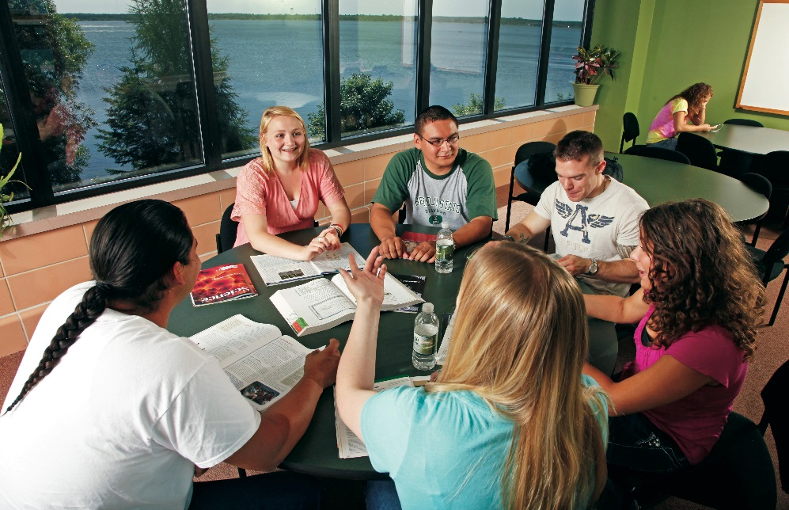
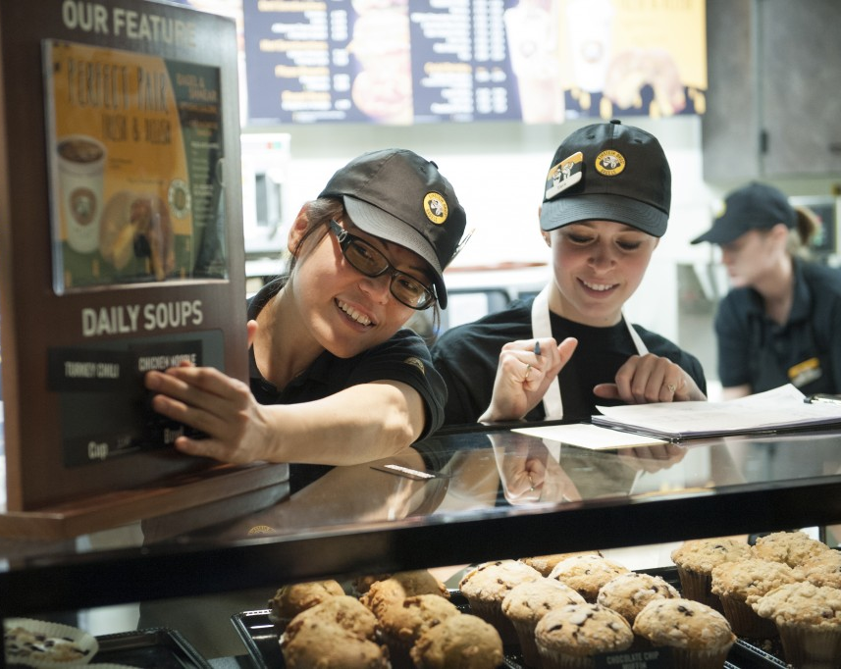
Employment/OPT/CPT and SSN
International students cannot legally work off-campus unless they have applied for appropriate work authorization with the U.S. Department of Homeland Security and have been approved to work. Students can work part time on campus (or full time during school breaks) without authorization from USCIS.

On campus employment:
International students are immediately eligible for “Regular Payroll” positions on campus upon obtaining F-1 status, but not “Work Study.” These jobs are competitive among all students. On campus employment does not require DSO or Department of Homeland Security approval. Your total hours on campus for all jobs cannot exceed 20 hours while school is in session or 40 hours during breaks. Working more than this is against regulations and can put your visa status at risk. For more information, please visit: www.bemidjistate.edu/students/services/employment/.

Off Campus employment (Severe Economic Hardship):
Make an appointment with your DSO to discuss this option, if you feel you qualify to apply for economic hardship.

Requirements
- Must have been in F-1 status for at least one full academic year before applying
- Must receive a recommendation and an amended I-20 from the DSO and submit the application packet to the United States Department of Homeland Security
- The application must include the completed I-765 application form, verification of economic hardship; DSO recommendation; copy of amended I-20, application fee, photographs and copies of other official documents (passport, visa, etc.)
- Approvals are granted in 1-year increments
- Authorization ends if student transfers schools
- Limited to 20 hours a week, can be full-time during official school breaks
- Does not have to be related to course of study
- May be in addition to on-campus employment
- Does not affect eligibility for practical training

Curricular Practical Training (CPT)
CPT is employment off campus that is an integral part of an established curriculum, defined as an internship, cooperative education, or practicum. Student must have been lawfully enrolled on a full time basis for one full academic year before being eligible for CPT. CPT is employer and date specific and can be full or part time. (Use of one year of full time CPT eliminates eligibility for OPT.) CPT requires authorization from your program of study chair, your employer, and your DSO. You are required to maintain your full time enrollment during your CPT employment period. Make an appointment with your DSO to learn more about how to apply for CPT.

Optional Practical Training (OPT)
OPT is temporary employment for practical training directly related to your major area of study. It is most commonly utilized after degree completion. Make an appointment with your DSO to learn more about how to apply for OPT.

Eligibility Requirements for OPT:
- Enrolled for a minimum of one academic year
- Apply prior to end of 60-day grace period following program end-date (Application approval can take up to 90 days, so apply early)
- Employment must be in student’s area of study
- Cannot exceed 12 months of employment per educational level (some exceptions made for STEM majors)

Social Security Number (SSN)
For any type of employment, you are required to acquire a Social Security number. Social Security numbers are generally assigned to people who are authorized to work in the United States. You may apply for an SSN only after you have been offered a job or upon receipt of work authorization. The Social Security Administration will only assign Social Security numbers to students with documentation certifying that they have an on-campus job or are authorized to work off campus and have a job offer.

- Once you have a job offer, your supervisor will provide you a letter of employment
- Provide the International Program Center with a copy of this letter. The office will generate an international student work authorization letter
- After receipt of the work authorization letter from the IPC, you should visit the Social Security Office (near Wal-Mart). Applications cannot be mailed in.
- When you go to the SSA Office, you must present the following documents: (Note: SSA will not process your application more than 30 days in advance of the scheduled employment start date.)
- Employment Letter (Issued by employing department on campus or by off-campus employer)
- Work Eligibility Letter for Int’l Students (Issued by the IPC)
- I-20 or DS-2019
- Passport, Visa Stamp, I-94 card (Please note: You will need to print the I-94 card online)
- SSA Application for a Social Security Card (Available at the SS Office)
- Be patient, the social security card processing may take up to 4 weeks.

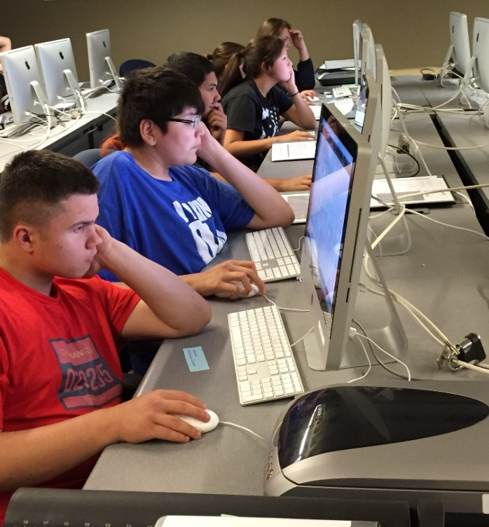
For further information on attaining a Social Security number you can visit the following links

- http://www.ssa.gov/pubs/EN-05-10181.pdf
- http://www.socialsecurity.gov/pubs/EN-05-10181.pdf

Social Security Administration
2900 Hannah Ave NW
Bemidji, MN, 56601
(218)751-2904

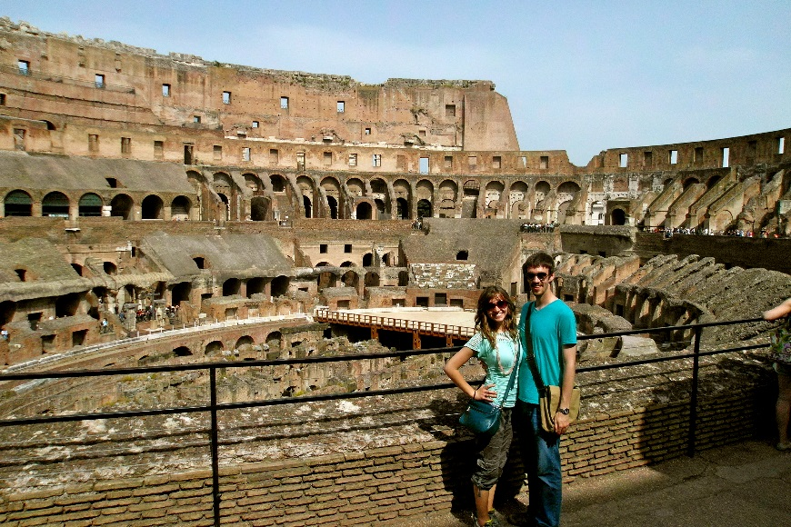
Travel
Make sure you have the following items when you travel:
- Valid Passport (passport must be valid for at least 6 months beyond return date)
- If you have changed your visa status to F-1 in the United States, you must apply for an F-1 visa at a U.S. embassy or consulate before returning to the United States.
- Have your DSO sign your I-20. Many ports of entry require a DSO signature to be dated within the last 6 months in order to be valid.

**Please take into consideration the fact that it can take a couple business days to get your I-20 signed, as the IPC DSOs are not always readily available.
- You are advised to carry your BSU transcript with you and evidence of your student status. You will need to request one from the Records Office. There is no charge for this. A valid picture ID and having no outstanding financial obligations are required.
- If you wish to have a “Verification of Enrollment,” please request that from the Records Office or the International Program Center.
- You may wish to carry evidence of financial support. Get current “Financial Support Documents” from your financial sponsor. You may be asked to show them to immigration officials at the airport/border when you return to the United States.
- You will also need updated or recent financial support documents if you plan to apply for or renew your visa.
- If you are traveling outside the United States to a country other than your home country, contact the embassy of that country to learn if you need a visa to enter that country. If so, know the requirements, cost and time frame needed to apply for a visa.
- If you are outside the U.S. for more than 5 months, you will need a new initial I-20 to re-enter.
- If you are traveling in the United States, you are advised to carry your original passport and I-20 with you at all times.

Renewing/Applying for a Visa
If you need to get your F-1 visa renewed or if you need to apply for an F-1 visa, you should contact the US Embassy/Consulate in the country where you are traveling BEFORE you travel. Be sure to find out what documents are required and how long the process may take. It is strongly advised that you obtain or renew your visa in your home country. Do not try and go to Canada or Mexico without consulting the IPC.

NOTE: Please be aware of the long delays affecting the visa application process. Be sure to plan ahead to avoid serious delays! Visit their website at http://travel.state.gov/visa/visa_1750.html.

If you do receive a new visa, be sure to report to your DSO when you return to campus. A copy of your new visa will need to be placed in your student record.

Returning to the U.S.
When returning to the U.S., be prepared for long waits at the initial port of entry. Procedures for students may differ from others. You will need to plan your travel, transportation, and connecting flights accordingly.

Stays after Program Completion
F-1 students who complete their study at BSU may remain in the United States up to 60 days after the end of the term.
J-1 students have a 30-day grace period. Students who leave the program prior to completion must leave the country within 15 days after the last day of enrollment.

Out of Status
If you do fall out of status, you may depart the country and re-enter with a new I-20. You may choose to remain in the U.S. and apply for reinstatement to the U.S. Citizenship & Immigration Services. Please make an appointment to discuss the reinstatement options available to you.

CULTURAL AWARENESS
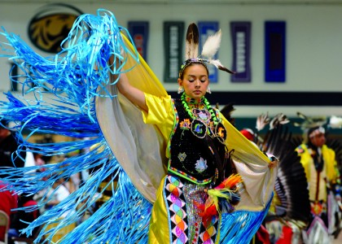
Be on Time
In general, Americans value punctuality. When specific times are given for events, it is expected that everyone involved will be on time or maybe a little early. Always be on time for your classes.

Personal Space
Typically, most Americans enjoy having quite a bit of personal space or “elbow room.” This means that they would prefer some extra space around them while waiting in line and standing or sitting in public places. Some people may feel uncomfortable having others too close to them, especially those that they do not know.

Addressing Others
Use “Dr.” when addressing instructors that have earned doctorate degree; otherwise, you can safely address them with the title of “Professor.” You may use “Mr.”, “Mrs.” (if you know she is married), or “Ms.” when you speak to those who are older than you or in formal situations. If someone tells you to call them by their first name, then you know that it is appropriate to do so.

Ask Questions/Show Interest
In the United States, asking questions is seen as a good way to learn and show interest. Students are encouraged to ask relevant questions in class.

Use English
It is recommended that students use English as much as possible while studying at BSU. Frequent usage of English will make the adjustment to living in the U.S. easier and will greatly increase the likelihood of academic success.

Eye Contact
In the United States, eye contact is very important. Maintaining eye contact shows interest and honesty.

Manners
It is polite to use words and phrases such as “please,” “excuse me,” and “thank you” when speaking with others.

Office Hours/Visits
Many people at BSU keep their office or residence hall room doors open when they are in the room. Before you enter the room, you should still knock or ask if it is okay for you to enter the room.

Shopping
In the United States, the price listed on a product is “final” and generally not negotiable. The exception to this is high priced items such as cars and houses. On items other than food, clothing and medicine, there is also a sales tax added to your final bill. The sales tax is approximately 7%.

Tipping
When eating at a sit-down restaurant, buying a drink or getting a haircut or beauty treatment, it is expected to provide a tip to the total bill. Everyone tends to tip differently. However, for a restaurant bill or a salon bill, 10% - 20% is expected. Tips will vary in that range depending on the quality of the service and the cost of the bill. For a bill for four drinks or fewer at a coffee shop or bar, a dollar or two is expected. If paying cash, the tip can be left on the table or can be added to a tip jar (if they have one). When paying with a credit card, there will be a line on the bill where a tip can be written in before the receipt is signed. The only time that you would not leave a tip in these situations is if the service was very bad. Service people rely on tips as part of their wages. Most work very hard to make sure that you are happy, so that they receive good tips.

Sharing a Ride with a Friend
Student may share rides with friends in order to save the cost of a cab. If you ask for or are offered a ride from a friend, there are some unspoken expectations. If it is more than a quick ride or if they give you rides regularly, offer them some money to help pay for gas. If they will need to wait for you for a while, let them know in advance. Always wear your seatbelt, and ask before eating, drinking or smoking in their car. Remember that it is always illegal to drink alcoholic beverages in a car, even if you are not driving. It is also illegal to have any alcohol in the car that is not fully sealed and unopened. This could mean major consequences for the drivers and passengers.

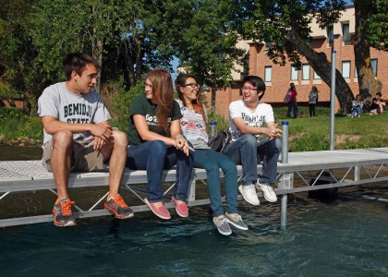
Roommates
Your roommate at BSU can be a great source of support and friendship at BSU. Here are some tips for getting along with your roommate.
- Communicate and discuss any expectations and rules for the room at the beginning
  - When is it okay to have guests? How late can we leave the main light on? What stuff is shared? These are all good things to discuss before they lead to larger arguments later.
- Respect your roommate’s things
  - Make sure you lock the door when no one is there and at night to keep yourselves and your belongings safe. Never use any of their things without asking first.
- Be clean and clean up after yourself
  - Your room does not have to be perfect. However, make sure that you are not leaving your stuff laying around or making your roommate clean up after you. Keeping yourself and your surroundings clean shows respect for your shared space.
- Give them some alone time in the room
  - College life can be stressful, and sometimes it is nice to have some time by yourself. Make sure that your roommate has that opportunity.
- Communicate and be kind
  - If your roommate is struggling, offer assistance. Occasionally invite them along if you are going to eat or out with friends. If something about what they are doing in the room is bothering you, let them know kindly.

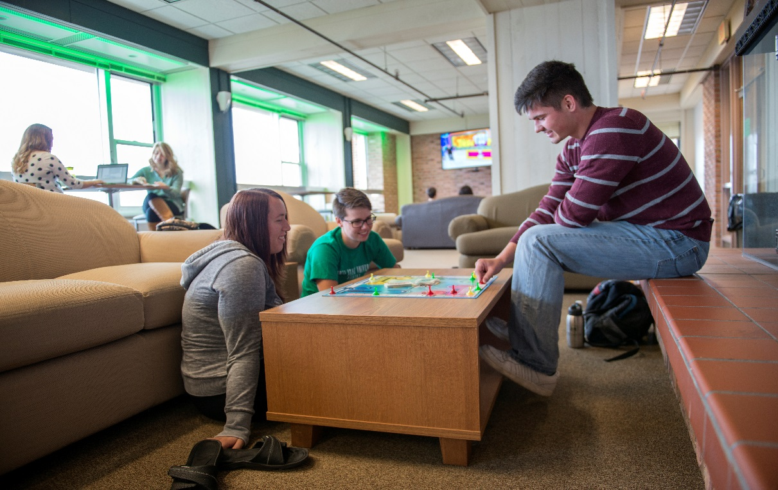

OFF-CAMPUS RESOURCES

Housing
International students are required to live on campus if they are under 21 and unmarried. For students who are able to live off campus, there are a number of places for students to rent a house or apartment in the greater Bemidji area should they wish to live off-campus after their first year. Students wishing to find off campus housing can ask others for recommendations or visit local websites. Bemidji State also offers a website listing some of the local housing options at http://www.bemidjistate.edu/services/student-activities/resources/off-campus-housing/ .
Stores/Restaurants/Places of Interest
You can find more information on events and things to do in Bemidji at the Visit Bemidji website at http://www.visitbemidji.com/ or at the Chamber of Commerce website at http://www.bemidji.org/ .

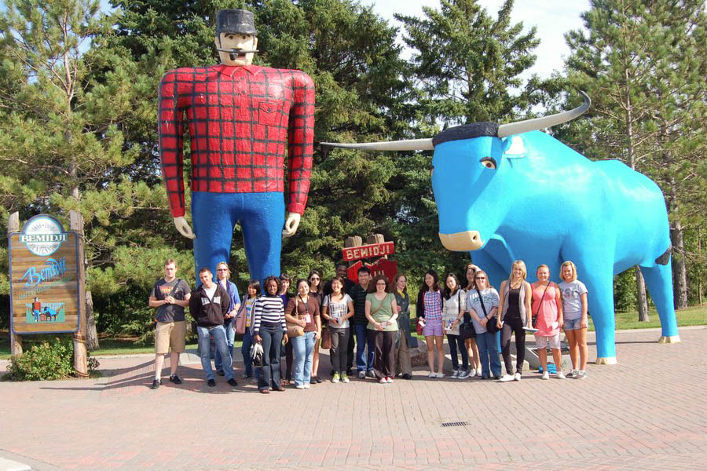

Banking Options
There are a number of banking options in Bemidji, for more choices, please refer to the Bemidji City Guide’s Directory.

Affinity Plus (also a campus location) Wells Fargo
1500 Birchmont Dr NE #45 122 3rd St. NW
(218)444-2575 (218)751-1530

Cell Phone (Mobile) Options

Verizon Wireless AT&T
1500 Paul Bunyan Drive NW 2500 Hannah Ave NW #1, Bemidji, MN 56601
(218) 333-8500 (218) 755-5113

Sprint
Paul Bunyan Mall
(218)751-0920

*For pre-paid phone plans, visit the electronics department at Target and Wal-Mart.

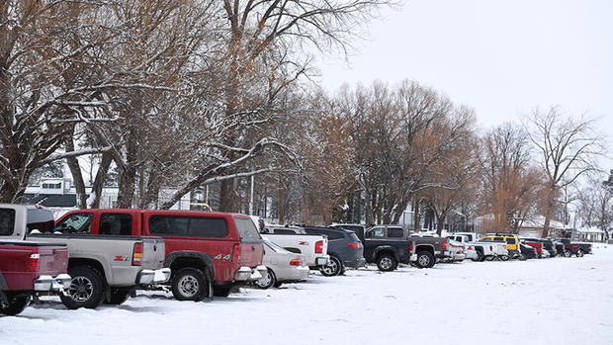
Department of Motor Vehicles (DMV)
Should you choose to get a Minnesota driver’s license while you are a student at BSU, you are able to do so by going to the Bemidji Department of Motor Vehicles (DMV). The DMV in Bemidji can contacted at:

Department of Motor Vehicles
111 Second St.
Bemidji, MN 56601

Phone: (218) 755-3956

www.dmv.org/mn-minnesota/

Renewing your Driver’s License
If you are renewing your driver’s license, you must be aware of your status check date on your driver’s license (also see DMV, under Off-Campus Resources). This is only on the driver’s licenses of international students and scholars. Please visit this website for more information:
https://dps.mn.gov/divisions/dvs/forms-documents/Documents/StatusCheckInformation.pdf

Transportation

Paul Bunyan Transit Bus Service
Specify where you want to go, at what time, and where you want to be picked up within the service area.
You may purchase a $15.00 pass for ten rides or pay $1.50 for a one-way ride. The Paul Bunyan Transit Bus stops are located on Birchmont Drive in front of the Library and near the dining center, Walnut Hall.

Phone: (218)751-8765

http://paulbunyantransit.com

Hours:
Sunday: Closed
Monday – Friday: 7am-6pm
Saturday: 8am-5pm

Taxi Service:

1st City Taxi Bemidji Cab
Call and request pickup. Call and request pickup.
Contact: (218) 444-TAXI (8294) Contact: (218) 759-1368
Hours: 6am – 10pm Hours: 5am – 2:30am
Safe Ride Hours: 10pm-1:30am
(During the safe ride hours it is a flat fee
of $3 with Student ID)
STAYING SAFE

Student Alerts
University alerts will be made through the BSU website homepage. The warning will be issued via the university web site, email, phone and other means deemed appropriate. Depending on the particular circumstances of the crime or threat, additional notices may be posted in each residential facility and within academic buildings. Students should always be alert for such announcements, especially during times of bad weather.

Weather
The wide variety in seasons in Bemidji can be very beautiful. The temperature in Bemidji ranges from an average of 26° C in July to an average of -8° C in January. During the winter, the average snowfall is 104 cm. For some international students, this may be their first experience with a cold, snowy winter. The IPC suggests the following tips to keep yourself well and warm during the winter:

- Wear multiple layers of clothing
  - This will help keep you warm and means that you can always remove a layer should you become too warm.
- Never leave heaters or electric blankets running unattended, and abide by all dorm rules concerning heaters.
- When sidewalks and roadways become snow and ice covered, wear appropriate shoes with traction.
- Purchase the following clothing for cold months
  - Rain coat/umbrella
  - Thermal pull over or hoodie
  - Winter coat
  - Waterproof winter boots
  - Wool or ski gloves
  - Wool or knit hat
  - Sweaters
  - A scarf
  - Long underwear (long pants and a long sleeve shirt that can be worn under clothing)
  - Wool/thick socks

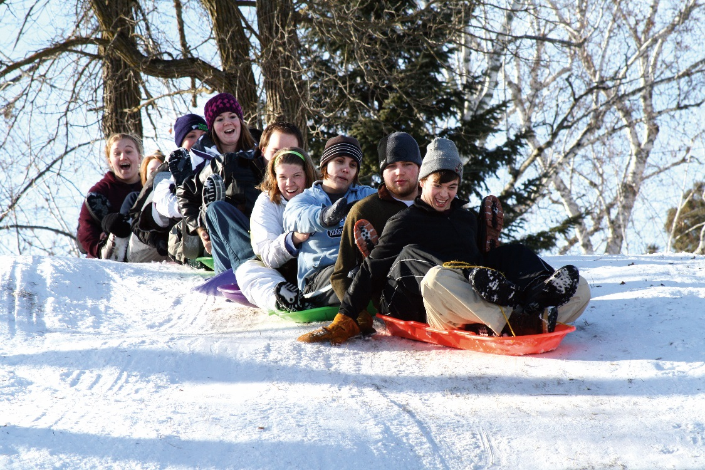
Extreme Weather
Blizzards can occur in Bemidji during the winter months. Blizzards can be dangerous due to very low temperatures and blowing snow causing limited visibility. Should there be a blizzard warning, use special caution when outside and try to avoid travel if possible until the blizzard is over. Should classes be cancelled or delayed due to winter weather, announcements will be made over email and with local media.

Alcohol and Smoking

Alcohol
Drinking alcohol when you are under the age of 21 is illegal. Being caught underage drinking can lead to legal and school punishments that could affect your visa status. Being drunk and disorderly in public, being drunk while operating a car, providing alcohol to underage students, and having alcohol open in your car or outside are all illegal. BSU also prohibits the display of empty alcohol bottles in your room. Students on campus who are around others violating alcohol policies are seen to be supporting the activity and are held liable as well. If you are over the age of 21 and choose to drink, please make sure you are doing so responsibly.

Smoking
Smoking tobacco is illegal if you are under the age of 18. Smoking marijuana is illegal for everyone in the state of Minnesota unless you have a medical prescription. Smoking is not allowed on campus grounds or in campus dorms. You will need to leave the grounds in order to smoke, should you wish to do so. In the United States, it is illegal to smoke inside of most businesses, including bars and restaurants. Violating these laws could negatively impact your visa status.

The Department of Public and Safety
The department of Public and Safety at BSU is responsible for all campus security, environmental health & safety and parking enforcement at both BSU and Northwest Technical College (NTC). The President of BSU has granted the Department of Public Safety the authority to take appropriate actions necessary to maintain a safe and secure environment on all property owned, leased or occupied by BSU and NTC. They also provide an escort service. You can call at any time to be driven to a different area of campus including streets and parking lots adjacent to campus. This is in order to provide added safety for students who may be walking at night. They can be contacted at 755-3888 to receive reports of unsafe activities and non-emergency crimes or to request an escort. Any emergency where people are in immediate danger should be reported by phone to 911.

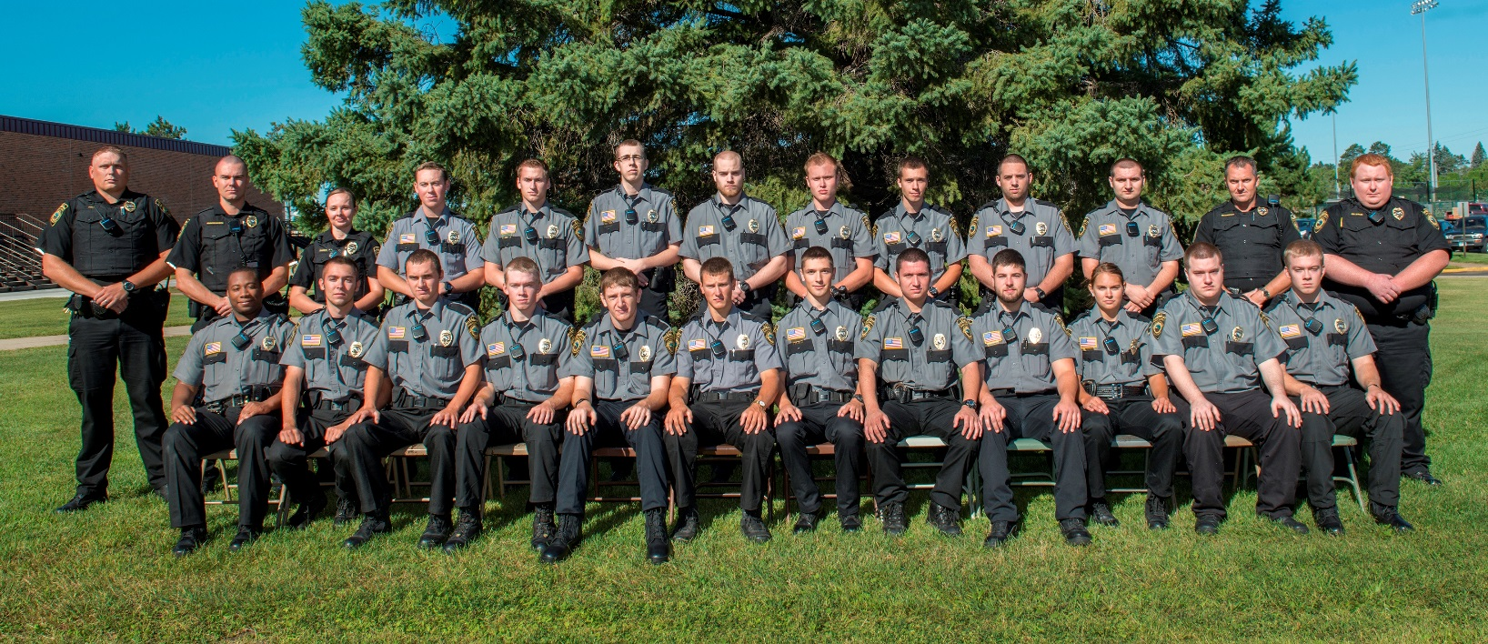
Sexual Violence
Sexual violence is an intolerable intrusion into the most personal and private rights of an individual, and is prohibited at Bemidji State University. Bemidji State University is committed to eliminating sexual violence in all forms and will take appropriate remedial action against any individual found responsible for acts in violation of this policy. Acts of sexual violence may also constitute violations of criminal or civil law, or other Board Policies that may require separate
proceedings. To further its commitment against sexual violence, Bemidji State University provides reporting options, an investigative and disciplinary process, and prevention training or other related services as appropriate. Sexual violence is defined as conduct including sexual assault, non-forcible sex acts, dating and relationship violence, and stalking, as well as aiding acts of sexual violence. Sexual assault includes but is not limited to:
- Involvement without consent in any sexual act in which there is force, expressed or implied, or use of duress or deception upon the victim. Forced sexual intercourse is included in this definition, as are the acts commonly referred to as “date rape” or “acquaintance rape.” This definition also includes the coercing, forcing, or attempting to coerce or force sexual intercourse or a sexual act on another.
- Involvement in any sexual act when the victim is unable to give consent.
- Intentional and unwelcome touching, or coercing, forcing, or attempting to coerce or force another to touch a person’s intimate parts (defined as primary genital area, groin, inner thigh, buttocks, or breast).
- Offensive sexual behavior that is directed at another such as indecent exposure or voyeurism

While you can never eliminate the risk of sexual assault, you can reduce the risk of being sexually assaulted.
- Go to social events with friends, check in with each other, and leave together.
- Communicate your limits
  - No matter what your decision is, it is your decision. You have the right to say no at any time. Be clear about what you want to do and what you do not want to do and tell your partner. If they are worth your time, they will respect your decision.
- Drink responsibly
- Lock your door
- Trust yourself
  - If you feel uncomfortable, get out of the situation or tell someone you trust. It is better to be rude than unsafe.

If you are sexually assaulted, contact help as soon as possible. The local police, RAs, BSU Health and Counseling Services, and Public Safety are all good resources. Should you wish to seek confidential help, you may contact BSU Counseling or Support Within Reach. Support Within Reach is a local organization that provides support to women who are victims of sexual violence. They can be contacted at 218-444-9524 or at http://www.supportwithinreach.org/ . BSU Counseling can be contacted at 218-755-2750 or at Student Center for Health & Counseling, Cedar Hall, First Floor. For official reporting of the incident, contact local police at 751-9111 or BSU Public Safety at 755-3888. Reports should be made as soon as possible to safeguard the victim and increase the chance of prosecution.

In any sexual situation, it is your responsibility to make sure that you have the consent of the other person. Consent is not the lack of a no, but a clear yes. Any violations to this can be considered sexual violence. Being charged with sexual violence will have both school and possibly legal repercussions.
- Listen and pay attention to the other person. If you feel you are getting mixed signals, ask for consent.
- Sexual assault is a crime. It is never okay to force sexual activity.
- Don’t make assumptions. Being dressed a certain way, being drunk, or their behavior does not give you permission. Only their verbal consent to the activity does.
- Having given consent in the past or giving consent to some activities, does not give consent to all sexual activities whenever.
- Anyone who is mentally or physically disabled, drunk, drugged, or passed out cannot legally give consent. If they cannot legally drive a car, they cannot legally have sex.
Discrimination and Harassment
Minnesota State Colleges and Universities defines discrimination as ‘conduct that is directed at an individual because of his or her race, sex, color, creed, religion, age, national origin, disability, marital status, status with regard to public assistance, sexual orientation, gender identity, or gender expression and that subjects the individual to different treatment by agents or employees so as to interfere with or limit the ability of the individual to participate in, or benefit from, the services, activities, or privileges provided by the system or colleges and universities or otherwise adversely affects the individual's employment or education.’

Harassment is defined as “verbal or physical conduct that is directed at an individual because of his or her protected class, and that is sufficiently severe, pervasive, or persistent so as to have the purpose or effect of creating a hostile work or educational environment.”

The student code of Conduct at Bemidji State requires that all students “speak and listen to others with care, seeking personal understanding and maintaining respect and civility. Students will respect and protect the personal privacy, rights, and safety of others with regard to physical and sexual boundaries, living space, possessions, electronic accounts and academic endeavors.”

Should you feel that you are the victim of harassment or discrimination, please report it and seek help. RAs, the IPC and Public Safety are all good resources. All school affiliated staff are mandatory reporters of any situation that shows that the well-being of the student is in danger.

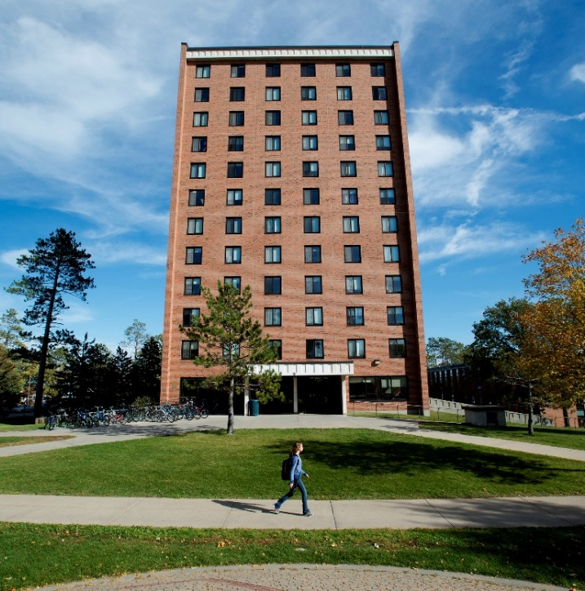

ACRONYMS AND BUILDING CODES
Once you begin classes, you will notice that most of the classroom building names are shortened on your class schedule. Use this as a guide to help you find the correct classrooms in the correct building. You can cross-reference the name of the Hall where your class is, with a current map of Bemidji State University.

HS- Hagg-Sauer Hall
S- Sattgast Hall of Science
BN- Bridgeman Hall
BG- Bangsberg Fine Arts Complex
BH- Benson Hall
M- Memorial Hall
D- Deputy Hall
DH- Decker Hall
PHED- Physical Education Complex (Gillett Wellness Center, etc.)

IMPORTANT CONTACT INFORMATION

Emergency (Fire, Police, Ambulance) Public Safety
911 Walnut Hall
(218)755-3888
Police Department (non-emergency)
(218)333-9111

International Program Center (IPC) Records
Deputy Hall 103 Deputy Hall 101
(218)755-4096 (218)755-2020
international@bemidjistate.edu
https://www.bemidjistate.edu/students/international/

Student Health and Counseling Services Cashiers
First Floor Deputy Hall 202
(218)755-2053 (218)755-2045

Residential Life Career Services
Walnut Hall Sanford Hall 102
(218)755-3750 (218)755-2038

Family Friends Program
familyfriends.bemidji@gmail.com

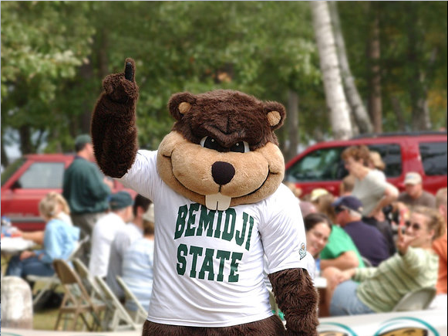
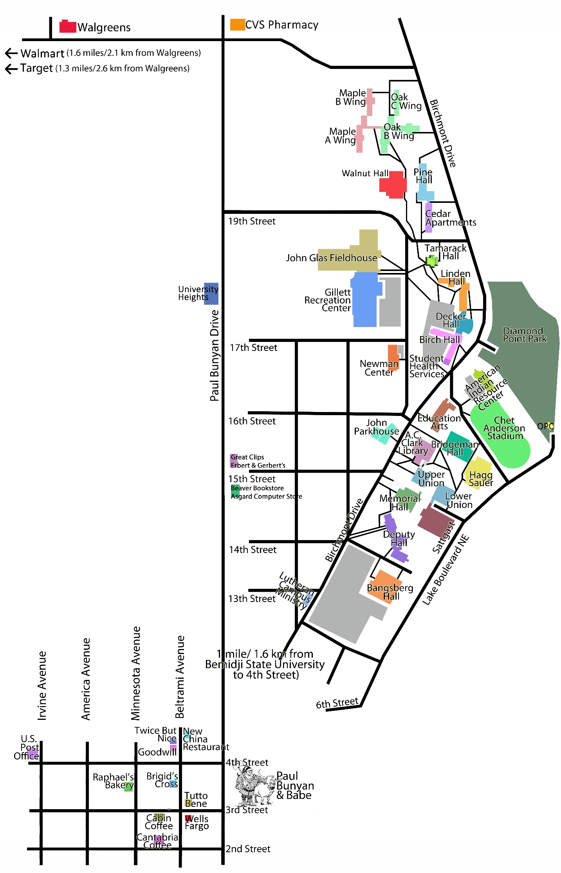
CAMPUS MAP

TUNNEL MAP
