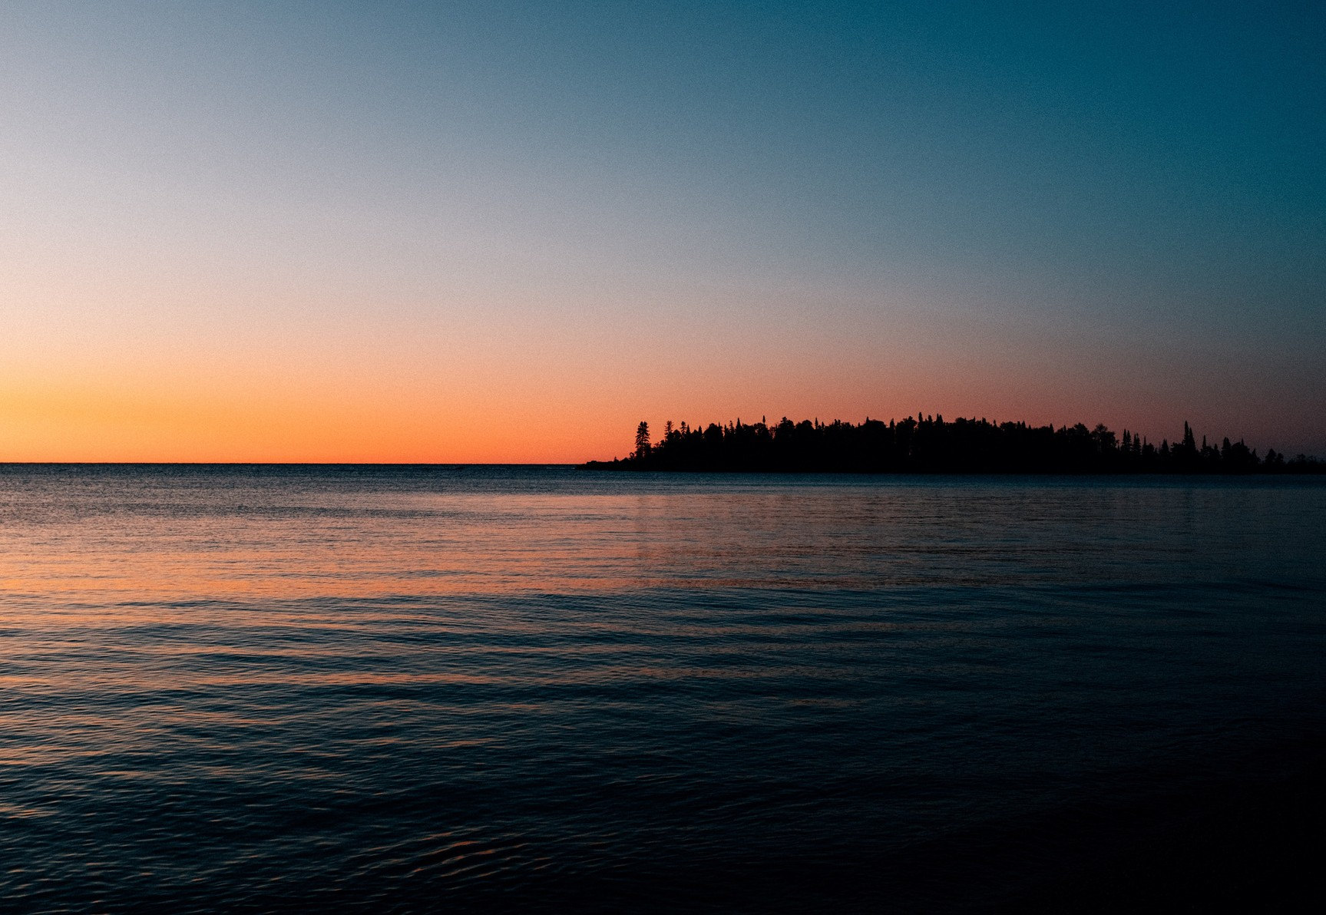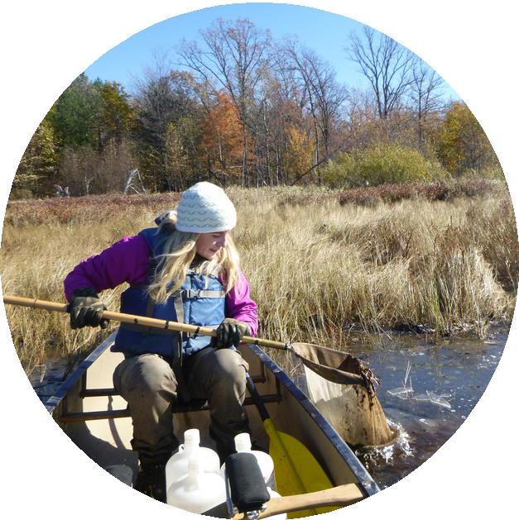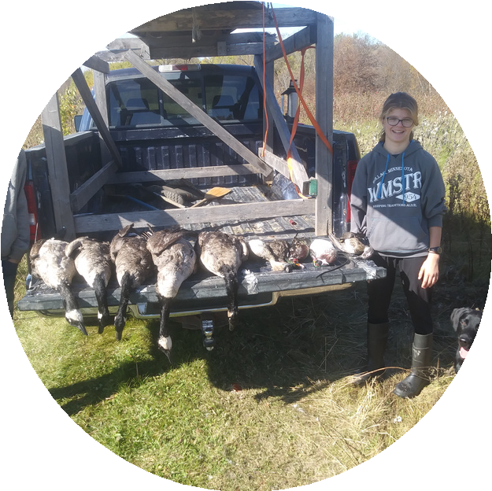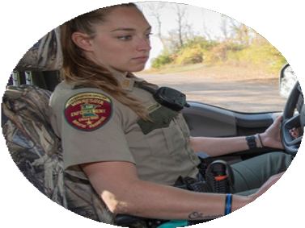B e m i d j i S t a t e U n i v e r s i t y

CA R E E R P A T H W A Y :

CON SE R V A T I ON OF F I CE R

Environmental Studies

Fisheries or Wildlife Biology
Copyright Deborah Rose, MN DNR

Peace Officer

Conservation officers help people enjoy the great outdoors while protecting fish and wildlife populations. If you like working with people and enjoy being outside, this is the career path for you.
BEMIDJI STATE UNIVERSITY
1500 Birchmont Dr. NE #27
Bemidji, MN 56601 - 2699
218-755-2920

By taking courses in Criminal Justice, Environmental Studies, Fisheries Biology and Wildlife Biology you will have the diverse course work that will set you apart in the conversation officer field. Many BSU students have completed their studies in these programs and have gone onto work as conservation officers throughout Minnesota and across the United States. If ensuring that fish and wildlife populations are around for the next generation is important to you, pursuing your higher education at Minnesota's northwoods university is the place for you!
HTTPS://WWW.BEMIDJISTATE.EDU/ACADEMICS/UNDERGRADUATE/

Scan to apply today!

OPTION 1 PART A: CRIMINAL JUSTICE, B.S. major, Police Science Emphasis
Required Credits: 48
Required GPA: 2.25

Required Criminal Justice Courses, complete the following:
QR codes link to
more information about particular degree programs.

CRJS 1120

Criminal Justice and Society ( 3 credits)
CRJS 3304
Police Process ( 3 credits)

CRJS 3201 Research Methods and Statistics for CJ (3 credits)
CRJS 3305 Judicial Process (3 credits)
CRJS 3310
CRJS 3359
Introduction to Emergency Management (3 credits) Criminal Investigations (3 credits)

CRJS 3315
Criminology and Delinquency (3 credits)
CRJS 3360
Criminal Procedure and Evidence (3 credits)

CRJS 3358 Criminal Law (3 credits)
CRJS 4920 Directed Group Study (3 credits)
JUST 3377
CRJS 4103
Forensic Victimology (3 credits)
Criminal Justice Diversity and Ethics (3 credits)
Criminal Justice

CRJS 4480 Police and Community Relations (3 credits)
- Required Criminal Justice Electives, complete 9 semester credits: (only select courses listed)

BIOL 3400
Fish & Wildlife Law and Adm. (3 credits)
CRJS 3306
Corrections and Penology (3 credits)

CHEM 3201 Criminalistics (3 credits)
CHEM 3305 Criminalistics Lab (1 credit)
INST 1107
INST 4000
Introduction to Turtle Island (3 credits) Nation Building and Leadership (3 credit)

JUST 4477
CRJS 4487
CRJS 3380
Restorative Justice (3 credits)
Principles of CJ Supervision (3 credits) Community Corrections (3 credits)
INST 4418
INST 4900
PSY 2217
Federal Indian Law (3 credits) Social Justice (3 credits) Abnormal Psychology (4 credits)

OPTION 1 PART B: WILDLIFE OR FISHERIES BIOLOGY OR ENVIRONMENTAL STUDIES minor
Required Credits: 18-26
Required GPA: 2.00-2.25 (example courses listed, scan QR codes to access our course catalogs)
GENERAL SCIENCE COURSES: ORGANISM IDENTIFICATION COURSES:

BIOL 1500
Diveristy of Life (4 credits)
BIOL 4510
Ornithology (3 credits)

BIOL 2610
General Ecology (3 credits)
BIOL 4520 Mammalogy (3 credits)

ENVR 2000 Intro. to Environmental Science (3 credits)
BIOL 4534
Ichthyology (4 credits)

PLANT IDENTIFICATION COURSES:
HUMAN DIMENSIONS COURSES:

BIOL 3170 Dendrology (2 Credits)
BIOL 3830 Aquatics Plants and Algae (4 Credits)
MANAGEMENT COURSES:
BIOL 4530 Ecology & Management of Large Mammals (4 credits)
BIOL 4545 Fisheries Management (4 credits)
ENVR 4210
ENVR 3600
ENVR 3700
BIOL 3420
Envir. Law and Policy (3 credits)
Envir. Justice and Sustainability (3 credits)Natural Resource Management (3 credits)
Human Dimensions... (3 credits)

OPTION 2 PART A: WILDLIFE OR FISHERIES BIOLOGY OR ENVIRONMENTAL STUDIES
- Select a major: Aquatic Biology: Fisheries Emphasis Credits: 73 Minimum GPA 2.50
COMPLETE THE FOLLOWING COURSES: ELECTIVE CREDITS, ONLY SELECT COURSES LISTED

major

BIOL 3361
BIOL 3362
BIOL 3830
Limnology (4 credits) Streams and Rivers (4 credits)
Aquatic Plants and Algae (4 credits)
BIOL 2339
BIOL 3400
BIOL 3420
Ethics of Fish & Wildlife Management (3 credits) Fish & Wildlife Law and Admin. (3 credits) Human Dimensions... (3 credits)

BIOL 4200 Freshwater Invertebrates (4 credits)
BIOL 4534 Ichthyology (4 credits)
ENVR 4220 Sampling and Analysis (4 credits)*
ENVR 3040 Environmental Economics (3 credits)
ENVR 3600 Environmental Justice and Sustainability (3 credits)
ENVR 3800 Environmental Data Analysis (3 credits)

Fisheries Biology

GEOG 3231 Intro GIS (3 credits)
BIOL 489X Fisheries Research I & II (4 credits total)
BIOL 4545 Fisheries Management (4 credits)
GEOG 4265 Spatial Analysis (3 credits)
PSY 4403 Advanced Statistics and Research Design (4 credits)
STAT 3610 Time Series Analysis (3 credits)

- Select a major: Wildlife Biology B.S. Credits: 74 Minimum GPA 2.25
COMPLETE THE FOLLOWING COURSES: ELECTIVE CREDITS, ONLY SELECT COURSES LISTED

BIOL 3610
BIOL 4510
BIOL 4520
Principles of Wildlife Management (4 credits) Ornithology (4 credits)
Mammalogy (4 credits)
BIOL 3150 Animal Behavior (3 credits)
BIOL 4620 Evolution (3 credits)
BIOL 3830 Aquatic Plants and Animals (4 credits)

GEOG 323X GIS courses (6 credits total)
BIOL 4623 Forest Ecology (3 credits)

BIOL 4330
BIOL 4780
Upland Wildlife Management (4 credits)* Wildlife Management Techniques (5 credits)
BIOL 3420 Human Dimensions... (3 credits)
BIOL 3400 Fish & Wildlife Law & Admin (3 credits)
Wildlife Biology

- Select a major: Environmental Studies B.S. Credits: 59 Minimum GPA 2.25
COMPLETE THE FOLLOWING COURSES: ELECTIVE CREDITS, ONLY SELECT COURSES LISTED

ENVR 2000 Introduction to Environmental Science (3 credits)
ENVR 3800 Environmental Controversies (2 credits)
ENVR 3800 Environmental Data Analysis (3 credits)
INST XXXX BIOL 2XXX BIOL 4330
Treaties Course (3 credits)
Fish and Wildlife of North America (3 credits) Upland Wildlife Management (4 credits)*

ENVR 3600 Environmental Justice and Sustainability (3 credits total)* ENVR 4220
Sampling and Analysis (4 credits total)

ENVR 4610
GEOL 3120
Sustainability: Theory and Practice (3 credits)* Soils (4 credits)
ENVR 4210
GEOL 3211
Environmental Law and Policy (3 credits) Environmental Hydrology (3 credits)
Environmental Studies

OPTION 2 PART B: CRIMINAL JUSTICE CERTIFICATE (POST ELIGIBLE) 24 Credits

CRJS 3304
CRJS 3305
CRJS 3310
CRJS 3358
Police Process (3 credits) Judicial Process (3 credits)
Emergency Management (3 credits) Criminal Law (3 credits total)
CRJS 3359
CRJS 3360
CRJS 4103
CRJS 4480
Criminal Investigation (3 credits)
Criminal Procedure and Evidence (3 credits) Criminal Justice Diversity & Ethics (3 credits) Police & Community Relations (3 credits total)

Additional Considerations:
*Other classes are available, see QR codes.
Students pursuing a major in Aquatic Biology, Wildlife Biology, and Environmental Studies under option 2 are encouraged to take INST XXXX as an elective.

