Questions

- Ends: What kind of humanity does this technology seem to promote? Identify specific relationships or behaviors as evidence for your answer.
- Means: What type of influence does this technology seem to impose on the human user: coercive, decisive, persuasive, or seductive? What is the evidence for this conclusion?

Points of Contact
Point | Form | Description
To the Hand | Physical | When humans physically interact with a technological object
Before the Eye | Cognitive | When humans receive or interpret information provided by a technological object
Behind the Back | Contextual | When technology is part of the infrastructure of the human’s environment

Types of Relations
Embodiment | A relation in which the human and technology temporarily “merge” to interact with the world, like a telephone or a microscope
Hermeneutic | A relation in which the human interacts with a temporary “merger” of a technology with the world, like an MRI or a metal detector
Alterity | A relation in which the human interacts with a technology while the world remains in the background, like an ATM
Background | A relation in which technologies are part of the ambient background of human experience, like the humming of a refrigerator or air conditioner
Cyborg | A relation in which the human and technology permanently “merge” to interact with the world, such as a chip implanted in the brain (the main difference between an embodiment relation and a cyborg relation is the duration and depth of the merger between human and technology)
Immersion | A relation in which the human interacts with a permanent “merger” of a technology with the world, such as the internet of things and smart assistants (the main difference between a hermeneutic relation and a immersion relation is the duration and depth of the merger between technology and the world)
Augmentation | A relation in which there is a simultaneous embodiment and hermeneutic relation, such as with Google Glass

Types of Influences
Decisive
Coercive

Strong
 | Apparent | Hidden
Strong | Coercive | Decisive
Weak | Persuasive | Seductive
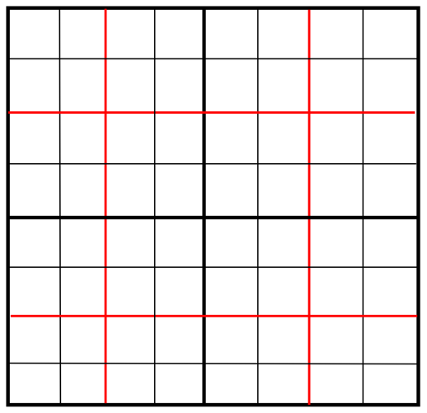
Seductive
Persuasive
Apparent
Hidden
Weak

Figure 1. Figure 2.

References

Verbeek, P-P. (2006). Materializing morality: Design ethics and technological mediation. Science, Technology, & Human Values 31(3), 361-380.
Verbeek, P-P. (2013). Technology design as experimental ethics. In S. van den Burg & Tsj. Swierstra (Eds.), Ethics on the laboratory floor (83-100). Basinstroke: Palgrave Macmillan.
Verbeek, P-P. (2015). Beyond interaction: A short introduction to mediation theory. Interactions 22(3), 26-31.

