The Impact of Women and Intersectionality on Bill Success in State Legislatures

Maggie Lowrey
Bemidji State University

Political Science Senior Thesis
Bemidji State University
Dr. Patrick Donnay, Advisor
April 2022

Abstract

Thousands of bills are introduced in state legislatures every year and there are a multitude of reasons as to why some of those bills become law and some do not. Female sponsorship and the intersectionality of female sponsors are the focus of my research. Previous research has found variable impact of these characteristics; however, little work has been done on the combined effects of race, gender, and partisanship on bill passage rate. I tested these ideas on bills that were introduced to state legislatures of forty states in 2015 from the Harvard Dataverse¹. By applying differing factors of race, gender, and partisanship to bill success, I am assessing whether racial differences among women in differing partisanship leads to a greater impact on bill passage in state legislatures.

- Holman, Mirya; Mahoney, Anna; Hurler, Emma, 2021, "Replication Data for: Let's Work Together Women’s Collaborative Success in Bill Sponsorship in U.S. State Legislatures", https://doi.org/10.7910/DVN/NVCQPB, Harvard Dataverse, V1
Literature Review

The History and Struggles of Female Representation
Historically speaking, women have not been viewed as political equals hence the need for the women’s equal rights fight of the early 1900’s. While there has been quite a bit of progress made on women’s rights, there are still daily battles for women’s rights. A recent example is a current abortion case in Mississippi. So why have women had so many struggles to be equal in the political field?
According to Nechemias (1985), a few of these obstacles that women face is geography, state culture, and the inequalities that stem from them. Her work focused on, “whether geographic immobility deters women from running for state legislatures” (Nechemias, 1985). It was found that with other factors such as public perceptions and female standards considered, geography played an incredibly significant role in what kind of office women would run for. The data showed that women were more likely to run for lower-level positions and for offices that were not too far from home than they were to run for a position that required them to be far from home. Compared to men this was a significant difference. It was difficult for women to “abandon” their home lives to become politicians as they were expected to maintain their status at home as the caregiver while they pursued becoming a politician. This research also shows how this is not an issue at all for men as their societal roles are the opposite of women’s. This obstacle was difficult to overcome as it truly relied on changing public opinion and extra support from a husband who supported their efforts.
Work by Rule (1990) found that women are more likely to be successful in a state legislative election than they are at a congressional or other national positions. This supports the original idea that women during this time period were more likely to choose offices to run for that were closer to home. Rule also focused on the women’s movement and its impact on elections at various levels. It was found that, “an important base of support for women’s organizations has been women in the workforce and professional women. It is expected that these changes in women’s work outside the home have impacted favorably on women’s legislative recruitment” (Rule, 1990). This change in social standards and expectancies, led to a change in perceptions for women in politics. Although it is not quite the kind of change that one may hope for, as the percentage of women in the state senate only increased to 8% and women in the house only increased to 6% (Rule 1990).
Kevin Arceneaux’s (2001) article, addresses more obvious obstacles that women face in becoming involved in the political world. He focuses on the “gender gap” in state legislatures. His research is focused on attitudes toward gender-role expectations and how culture and ideology influence gender-roles. The gender-gap as explained in the article, is that in some states, politics are a “man’s world” activity which creates a negative and limited attitude towards a woman’s gender-role. His research found three consequences of the negative gender role attitudes, “First, women may not run for office because they do not believe it to be appropriate. Second, women may not be highly recruited to run for political office because party officials and other political elites are biased against female candidates. Or third, even women who are not socialized into passive gender roles and who do run despite unsupportive elites face unsympathetic voters at the polls and are, consequently, more likely to lose than female candidates in states with more positive gender role attitudes.” With this concept being socialized and widely accepted among an entire state’s culture it leads to significant consequences. It creates a sense of bias against women in the fact that it is considered “inappropriate” for women to hold office. All of these obstacles, obvious or not, have all significantly influenced the progression of women in politics.
Recruitment Tactics for Female Representatives
Another interesting aspect of women in politics is how they recruit women and campaign to run. One piece focused on recruitment is based on a case study in Santa Clara County. (Flammang, 1985). Santa Clara County was known as the ‘“feminist capital of the nation’ because of its impressive number of elected women” (Flammang, 1985). This research found that some political environments are better than others for women to thrive in. The political environment in which women thrive are environments where both men and women support women’s issues, they have effective women’s groups throughout the community, and have a highly educated base of constituents. Santa Clara County fostered this exact political environment, which led to its title of the “feminist capital of the nation,” Flammang also found that women have quite different campaign strategies than men do in order to accommodate their constituents needs and convince them that they are just as qualified as a man to do the job. In the Santa Clara case study, Shirley Lewis was a councilmember who was running in the local election during this study. Her strategy was a different approach from her male opponents as she avoided imitating how her male opponents were campaigning created new strategies. These strategies were based on networking with more women constituents and developing a feminist consciousness among their total constituents. So, it would make sense that in areas that are accepting of women’s issues and women in political office, that there would be higher tendencies of women being elected.
Kira Sanbonmatsu’s (2002) Political Parties and the Recruitment of Women to State Legislatures also looks at women’s recruitment in politics. This article analyzes how political parties shape women’s representation and how each party impacts recruitment. She studied, “The social eligibility pool, legislative professionalism, and partisan composition of the legislature affect women's representation differently” (pg. 1). Rather than just assuming that political success was the same for all women across the board, Sanbonmatsu wanted to study the strategies of recruitment based on political parties. This was beneficial in studies as she found that the social eligibility pool was a conditional concept based on party. She also found that legislative professionalism varied between parties but also was impacted by which party was the majority versus the minority. Lastly, she found that partisan composition affected the opportunities that were available to women in state legislatures. These recruitment studies added a level of density to the research regarding the struggles of women in politics prior to 1990.
Modern Female Representation
While there has been progress towards increased female participation in our political system, it does not mean that women face fewer issues today than they did previously. In fact, many things with which women struggled previously, they still struggle with today. Just on a smaller scale or in different ways. Now that it is more widely accepted that women can be politicians and they can be successful as a politician, a more modern issue that women struggle with is how the electoral system is designed (Matland, 2005). In electoral systems with plurality/majority systems women are less likely to be elected than those in a mixed/multi-member district system. According to Matland this is because voters are more comfortable voting for a woman in a mixed/multi-member district because they know they can also vote for a man at the same time. Because the United States is a plurality/majority system, its electoral system falls under the category of systems that do not favor women candidates. A conclusion that is drawn from this volume is that “Changing the electoral system is only one part of a more comprehensive strategy for improving women’s representation” (Matland, 2005).
A few other theories explored on women’s representation are the patriarchal culture in society that oppresses women, the familial responsibilities of women, and limitations of the gatekeepers to the primaries (Conway, 2001). Conway focuses more on the opportunity side of the question. She argues that in a patriarchal society, women do not have the same opportunities as men, as they are generally reduced to secretary positions, nurses, or teachers. This creates a barrier of what is considered an acceptable opportunity for women to pursue. When it comes to expectations of familial responsibilities, they can make women appear inadequate or less appropriate to fulfill the demanding tasks of a political career. Their opportunities are further limited if they are expected to maintain perfect images of motherhood and that of a successful politician. In the eyes of the patriarchal society, this simply was not possible. Lastly, Conway dives into the limitations that are created by the people in power already. The gatekeepers of the primaries are what she considers the greatest limiters to political opportunity for women. The gatekeepers are typically male politicians, but not always, that participate in the caucuses and party conventions prior to the primaries. The job of a gatekeeper is to select a candidate for the primaries that they feel has a chance at actually winning the primary and essentially the election. If the gatekeepers are not supportive of women at the primary stage, they limit the opportunity for women to even make it past step one.
In addition to opportunities and electoral design, further research was conducted on state legislative elections and focused on the term “women friendliness.” This research was based on the “women-friendly” district index to construct theoretical and empirical research. (Flammang, 1985). They found that their research and this index was useful in predicting election outcomes for women and surpasses a study of just political culture of an area. This research also concluded that districts that were considered to be more “women-friendly” were more likely to elect a woman to office than districts that scored lower on the friendliness scale. The most significant feature of this research was that this index established that “women-friendliness” is a valid and useful empirical concept that can be used for further research in multiple political contexts.
The Effect of Constituents on Female Representation
A factor to consider when studying the struggles of female representation, is who they represent and what is their perspective on women in politics. Distinct factors to consider here are socioeconomic and political characteristics of constituencies, a state’s policy priorities, the demographics of the state, and the values of the constituents (Leigh, 2006). This research lists eight different hypotheses that emphasize a few basic characteristics of a state. These characteristics being, how urban a state is, the population of a state, the location of a state, support for diverse groups of people, income levels, and education levels. After studying these hypotheses, it is revealed that each one provides different limitations for women’s connections to public office.
Another study on constituents, was done by Lonna Rae Atkeson and Nancy Carrillo (2007), only this time they focused specifically on female constituents. This focus on female constituents proved to be beneficial in learning more about the public view of women politicians. They had hypothesized that higher female representation in politics would lead to an increase female constituents’ interest in government and politics but would have no effect on men. They had found that while there was an increase in interest of female constituents, they were wrong about it not having an effect on male constituents. It was discovered that it increased the interest in men as well, but not further test was conducted to see whether the interest was supportive towards the women in office or if it was in opposition. Overall, they had concluded that “collective female descriptive representation has important benefits to a democratic society” (Atkeson & Carrillo, 2007).
Policy Priorities of Representatives
Defining a problem is central to policy making and categorically part of the political process. Politicians use problems to create their platforms for their campaigns, they use problems to contrast opponents, and of course they use problems while they are in office. Problems create their agendas and essentially lead to actual policy making. So how does one define a problem? How do representatives decide what is a problem and what is not? Better yet, how do they decide which problems to focus on and which ones to ignore? Do women go about this differently? When a social predicament arises, it is the job of the public officials to address this predicament, while utilizing empirical evidence to develop a degree of seriousness (Rochefort & Cobb, 1993). This is a simplistic view of course as nothing is fully addressed in this manner. In politics there are many aspects to consider when deciding on whether or not something is actually a problem.
So, when it comes to women in politics, what problems are considered problems and what are not? From the perspective of women, policies that surround body autonomy, maternity leave, children’s rights are likely high priority policies. From the perspective of men, policies surrounding the economy, foreign affairs, or budgets are likely high priority policies (Thomas, 1991). Now there is nothing to say that these high priorities are not flipped in any situation, but an overall majority of men and women will have increased tendencies towards these policies. How these policies are addressed vary on the state and the legislatures’ composition. Thomas found that policies that were more supported by women, were likely to be more successful than those will less female support. It was also discovered that policies with more equal support from men and women, the more successful that policy will be.
Taking this research one step further on policy priorities of women in state legislature, Edith J. Barrett (1995) examines the priorities of Black women in state legislatures. She acknowledges the lack of research conducted on Black women, as most research regarding women is focused on white women and most research regarding Black people is based on men. She finds in her research that Black women do align with white women and their feminist priorities, and they also align with Black men and their priorities on minority issues. What was unique about her findings was that Black women have different priorities than both of these groups. In fact, they find that women, “the most pressing issues are education, health care, economic development, and employment” (Barrett, 1995). This outlines a significant level of intersectionality among women and their priorities.
To segue into intersectionality, race, gender, and ethnicity all have a significant impact on our politics and how it is shaped. These three factors also impact the level of participation in government and affect voter turnout (Uhlaner & Scola, 2016). Their work focuses on historically excluded groups based on race, gender, and ethnicity and how they specifically impact policy priorities through voter turnout. They found that an increase in diversity among gender, race, and ethnicity led to an increase in voter turnout based on the last seven state legislative elections. They used the Cooperative Congressional Election Studies (CCES) dataset to study each of these factors. When looking specifically at Blacks and Hispanics, they found that the higher the turnout of these races, the greater the proportions of members of Congress also being Black or Hispanic. They also took in account some contextual factors as well, education, income, and workforce participation. They found that these greatly affected voter turnout, specifically among each of the historically excluded groups from politics. They concluded that the greatest influencing factor for voter turnout is race.
Women and Intersectionality on Bill Success
It is believed that the primary goals of legislators are passing legislation and getting reelected. What makes legislators effective in law-making is based on three categories: Institutional status, Legislative activity, and descriptive attributes, according to Rocca and Sanchez (2011). They explore the way that these three factors contribute to the success of legislators and passing legislation. They find that the greater institutional status a politician has the greater the influence they have in passing legislation. Their focus is the effectiveness of minorities in Congress. Rocca and Sanchez discuss the disadvantages that minorities face when serving in Congress and the hardships they come across to gain the necessary influence in order to be more effective legislators. One of the significant hardships that minorities face is, “Another reason for minorities’ lack of influence may be due to racial polarization in Congress” (Rocca and Sanchez, 2011). This is an extensive issue that members of these groups face every day and is likely an issue that they face as legislators. Their research expands on the content of bills being an additional factor that leads to a bill becoming a law. They are supported in this notion by other researchers as well, “The quality of the bill is a major driving factor it is success as higher quality bills are more likely to attract expert sponsors and increase the total number of sponsors” (Hitt, Volden, and Wiseman 2017; Alder and Wilkerson 2015). Hitt, Volden, and Wiseman created a spatial model to determine what makes some legislators more effective than others. Their model is called the Legislative Effectiveness Model (LEM) to determine factors of effectiveness. They assess quality of the norms, voter, setter, and pivotal politics models, and have created new empirical predictions with the (LEM). They found that ideological positions make a significant difference as to whether a bill will be successful. According to their findings, it is based on the proposers’ ideological position that can determine the outcome of its success. So how does this affect women and their contribution to bill success? Women fall under the umbrella term of minorities and struggle as well to gain influence over policy making. This is attributed to similar factors as mentioned before, but female legislators have been able to work to overcome some these hardships. Mirya Holman, Anna Mahoney, and Emma Hurler study the ways that women overcome these hardships and find that collaboration is the key to women’s success in legislatures. They argue that “one mechanism by which women overcome marginalization and gendered expectations of overperformance is bill success from cosponsoring legislation with other women” (Holman, Mahoney, and Hurler, 2021). This research is the foundation by which I based my own research on. This study explains the several factors that women face regarding marginalization and vulnerability. This study does not expand to include the differing factors of race, thus equipping me with the groundwork to broaden this research.

Methods and Analysis
The dataset that was used to conduct this research was found from the Harvard Dataverse. The data was compiled and replicated for previous research conducted by Mirya Holman, Anna Mahoney, and Emma Hurler. The data contains information about 40 state legislatures and the bills introduced within those legislatures in which there are a total of 168,736 bills that were analyzed (n = 168,736). The unit of analysis in my study is bills in the state legislature. Due to the high number of bills, I was granted the ability to see an overall effect of the variables that I evaluated. The variables contain information regarding gender, race, partisanship, political party control of the chambers, and many more factors. This study focuses on the variables involving female sponsors, black sponsors, Hispanic sponsors, bipartisan sponsors, and party control of the chambers. A multitude of the variables are dichotomous, and others are interval based upon percentages. Due to the nature of the tests I ran to evaluate these variables, the interval variables were broken down into ordinal variables of four categories to group the percentages to make the results more straightforward.
With support from previous research and analyses, my research study hypothesizes the following:
- In a comparison of State Legislative bills, those that have a higher number of female sponsors will be more likely to be signed into law than those with fewer or no female sponsors.
- In a comparison of state legislative bills, those with more Democratic support for bills will have more female sponsors than those with more Republican support.
- In a comparison of state legislative bills, those with more diverse female sponsors will be more likely to be signed into law than those with less diverse or only white female sponsors.
In order to assess these hypotheses, I utilized a recode process in order to simplify the interval variables for the differing races and gender: Black, Hispanic, and female sponsors. I excluded the “white” variable because it was not female exclusive. I also excluded the variables “Asian” and “American_Indian” due to the smaller numbers that they did not have sufficient amount of data available to test. These interval variables were broken down into ordinal variables of four categories to group the percentages to make the results more straightforward. These new ordinal variables were labeled as “Gender4,” “pct_white_cat4,” “Black4”,” and “Hispanic4”. The 4 categories were broken down into 0 – 10%, 11 – 40%, 41 – 70%, and 71%+. These percentages were selected to balance out the data within each percent range. The dichotomous variables used for this analysis were “Signed_law,” “up_for_vote,” and “caucus_dem.” “Signed_law” and “up_for_vote,” are determined by a “yes” or “no” answer code. “Caucus_dem” is determined by whether the chamber is in control of republicans or democrats.
Hypothesis One: Female Sponsorship Affecting Bill Success
I conducted a crosstabulation with “gender4” which tested the percentage of female sponsors on bills, with the variable “signed_law” to show if the bills were signed into law. I focus on bills signed into law for my variables as it shows the highest level of success of a bill. I controlled with “caucus_dem” to show the effect that party control has on “gender4” and “signed_law”. The focus for this hypothesis is to look at the total bills that became law. As shown in Table and Figure 1, the results are statistically significant (p <.001).
(Table 1 and Figure 1 about here)
I found that under Republican control there was a decrease in bill passage as the number of female sponsors increased. It was an opposite affect under Democratic control until a bill had 71% or higher female sponsors of bills. We see a considerable drop in both parties when women primarily sponsor bills. These results are interesting as they show great strides for women in getting bills passed but alludes to additional struggles in getting women dominated bills passed. As these findings are mostly consistent with the hypothesis, I reject the null hypothesis.
Hypothesis Two: Party Control Affects Total Number of Female Sponsors
Taking a second look at Table 1 we see that the original hypothesis is not supported as the Republican Control has much higher rates of women sponsors overall all compared to Democratic control. I decided to take a another look at these variables and run a separate crosstabulation for just “caucus_dem” and “Gender4” without factoring in whether a bill was passed into legislation. Table 2 shows that under Republican control that overall, there are higher rates of women sponsors on bills under Republican control than there are under Democratic control.
(Table 2 about here)
These variables prove to be statistically significantly as well (p<.001). An additional factor to consider for these results is that in 2015, when this data was collected, most state legislatures were under Republican control. Being that this data encompasses just one year’s worth of data, this hypothesis cannot be effectively proven based solely on the data provided.
Due to the significance of the data, I reject the null hypothesis.
Hypothesis Three: Female intersectionality Affecting Bill Success
To test this hypothesis, I ran cross tabulations for each separate race variable. I chose to focus on Black female sponsors, Hispanic female sponsors, and white sponsors for this hypothesis. I evaluated the percentage of Black, Hispanic, and white sponsors with bills that were signed into law, while I controlled for the party control of the chambers. Table 3 and Figure 2 show the results for the percentage of Black female sponsors. This table sticks out because, under Republican control there is no statistical significance, but under Democratic control there is statistical significance.
(Table 3 and Figure 2 about here)
Looking at our next table, I ran the same crosstabulation as before, except I replaced “black4” with “Hispanic4”. Similar to the results of the Black female sponsors, there is no statistical significance for the percentage of Hispanic female sponsors under Republican control, but there is under Democratic Control. Table 4 and Figure 3 show these results and show surprising percentages in each column. This is likely attributed to the total amount of Hispanic women in state legislatures is much smaller than the total amount of white or Black women in state legislatures. Overall, it shows that Hispanic women have more success with bill passage under Democratic control than under Republican control.
(Table 4 and Figure 3 about here)
To analyze these to variables I created Table 5 and Figure 4. These charts give us a visualization of the success that these two groups of women have under democratic control. I only included the democratic control percentages as they were the only ones that proved to be statistically significant.
(Table 5 and Figure 4 about here)
Here the table and figure show us that compared to the Black female sponsors, the Hispanic women have greater success at bill passage. Again, this is likely attributed to the differing numbers of legislators that make up each group. Based on all these analyses, and the fact that I did not have a female exclusive white variable, I was not able to fully test this hypothesis. I did find interesting information regarding both groups of women sponsors and their bill success.
Discussion
As shown by my initial analyses that data is a mix of being statistically significant and not statistically significant. My data showed interesting trends among women and their intersectionality in regards of their influence on bill success. Thus far, none of the previous tests fully support what I was expecting. I ran one last test on all my variables involved in my research with a logistic regression analysis. Table 6 represents the variables I chose, and I included “up_for_vote” as well. This analysis is quite different from just the regular crosstabulation. What this table shows is the relationship between the interval variables and the nominal (dichotomous) variables. This form of analysis focuses on probability and the odds of something changing or occurring. They calculate these numbers with logarithms which determine the probability or the odds of change. Table 6 shows our dichotomous variables across the top and the interval variables down the left-hand side of the table. The column I focused on is the right-hand side of each dichotomous variable. When interpreting this data, it is important to note that all this data is statistically significant. The right- hand column under Bills Signed into Law and Bills that came Up for Vote tells us the odds ratio of whether the answer is a “yes” or “no.” Looking at percent female under bills signed into law we see that it has an odds ratio of 0.782. This is calculated as a negative relationship of -22%, meaning that as the percentage of female sponsors increases, the odds of the bill being signed into law decreases by 22%. Democratic Control (-28%) and Percent Black Female Sponsors (-23%) also have negative relationships with bills being signed into law. When we look at percent Hispanic Female sponsors (+78%) we see a positive relationship with bills being signed into law. The rationale behind these results is again attributed to the number of legislators compared to the other groups. When we analyze bills that came up for vote we see a negative relationship again for percent female sponsors (-26%) and Democratic control (-41%). We see a positive relationship instead for Black (+77%) and Hispanic (+448%) female sponsors. This analysis is more conclusive on what I was assessing for. It did not prove any of my hypotheses to be correct. There are questions that remain regarding this research and could be further explored with more information provided on the data along with additional years of information incorporated in future research.

Appendix

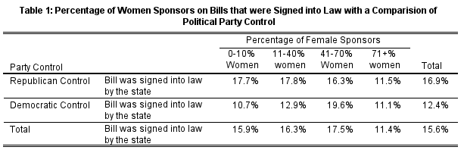
Rep Chi = 316.1, Dem Chi = 390.5, P<.001, Rep Phi and Cramer’s V = .052, Dem Phi and Cramer’s V = .091

Figure 1: Percentage of Women Sponsors on Bills that were Signed into Law with a Comparison of Political Party Control
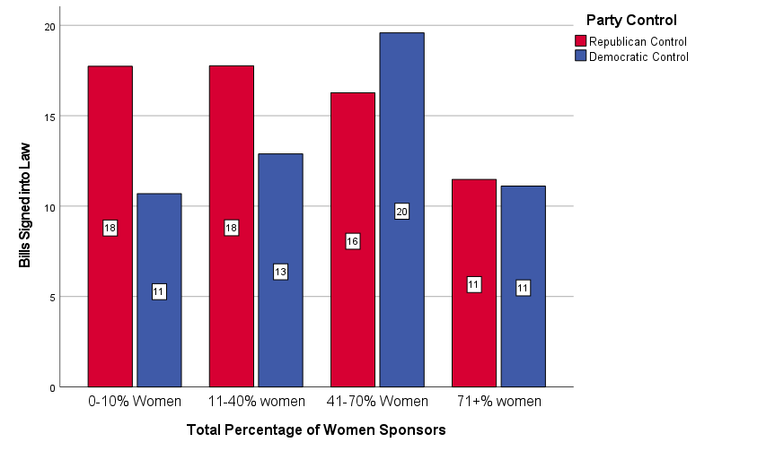

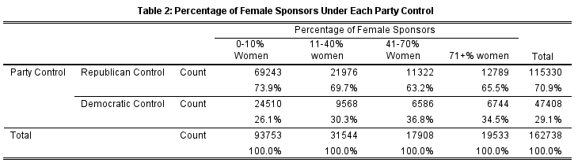
Chi = 1209.9, P<.001, Phi and Cramer’s V = .086

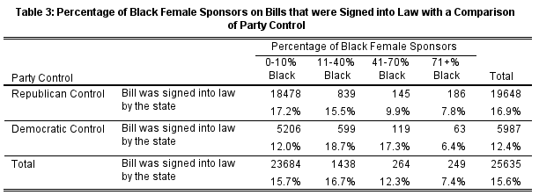
Rep Chi = 206.7, Dem Chi = 168.3, P<.001, Rep Phi and Cramer’s V = .042, Dem Phi Cramer’s V = .059

Figure 2: Percentage of Black Female Sponsors on Bills that were Signed into Law with a Comparison of Party Control
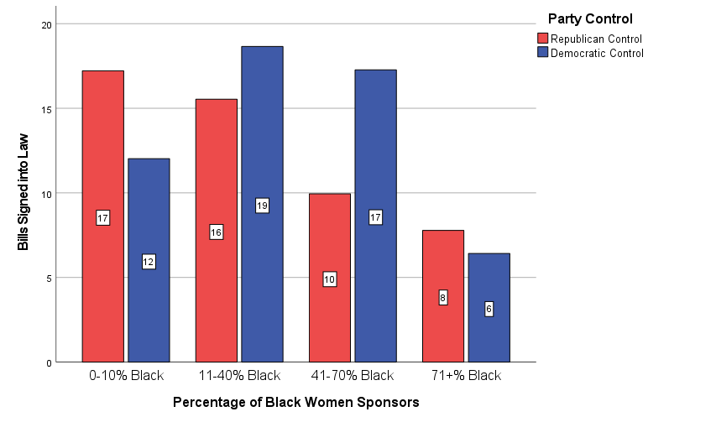
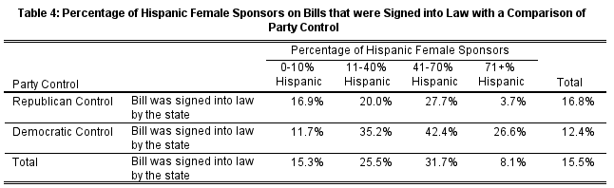
Rep Chi = 210.4 Dem Chi = 760.0, P<.001, Rep Phi and Cramer’s V = .042 Dem Phi and Cramer’s V = .125

Figure 3: Percentage of Hispanic Female Sponsors on Bills that were Signed into Law with a Comparison of Party Control
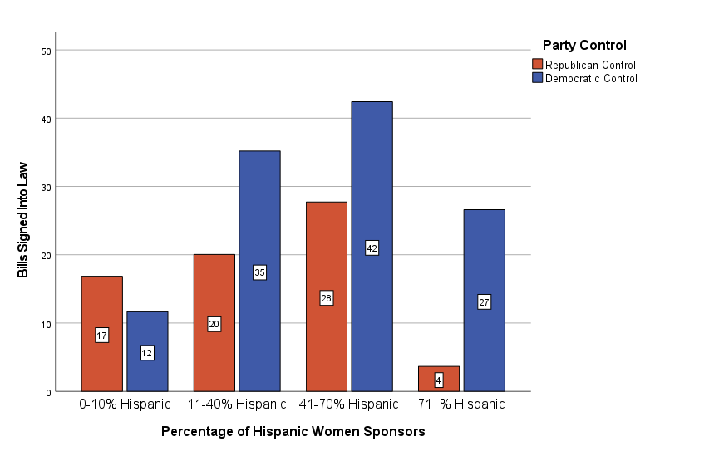

Table 5: Comparison of Black and Hispanic Female Sponsors on Bill Success Under Democratic Control
 | 0 – 10% Sponsors | 11 – 41% Sponsors | 41 – 70% Sponsors | 71%+ Sponsors | Total
Black Sponsors | 12% | 18.7% | 17.3% | 6.4% | 16.8%
Hispanic Sponsors | 11.7% | 35.2% | 42.4% | 26.6% | 12.4%

Table 6
Logistic Regression Analysis: The effect of women and intersectionality on the success of bills in state legislatures
_{Independent Variables} _{Bills Signed into Law} _{Bills that Came Up for Vote}
Percent Female Sponsors -0.246** 0.782 -0.302** 0.739
(0.026) (0.021)
Democratic Control -0.328** 0.720 -0.527*** 0.591
(0.016) (0.013)
Percent Black Female Sponsors -0.266* 0.767 0.720** 2.055
(0.122) (0.118)
Percent Hispanic Female Sponsors 0.576** 1.779 1.701** 5.480
(0.127) (0.122)
Constant -1.849** 0.157 -1.856** 0.156
(0.113) (0.114)
Number of Cases 168,736 168,736
Note: Entries are logistic regression coefficients in the first column with standard errors in parentheses and the odds ratio in the second columns.
*p<0.05, **p<0.001, ***p<0.000.
Source: Let’s Work Together: Bill Success via Women’s Co-sponsorship in U.S. State Legislatures, “Bill_Outcomes” data set.

References
Alder, E. Scott, and John D. Wilkerson. 2013. Congress and the Politics of Problem Solving. Cambridge University Press.
Arceneaux, K. (2001). The “Gender Gap” in State Legislative Representation: New Data to Tackle an Old Question. Political Research Quarterly, 54(1), 143–160. https://doi.org/10.1177/106591290105400108
Atkeson, L. R., & Carrillo, N. (2007). More is better: The influence of collective female descriptive representation on external efficacy. Politics & Gender, 3(1), 79-101.
Barrett. (1995). The Policy Priorities of African American Women in State Legislatures. Legislative Studies Quarterly, 20(2), 223–247. https://doi.org/10.2307/440449
Conway, M. M. (2001). Women and political participation. PS: Political Science and Politics, 34(2), 231-233.
Flammang, J. A. (1985). Female Officials in the Feminist Capital: The Case of Santa Clara County. Western Political Quarterly, 38(1), 94–118. https://doi.org/10.1177/106591298503800108
Hitt, Matthew P., Craig Volden, and Alan E. Wiseman. 2017. “Spatial Models of Legislative Effectiveness.” American Journal of Political Science 61 (3) 575-90
Holman, M. R., Mahoney, A., & Hurler, E. (2021). Let’s work together: Bill Success via women’s cosponsorship in U.S. state legislatures. Political Research Quarterly, 106591292110201. https://doi.org/10.1177/10659129211020123
Leigh, M. (2006). Factors affecting female representation in state legislatures. John Carroll University. Retrieved online at pol. illinoisstate. edu.
Matland, R. E. (2005). Enhancing women’s political participation: legislative recruitment and electoral systems. Women in parliament: Beyond numbers, 2, 93-111.
Nechemias, C. (1985). Geographic mobility and women's access to state legislatures. Western Political Quarterly, 38(1), 119-131.
Rocca, M., & Sanchez, G. (2011). Taking Advantage of Disadvantages: The Legislative Effectiveness of Minority Members of Congress. APSA 2011 Annual Meeting Paper. Retrieved April 11, 2022, from https://ssrn.com/abstract=1901414.
Rochefort, D. A., & Cobb, R. W. (1993). Problem Definition, Agenda Access, and Policy Choice. Policy Studies Journal, 21(1), 56–71. https://doi-org.bsuproxy.mnpals.net/10.1111/j.1541-0072.1993.tb01453.x
Rule, W. (1990). Why more women are state legislators: A research note. Western Political Quarterly, 43(2), 437-448.
Sanbonmatsu, K. (2002). Political parties and the recruitment of women to state legislatures. The Journal of Politics, 64(3), 791-809.
Thomas, S. (1991). The impact of women on state legislative policies. The Journal of Politics, 53(4), 958–976. https://doi.org/10.2307/2131862
Uhlaner, C. J., & Scola, B. (2016). Collective representation as a mobilizer: Race/ethnicity, gender, and their intersections at the state level. State Politics & Policy Quarterly, 16(2), 227-263.

