Do voter ID requirements impact voter turnout in Minnesota and Wisconsin?

Jacob Berg

Senior Thesis Political Science
Bemidji State University
Dr. Patrick Donnay Advisor
May 2022

Abstract
After the 2020 General Election there was wide disagreement over the process of how elections are administrated specifically related to voter ID laws. Prior research that attempts to answer the question has mixed results and there has been controversy over how to approach the research. The use of demographic data from the American Community Survey, turnout data from the Minnesota Secretary of State office, and the Wisconsin Election Commission. I made use of different statistical tests to evaluate if there was a connection between voter ID and voter turnout. Preliminary results are mixed for the relation between voter ID and voter turnout. Initial conclusion is that there is no clear evidence of voter ID laws impacting voter turnout.

Literature Review
The topic of voter ID legislation is a very contentious issue which is generating a lot of controversy. Recently, many scholars have investigated the issues surrounding voter ID laws with mixed conclusions. Wisconsin’s legislature passed a voter ID law in 2011 for implementation for the 2012 general election. While in 2012 Minnesota had a ballot measure that was voted on to require voter ID to vote in Minnesota. It failed in 2012, but there have been attempts by the State legislature to add that requirement most recently in 2021, as is discussed later in the paper. The purpose of my research is to pursue the question of whether or not voter ID laws impact voter turnout in the states specifically, Minnesota and Wisconsin.
Hajnal, Lajevardi, and Nielson (2017), discuss the impact of strict voter ID laws on minority voters. They conclude there is great evidence, notably the results of a statistical test that compared minority turnout between states with stricter voter ID law, versus those without it. Hajnal et. al. used the validated vote totals from the Cooperative Congressional Election Study (CCES) to compare turnout in states they described as having strict voter ID laws. Those states differed from election cycle to election cycle. Their results showed substantial drops in minority turnout. For example Hajnal et. al. (2017) found that Hispanic turnout was 7.1 percent lower in general elections, in states with strict voter ID laws. The authors found that “For Blacks the gap is negligible in general elections but a full 4.6 percentage points in primaries.” (Hajnal et al., 2017) However, an article by Grimmer, Hersh, Meredith, and Mummolo (2018), was written as a response to Hajnal et. al. Using the same data that the Hajnal et. al. article used from the CCES, where the Grimmer et. al. article fixed a few data related mistakes, of the Hajnal et. al. article. For example, in the Hajnal et. al. data, the author’s data was not representative of the turnout in the years that the Hajnal et. al. was studying, because the CCES does not inform researchers who use the CCES, how the validated voter file, is validated. Another issue that Grimmer et. al. brought to attention was how the validated voters were in the data set. “Respondents who claimed to have voted in such jurisdictions were coded as not matching the database, and hence dropped, while those who claimed to have not voted remained in the sample.” (Grimmer et al., 2018) Grimmer et. al. came to the conclusion, that the Hajnal et al. article drew incorrect conclusions, and that it is in fact incredibly difficult to prove that voter ID laws greatly impact minority voters. In, Disagreements over ID Requirements and Minority Voter Turnout, by Burden (2018) is written in response to both the Hajnal Et al., and the Grimmer Et al. articles. Burden’s article discusses the Hajnal et. al. article and the Grimmer et. al. article and concludes there is no definitive answer to the extent of the impact that voter ID laws have on minority voters. The reason for there being no definitive answer in survey data as it is incredibly challenging to model the true turnout from an election. Researchers are limited to using national response surveys such as the Cooperative Congressional Election Study to simulate true turnout, because no state tracks the age, race, etc. of their voters. Though, with the CCES there is drawbacks as discussed earlier, there are other issues as well, since it is a response survey there is always the possibility of false answers for multiple reasons on the questionnaire. Another problem could be over sampling of certain population demographics. However, the reason why researchers use the CCES is because the CCES has the vote validation variable. Though, the vote validation variable is incredibly complicated in the CCES, and the survey does not give good advice on how to use that data for research. Heller, Miller, and Stephenson (2019) broadened the question of whether voter ID laws impact minority voter turnout. Heller et. al (2019) investigated whether Voter ID laws decrease fraud in the states that implement voter ID laws. The conclusions drawn by the Heller et. al. article that there is no clear statistical pattern in either direction in the debate over voter ID laws and if the voter ID laws have any effect on decreasing fraud as it is so rare that fraud occurs in elections. While Heller et. al. did find that Hispanic voter turnout decreased. The decrease in Hispanic voter turnout was before state fixed effects as the authors called them were controlled, which then decreased the magnitude of the decrease in Hispanic turnout. A state fixed effect, as Heller et. al. described, is for example, a states ease of registration or the number of polling places. All four of these articles are exceptional in framing the debate over voter ID laws and their impact on voter turnout. However, all the articles deal with very broad survey data and the articles do not focus on a state-by-state basis.
In 2014, The Governmental Accountability Office (2014) published a report regarding issues with the implementation of Voter ID laws. This report offered important insights how the data was interpreted. One example, from the CCES is that national response surveys and the data produced is not standardized when used in research articles. Some problems arise when the researchers are collating their data. For example, the researchers may code things differently, as was the case in the prior article by Hajnal et. al. Respondents said they voted but were not validated and then taken out of the sample, and when someone responded they did not vote, that respondent was left in. Another point discussed was authors not excluding missing cases, or any number of problems associated without having standardization for data use.
Fraga (2016), finds that minority voter turnout is not tied to the candidate’s race but the racial makeup of the district or area in which they are voting. This is an extremely interesting question that is related the other articles, as this article investigates the possibility of outside factors into why certain groups turnout in elections related to other groups. The author’s findings are that minority voters are more likely to turnout to cast a ballot when they are a part of the majority population of the district or close to the majority population. The authors also found that white turnout decreases as minority population inside a district increases. The decreases in turnout as described by previous articles attribute the decrease to voter ID laws in the states without investigating other reasons affecting why someone may vote. This article’s results are vital to understanding the central theme of the conversations surrounding voter ID laws. These results may shed some light on the debate regarding the Voter ID laws effect.
Ghattas (2021) wrote an article regarding the data and statistical tests used when researching turnout. Ghattas (2021) attempts to standardize, for example, what to do with voters who report voting on the CCES and are not validated by the CCES. As well as what to do with voters who report not voting in an election. The author also explains how researchers should use data, the standardization is how to use the data mostly the types of tests to run, and what data is good to use. Ghattas (2021) also discusses the approach to the collation of data that they are using, which is a big point of difference throughout the conversation regarding voter ID laws. This article was very impactful on my research due to how the article presented what type of statistical tests to use and what types to not use.
Pryor, Herrick, and Davis (2019) replicated a previous study. However, their conclusion demonstrated, that how the data was collated, and how the data is used is incredibly easy to manipulate the data to show what the researcher may want to show. The authors also found that where you get the data from, for example the CCES or Current Population Survey, can affect the results of the study. While the results could easily be replicated; however, the data could definitely be manipulated, as they discussed how to deal with voters that report not voting by either excluding them from the study, or placing them into voters who were turned away from voting, to vary the outcome from the previous articles.
Quillian in 2017 wrote an article which asked a very important question, are current voter ID laws are harmful to minority voters. While Quillian’s (2017) article did not utilize a lot of data, the questions that were asked were specifically related to the experiences of voters at the polling places. This article was important in my research as it also broadens the debate, to look at how the history of voting in a state may influence adoption of current day voter identification laws, also to include the polling place sites themselves, and what impact that may have on turnout.
Rocha, and Matsubayashi (2013) effectively tying the new voter ID laws being passed in 2013 to the Jim Crow era, laws that were put in place to make it very hard for minorities specifically to vote. The main reason for the authors to compare the laws to the Jim Crow ear was the fact that it costs money to get an ID, and since ID’s are required to cast a ballot, that constitutes a poll tax, was the authors conclusion. Their conclusions are drawn from extensive data, that covers the years from 1980 to 2011 around states who adopted some form of identification to register to vote, which the researchers found from the National Council of State Legislators. This data is a great indicator to demonstrate what may occur when states implement strict Voter ID Laws. While all the previous six articles are delving into more than just a national review, they are looking at regional or a specific state. These articles move this conversation forward, by investigating other possible influences on why an individual chooses to cast a ballot. While also assisting us in finding an answer to this very important question.
Throughout my research, I came across some interesting pieces that investigate the states of Minnesota and Wisconsin. Alperin, and Kraus (2012) wrote an article that looked precisely at what are the types of people support voter ID laws, and more importantly, the type of state legislators that supports voter ID law bills. The Alperin et. al. article along with an article from Hicks, McKee, and Smith (2016) reviewed what types of states, for example, those in the former confederacy have a higher likelihood to enacted voter ID laws. Hicks et. al. (2016) article analyzed what types of legislators introduce these bills and support them. As one would expect, Republicans are almost in perfect unity in voting yes, while Democrats almost always vote no. One major outcome is the population of minorities, specifically African Americans, in the legislator’s district in how the legislator votes on the voter ID bills in the state legislature. The two prior articles bring the debate into a micro level inquiry, by investigating the type of states who adopt voter ID bills, and of the types of legislators who support voter ID bills.
Media coverage of voter ID issues are illuminating in seeing the debate on both sides. One story was from Kare 11, titled GOP-led Minnesota Senate Approves voter ID bill. However, the bill is unlikely to become law due to the Governorship, and the State House of Representatives being controlled by the Democratic-Farmer Labor Party. The article also gives input from Minnesotans who a reporter talked to on the street in Minneapolis regarding their opinions and how it may impact Minnesota. Some of the people quoted in article feared that minority voter turnout may decrease, for a variety of reasons.
The Atlanta Journal-Constitution discusses Georgia’s new voting law. The debate within the state and what some research has shown whether the impact of voter ID laws effect on turnout. The researcher cited said that while the effect of the new law may decrease turnout in the short term, over time the affect may become less noticeable. This article links the scholarly debate with the public debate around voter ID laws.
Meyor and Decrescenzon, (2017) investigate how people in Wisconsin who are not currently registered to vote already are impacted by Wisconsin’s voter ID law. This article is critical to the debate surrounding the impact of voter Id laws on registration. The authors investigate this topic as it is another possible avenue that minorities are impacted by laws regarding voting. The authors seeks to determine what if any impact there is on voter ID laws on voter registration in Wisconsin. Which they find that it had a minimal impact for the election that the authors chose to use but discussed that a more comprehensive study could better illuminate what is happening in regards to the voter ID laws impact.
Broad generalizations with regard to voter ID laws aimed at the national level can be detrimental to the discussion. Each state is different, and what may work in Wisconsin may not work in Idaho for example. A more appropriate approach for this conversation is to compare closely related states, i.e., regionally similar states.
Over the past ten years there have been numerous conversations regarding voter ID laws. One thing has been made clear, there is no definitive answer as to the impact of voter ID laws because there have not been enough states implementing such laws. In order for us to get a clear picture, of the impact of the voter ID laws we need more states to implement these laws. The implementation of the voter ID laws are so recent that there is a possibility that with time the laws true effect can be determined. Ten years is not very long to see the full effect of a law being implemented especially since each and every election cycle is different and may impact who chooses to voter or not. The biggest controversy found in all of these articles that I read seems to be dealing with data, especially with what source of data is being used, because most states do not publish voter details. Another component of the question of what kinds of data are useful in researching the question of how voter ID laws impact turnout. The final major question is how the researchers collate the data that they will use to answer the question. The biggest question that needs more research is the most basic question of the whole debate, do laws requiring voters to show photo identification impact voter turnout in states that have enacted such laws?

Methods
From the previous literature that I read; I began to see a pattern. Wide scholarly debates regarding the proper use of survey data, and the draw backs of self-reporting survey data. Some issues discussed is that each survey is different with how the survey reports the answer. Along with who is responding to the survey, could there be an oversampling of one group, is another question routinely brought up. In light of this debate I chose to approach it from a angle where I took full turnout numbers from the states themselves, instead of relying on response surveys
I use data from the Census Bureau specifically the American Community Survey. This is a survey that is conducted by the United States Census Bureau and is one that inquires about, demographics, including race and age, educational attainment, income levels and other demographic variables. The data from the American Community Survey is available at the county level which is the level of aggregation I use for this analysis. The data is collected through a mailer that is sent to different homes every year that are demographically representative of the population of the county. The American Community Survey data is frequently used in social science research as it is highly respected.
Voter turnout is collected from the Minnesota Secretary of State’s office, where I was able to access total votes cast and registered voters in each county, and from the Wisconsin Election Commission. The election year I chose was the Senate Class One, for Minnesota and Wisconsin in 2018. I chose this election due to strong turnout in both Minnesota and Wisconsin. In Wisconsin, 2018 was the fourth major election cycle since Wisconsin passed their voter ID law in 2012.
The data collected provides excellent variables for my research. The different variables that I aim to investigate are, the racial makeup, educational attainment, age, and income variables within each county as that is my unit of analysis. Each variable is important because my hypothesis as outlined above relies on seeing the demographics of the counties and turnout data.
Statistical Tests
(Figure One)
In figure one is a map created to help visualize where, and how turnout varies by county. Some interesting points to note on the map, Minnesota has very high turnout around the Minneapolis metropolitan area, as well as very strong turnout in the arrowhead region of Minnesota. In Wisconsin, Dane county which is home to Madison, and the suburbs of Milwaukee have the highest turnout. One other point about Wisconsin, Menominee County in the northeastern part of the state is home to the Menominee tribe of Wisconsin and, the county is the least populous in Wisconsin, with low turnout. A baseline average for turnout in Minnesota was 59.33%, and in Wisconsin the average turnout was 57.96% both states are quite close in turnout for the election.
Hypothesis One: In a comparison of counties, counties in Wisconsin that have high population of American Indians will have lower voter turnout, when compared to counties in Minnesota that have high American Indian populations.
The tests of the hypothesis should show a decrease in turnout in Wisconsin, at a higher rate, than in Minnesota.
(Figure Two)
(Figure Three)
Surprisingly in both states the higher the population of American Indian does decrease turnout. In Minnesota the line of regression starts at 59% but decreases more by .24 versus Wisconsin that their line starts at 58% and decreases by .23, both states are statistically significant regarding American Indian turnout. This is surprising when looking at Minnesota, as conventional wisdom in the papers discuss that minority turnout is higher in states without voter ID laws. The results are in line with what other researchers have found, with decreasing turnout in Wisconsin but are slightly different in Minnesota, where turnout is also decreasing.

Hypothesis Two: In a comparison of counties, counties in Wisconsin with high African American Population will see lower voter turnout, when compared to counties in Minnesota that have high African American populations.
The results of the test should show a greater decrease in the turnout of African Americans in Wisconsin compared to Minnesota.
(Figure Four)
(Figure Five)
The results are different than the expected outcome. In Wisconsin where conventional wisdom would show that the turnout of African Americans would decrease as the literature describes, we see this is not the case. In Wisconsin while the line starts 57%, the line is actually, increasing at .03 in Wisconsin. Compared to Minnesota where the line starts at 58% it increases by .35. Neither of the states regression lines are significant which lends to more investigation of how much does voter ID requirements impact African American turnout in elections.
Hypothesis Three: In a comparison of counties, counties in Wisconsin with high elderly population (65+), will see lower turnout when compared to counties in Minnesota that also have high elderly population (65+).
The results for these statistical tests should show that there is a decrease in turnout among seniors in Wisconsin and Minnesota.
(Figure Six)
(Figure Seven)
The results of these two tests also show a not so surprising line. Some of the literature that I read had discussed the possibility of older Americans having a harder time acquiring the proper identification to vote, when presented with strict voter ID laws. While another conventional wisdom is that older Americans turnout at much higher levels than do younger Americans. This prevailing idea seems to be confirmed in these statistical tests. One interesting point to investigate is why in Wisconsin, which has a strict voter ID law, has statistically significant line, and Minnesota does not. The lines of regression in Wisconsin, start at 50.65% and increase by .37% which is a very large increase and will surpass Minnesota turnout relatively quick.
(Table One)
The correlation analysis compares the two states nicely with respect to how each variable impacts the turnout in each state. Some interesting things to note about the correlation analysis is that Wisconsin has three significant variables, compared to Minnesota that only has two. The two significant variables for both states are American Indian population, and those who are 25 years and older with a bachelor’s degree. In both states the American Indian population, has a decrease in turnout by -.233 in Minnesota and the larger -.367 in Wisconsin which since both states are negative there is the possibility of another reason causing the decrease. As is common wisdom the more educated someone is the more likely they are to vote and you can observe that in the table, where in Minnesota turnout is increase for those with a bachelors by .491 and in Wisconsin the turnout is even greater at .681 which is very interesting to see it more pronounced in Wisconsin. The one variable that is significant in only in Wisconsin and not in Minnesota is the Population of 65+ in the county, where it Wisconsin it increase by .256 which is interesting as some of the literature notes that it should be the opposite if the voter ID laws impacted voter turnout.
(Table Two)
The regression analysis table that was produced sums everything up nicely. The first data piece that is of note is that in my state coding variable. That variable, where Wisconsin is coded zero, and Minnesota is coded one, shows that when moving from Wisconsin to Minnesota on average there is a .444 percent increase, which is not statistically significant. The other two non-statistically significant variables that were tested was White turnout and African American turnout. Which both of those points are surprising as both the White and African American increase turnout. The three statistically significant variables that I ran were native American, age 65+ turnout and bachelor’s degree turnout of people aged 25 years or older.
Interpretation
All these statistical test gives insight into answering the question of do voter ID requirements impact voter turnout. We see that there are two groups that are not statistically significant that is surprising. As one would expect the White turnout is not significantly affected when comparing the turnout in both Minnesota and Wisconsin. African American turnout as well, is not statistically significant which is interesting when compared to the much of the literature that I read. Though one area that I would like to expand would be to look into the primary elections as well, as in a few pieces of literature, they pointed to African American turnout decreasing more in primary elections than general elections.
The three statistically significant variables that I found were both unsurprising and surprising. The only group to be negatively affected is that of the American Indian population. With a decrease of -.348, the American Indian population has a decreasing trend line in both states. There are many reasons for this decrease outside of just voter ID laws. More research into why Native Americans vote at lower levels generally when compared to other Minority groups is needed. The other two statistically significant variables are percent with bachelor’s degree and the age 65+ turnout. The bachelor’s degree turnout follows much of the prevailing wisdom, that as more people are educated, they turn out to vote at higher rates. The elderly vote percentage is one that is debated. One side of the debate says that the high propensity voters, those who turnout most frequently, are people who are generally older, and on the other side of the debate people discuss, how it is much harder for elderly Americans to get to the polling sites.
Overall, more researcher is needed to finally come to a full conclusion as to how voter ID laws affect turnout in states. No voter should ever be turned away from the polls, and the debate around voter fraud is one that also needs more investigation. Many of the strict voter ID laws in place are relatively new, and one other aspect that has not really been research is the effect of time on the laws. As more people become aware of the law does it become less common that people do not have the required ID? The results of these tests are mixed, and one thing is certain, debate over the impact of voter ID laws on turnout will continue.

Appendix

Figure One- Voter Turnout in Minnesota and Wisconsin Countries in the 2018 General Election
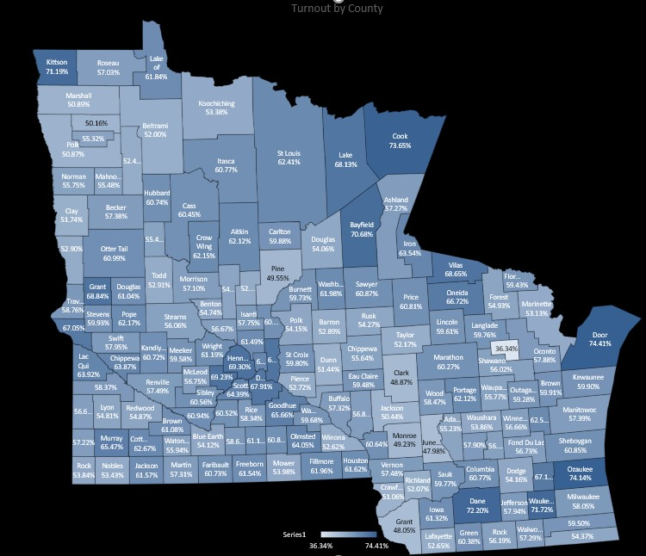

Figure Two - Minnesota American Indian Voter Turnout by County
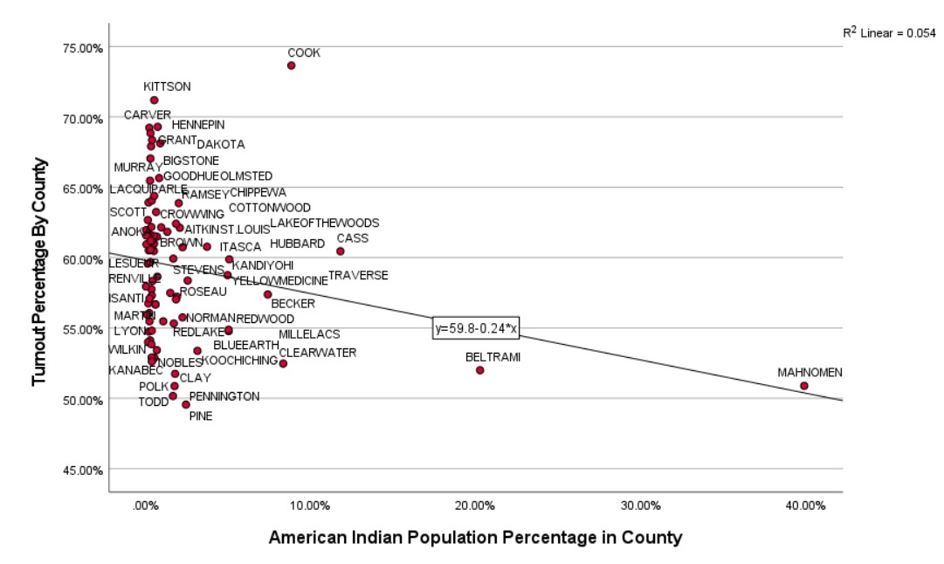
Figure Three – Wisconsin American Indian Voter Turnout by County
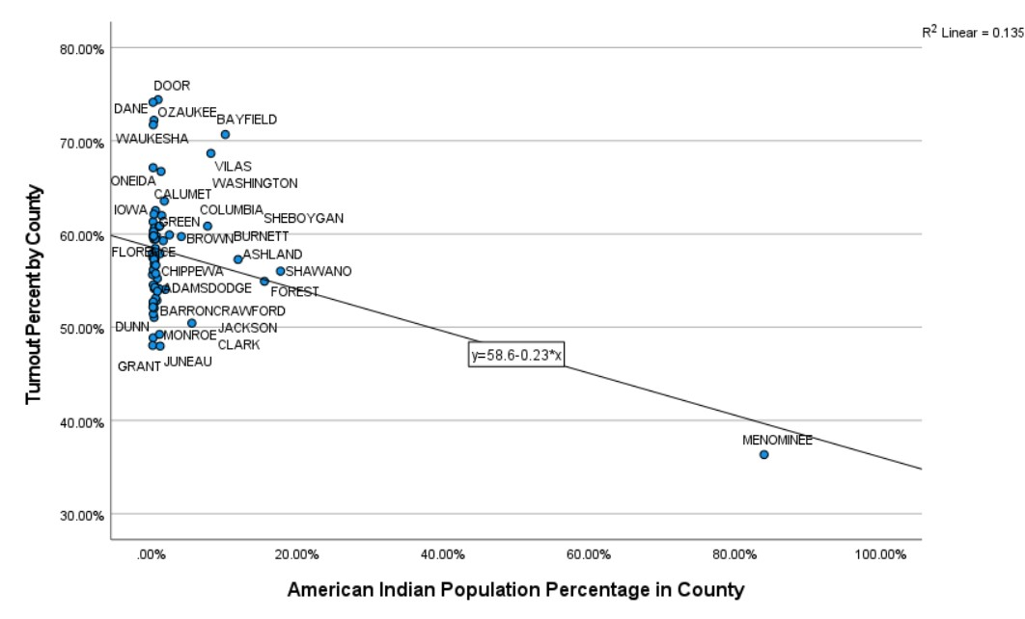

Figure Four – Minnesota African American turnout
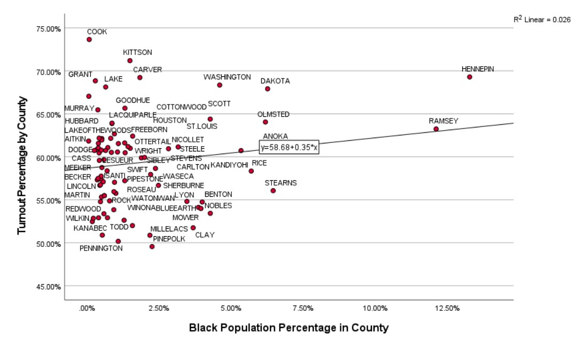

Figure Five – Wisconsin Africa American turnout
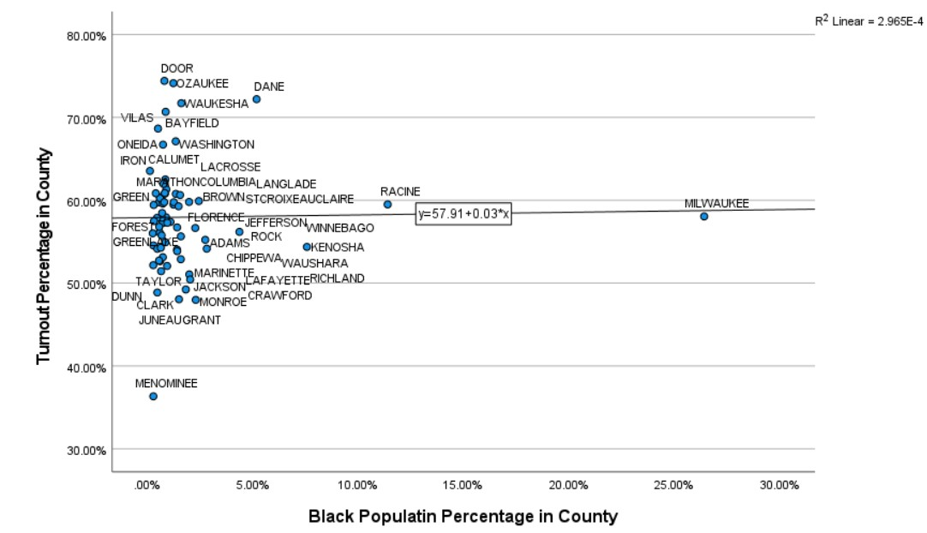

Figure Six – Minnesota age 65+ turnout
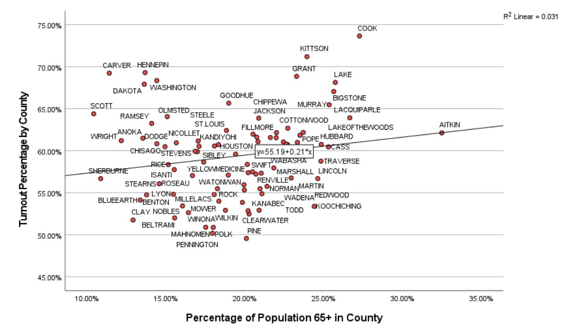

Figure Seven – Wisconsin age 65+ turnout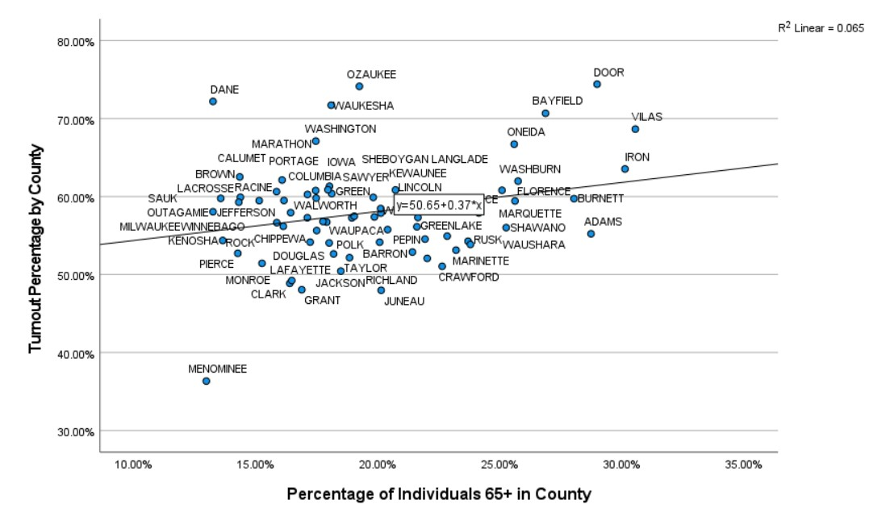

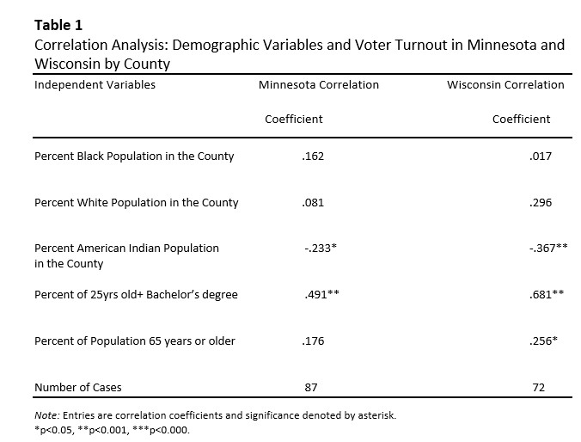

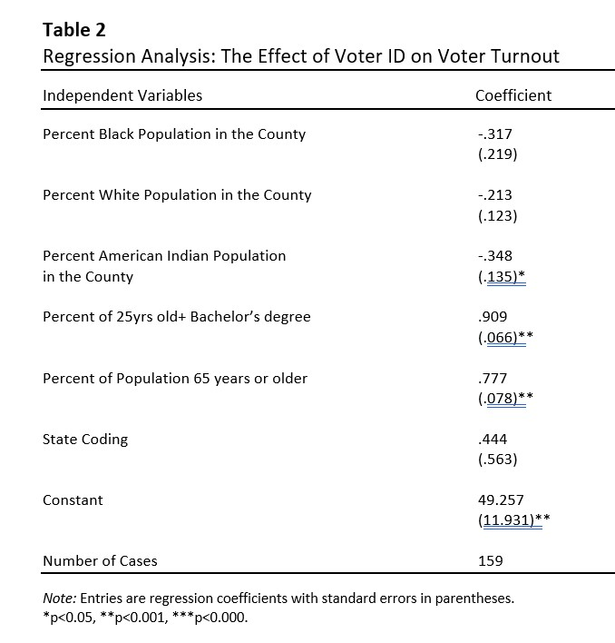

Bibliography
2012 Fall General Election | Wisconsin Elections Commission. (n.d.). Elections.wi.gov. Retrieved April 14, 2022, from https://elections.wi.gov/elections-voting/results/2012/fall-general
Alperin, D., & Kraus, N. (2012). Voting Restriction Politics in Minnesota and Wisconsin.
Burden, B. C. (2018). Disagreement over ID Requirements and Minority Voter Turnout. The Journal of Politics, 80(3), 1060–1063. https://doi.org/10.1086/696616
Bureau, U. C. (n.d.). County Population Totals: 2010-2019. The United States Census Bureau. https://www.census.gov/data/datasets/time-series/demo/popest/2010s-counties-total.html
Fraga, B. (2016). Candidates or Districts? Reevaluating the Role of Race in Voter Turnout. Source: American Journal of Political Science, 60(1), 97–122. https://doi.org/10.1111/ajps
Ghattas, L. (2021). The Differential Effects of Strict Voter Identification Laws on Minority Voter Turnout. Western Social Science, 20(1).
Grimmer, J., Hersh, E., Meredith, M., Mummolo, J., & Nall, C. (2018). Obstacles to Estimating Voter ID Laws’ Effect on Turnout. The Journal of Politics, 80(3), 1045–1051. https://doi.org/10.1086/696618
Hajnal, Z., Lajevardi, N., & Nielson, L. (2017). Voter Identification Laws and the Suppression of Minority Votes. The Journal of Politics, 79(2), 363–379. https://doi.org/10.1086/688343
Heller, L. R., Miller, J., & Stephenson, E. F. (2019). Voter ID Laws and Voter Turnout. Atlantic Economic Journal, 47(2), 147–157. https://doi.org/10.1007/s11293-019-09623-8
Hicks, W. D., McKee, S. C., & Smith, D. A. (2016). The Determinants of State Legislator Support for Restrictive Voter ID Laws. State Politics & Policy Quarterly, 16(4), 411–431. https://doi.org/10.1177/1532440016630752
Issues Related to State Voter Identification Laws. (2014).
Jacobson, J. (2021). GOP-led Minnesota Senate approves voter ID bill, but it’s unlikely to become law. Kare11.com. https://www.kare11.com/article/news/politics/elections/minnesota-senate-approves-voter-id-unlikely-to-become-law/89-1e9ef296-5716-4354-9e76-0a411633292c
Mayer, K., Decrescenzo, M., & Candidate. (2017). Supporting Information: Estimating the Effect of Voter ID on Nonvoters in Wisconsin in the 2016 Presidential Election.
Minnesota Secretary Of State - Election Results. (n.d.). Www.sos.state.mn.us. https://www.sos.state.mn.us/elections-voting/election-results
Niesse, M. (2021, October 21). Will Georgia voting laws reduce turnout? Maybe not, studies show. The Atlanta Journal-Constitution. https://www.ajc.com/politics/will-georgia-voting-laws-reduce-turnout-maybe-not-studies-show/YNNYSZZTIZFVBNWNVANPWMII2A/
Pryor, B., Herrick, R., & Davis, J. A. (2019). Voter ID Laws: The Disenfranchisement of Minority Voters? Political Science Quarterly, 134(1), 63–83. https://doi.org/10.1002/polq.12868
Quillian, B. (2017). Why Current Voter ID Laws Are Harmful to American Democracy. Kennedy School Review; Cambridge, 17(1).
Rocha, R. R., & Matsubayashi, T. (2013). The Politics of Race and Voter ID Laws in the States. Political Research Quarterly, 67(3), 666–679. https://doi.org/10.1177/1065912913514854

