ISRS-Brightspace Courses - Instructor Self-Service (KA #2348)

Published 12/19/2021 | Updated 2/14/2022
Audience: Instructor

How do I use the remove my course from Brightspace? How do I merge course sections?
Table of Contents
Overview 1
Course Removal/Recovery 1
Remove a course from Brightspace 2
Restoring a Deleted Course 3
Course Merging Actions 4
Combine multiple sections together 5
Remove a section from a merged course 6
Add a section to a previously merged course 8
Double Mapping 9
Get help with D2L Brightspace 9

Overview
The instructor self-service tool offers a way for instructors to manage the courses sent to Brightspace from ISRS. This tool is being implemented during Spring 2022 as part of the ISRS-Brightspace integration change. If you do not have access to the tool, your school may not be fully configured yet.

Course Removal/Recovery

Remove a course from Brightspace
If there is an ISRS course section that is not needed in Brightspace, you can choose to remove it using the self-service Brightspace Courses tool.

- Click on My Courses.
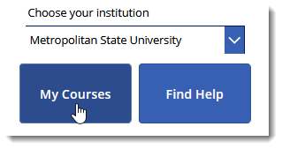
- Select the checkbox for each course section.
- Click Remove from D2L.
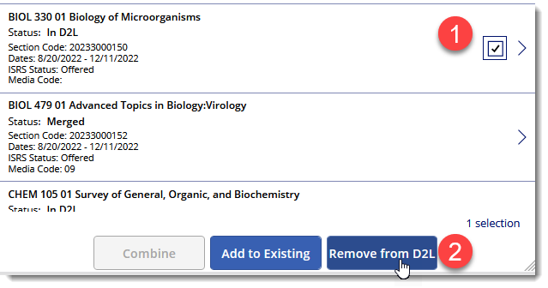
- Confirm that you want to delete the course by typing delete in the confirmation text field.
- Click Remove from D2L.
Note: This will remove the course from Brightspace.
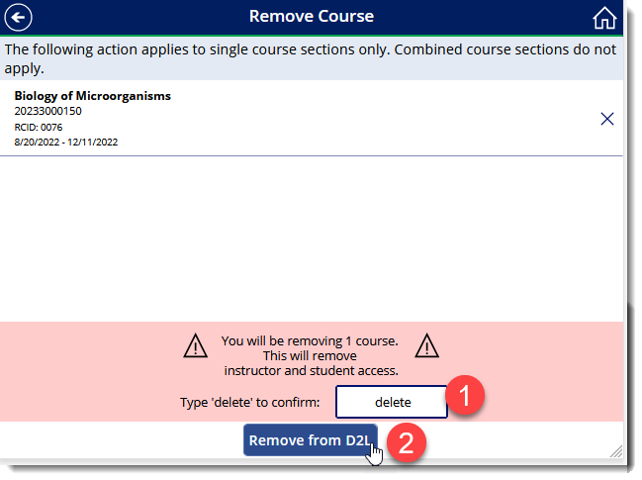
- The removal request has been submitted. An email will be sent when the request has been processed.
Back to top

Restoring a Deleted Course
When a course has been removed per the steps above, it will display in the section search area with a status of ‘Removed’:
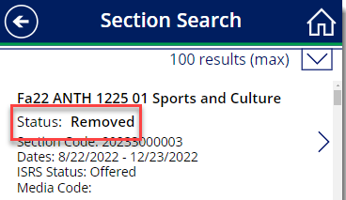
To restore a course, follow the steps below.

- Click on the right chevron to see more details about the course section
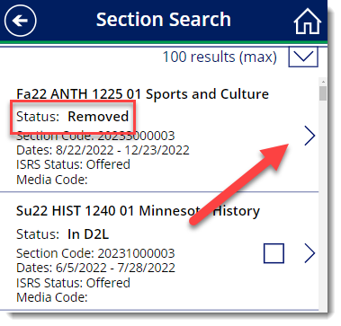
- Click on the delete request icon.
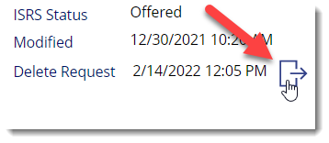
- Click Recover This Course.
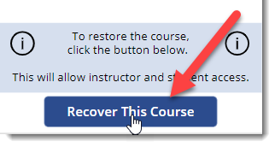
- An email will be sent when the request has been processed.

Back to top

Course Merging Actions

Combine multiple sections together
All course merge requests (combining multiple course sections together) should be requested through the self-service Brightspace Courses tool.

- Click on My Courses.
- Select the checkbox for each course section.
- Click Combine.
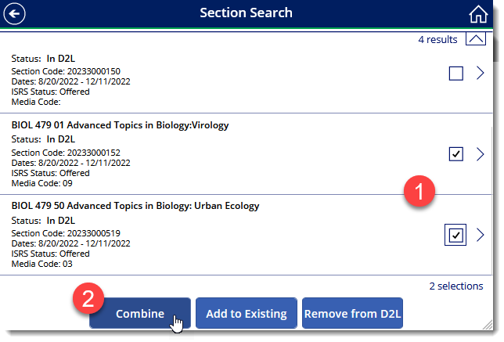
- Confirm the merged course details.
Note: The section listed first is the ‘base’ course. Any course materials in the base course will be copied automatically into the new, merged course. Click the pin icon to adjust.
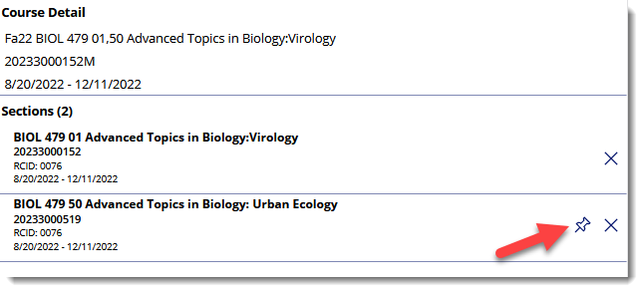
- Type the word merge into the confirmation field, and click Merge.
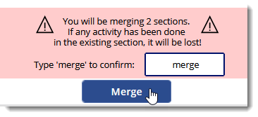
- The merge request has been submitted. An email will be sent when the request has been processed.
Back to top

Remove a section from a merged course
- Locate the course section in the Brightspace Courses tool.
- Click the right chevron to view the course section details.
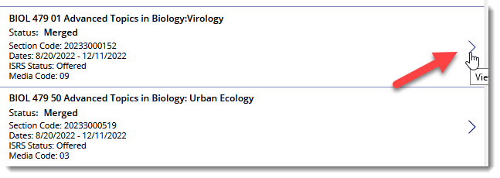
- Click on the See merge request icon.
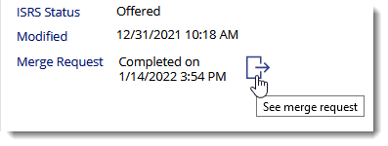
- Click on the Parent Course icon.
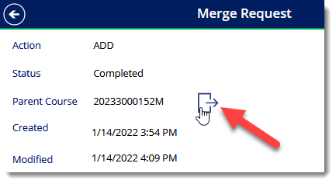
- Select the checkbox next to the section to remove.
- Type remove in the confirmation text field.
- Click Remove 1 section from course.
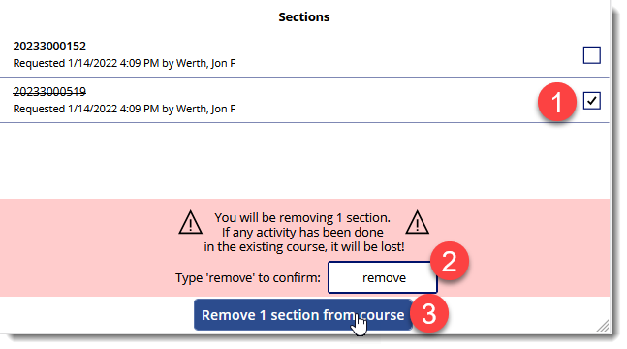
- The removal request has been submitted. An email will be sent when the request has been processed.

Back to top

Add a section to a previously merged course

- Find the course section and select the checkbox.
- Click Add to Existing.
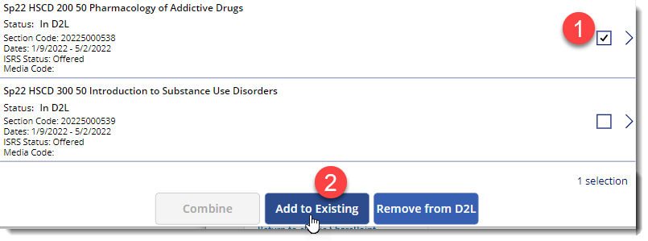
- Select the checkbox for the existing merged course you want to use.
- Type merge into the confirmation text field.
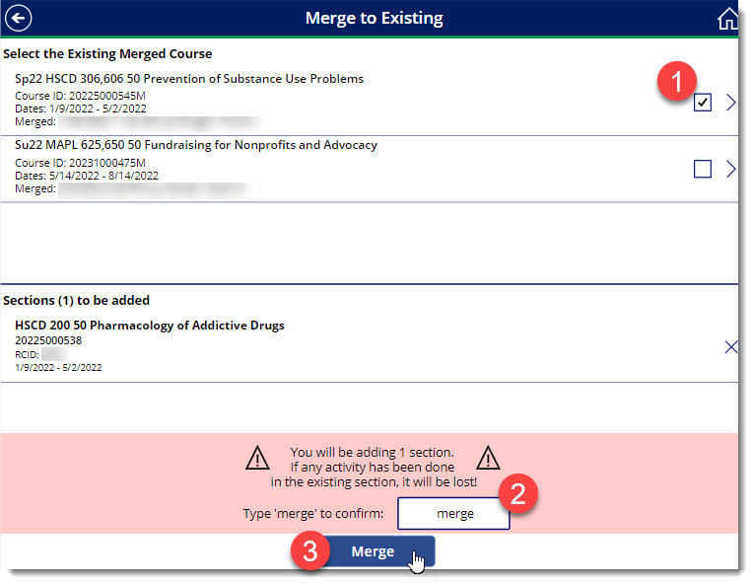
- Click Merge.
- The merge request has been submitted. An email will be sent when the request has been processed.
Back to top

Double Mapping
When you need to map a single course section’s enrollments to multiple course offerings (such as a lab and lecture scenario), you will need to contact your local D2L Brightspace support team.
Note: This scenario is rare.

Back to top

Get help with D2L Brightspace
We are here to help! You may reach us – the Minnesota State Learning Technologies team – by submitting a request from the Contact Us page from the D2L Support site, or from the Request Help widget when you’re logged in to D2L Brightspace (learn more in the instructor article #1887 Request Help widget).
Back to top

