Economic Strength and National Power: A Quantitative Analysis of Global Influence

Adrian Falcon
Bemidji State University

Political Science Senior Thesis
Bemidji State University
Dr. Patrick Donnay, Advisor
April 2026

Abstract
This study examines the extent to which economic strength contributes to a country’s national power within the international system. In international relations, economic capability is often viewed as a core foundation of national power because it allows states to support military forces, invest in technology, expand trade, and strengthen diplomatic influence. However, scholars continue to debate how directly economic resources translate into geopolitical power and how national power should be measured. This research builds on those debates by using a quantitative approach to analyze the relationship between economic indicators and broader measures of national power. The study relies on the Diplomacy, Military, and Economic (DiME) Power Index dataset, which combines measures such as economic capacity, trade, military spending, and diplomatic presence to estimate states’ relative power over time. By comparing economic indicators with changes in power scores, the study evaluates whether stronger economies are more likely to gain influence in the international system. The findings suggest a positive relationship between economic capacity and national power. States with larger and more productive economies tend to rank higher in power measures and have greater ability to project military and diplomatic influence. However, economic strength alone does not automatically produce power; institutions, strategy, and diplomacy also shape how resources become influence.

Literature Review
Introduction
Understanding what makes some countries more powerful than others has long been a central concern within the field of international relations. Intellectuals have made it a center part of their work to understand where national power comes from and how states accumulate, maintain, and project influence within the international system. Economic strength is understood to be around the world as one of the most significant foundations of national power. Economic resources enable states to sustain military forces, influence global markets, shape diplomatic relations, and grow technological and industrial capabilities. However, the debate on how much influence economic strength has on national power, and therefore geopolitical power is still present (Beckley, 2018).
Understanding National Power
A vital part of understanding economic strength and national power is defining and measuring power. In international relations, power is seen as a vehicle in which a state is able to influence the behavior of other actors or shape outcomes on an international system. Yet scholars have long struggled to identify precisely how power should be understood and more importantly measured.
Goldmann (1977) really lays down a clear way to understand the misunderstandings surrounding the study of power in international relations. According to Goldmann, scholars often assume the existence of an identifiable international power structure without fully understanding the sources from which power derives. These sources which he describes as “power bases,” may include economic resources, military capabilities, political institutions and strategic influence. Because power can be exercised in multiple ways across different contexts identifying the relative importance remains a complex task, meaning the landscape in which power is applied plays a major role in how power is understood.
Even modern research into the makings of what national power is still faces difficulties in accurately measuring it. Beckley (2018) argues that while power is typically defined as a country’s ability to shape international outcomes according to its interests, such influence is extremely difficult to measure directly. Due to this reason, there’s a significant amount of reliance on observable indicators such as economic output and military resources as proxies for national power. Wealth and military capability therefore become a key part of the metrics used to assess the relative power of states.
Despite these efforts, the conceptual literature shows a real limitation. Although it is widely agreed that economic resources are a central part of “power”, there is heavy disagreement regarding exactly how economic strength serves as an instrument for political influence, making research focus precisely on the connection between economic capacity and other forms of national power.
The contemporary U.S.- Iran conflict shows a clear real-world example of these theoretical challenges in defining and measuring national power. While the United States possesses overwhelming economic and military superiority, Iran has demonstrated an ability to impose significant strategic costs through asymmetric tactics such as missile strikes, cyber operation, and disruptions to global energy markets, most notably its ability to affect passage through the strait of Hormuz disrupting global energy on a global scale. This supports the argument that national power is not solely determined by the possession of material capabilities, but by how effectively those capabilities are employed within specific geopolitical contexts. As Saikal (2020) explains, Iran’s national security strategy is specifically designed to offset conventional disadvantages by leveraging asymmetric warfare and regional influence, increasing its effectiveness resulting in Iran being able to challenge a more powerful state such as the U.S. despite its relatively smaller economic base. Consequently, the U.S. Iran conflict reinforces the broader scholarly understanding that national power must be understood as a multidimensional concept, incorporating not only economic and military resources but also strategic adaptability and the ability to convert resources into influence.

Economic Strength as a Foundation to Military and Geopolitical Power
Much of the literature out at an academic level sees economic capability as the priority material foundation of national power. With this concept in mind, economic capacity becomes an important determinant of a state’s ability to develop vital components of its national infrastructure such as military forces, investments into technology, and its ability to compete strategically with other nations.
Beckley (2010) provides one of the most influential empirical arguments supporting this view. His analysis of historical military conflicts demonstrates that economically developed states consistently outperform less developed states in warfare. Although there has been debate on whether exterior factors such as cultural, democratic institutions, or levels of education influence military effectiveness, Beckley’s findings stand strong on economic development remaining the most significant determinant. We see this in the way that wealthier states are able to better equip, train, and sustain their armed forces, raising force quality.
Furthermore, economic strength shows up again as a major factor in considering what power is, this time on a global scale. Lind (2024) argues that shifts in economic growth among major powers have historically reshaped the international balance of power. Debates that often lead to discussions on whether a global system is unipolar, bipolar, or multipolar tend to steer towards the topic of relative economic strength of major states. A great example is the rise of China, and how its exponential growth economically in recent decades has been interpreted from a U.S. analytical risk assessment point of view as a real challenge to dominance due to China’s economic expansion leading to its increased capacity to project military and geopolitical influence.
These studies reinforce economic strength as main factor the in shaping of national power. However, they also show that economic resources as a means of power can have varying outcomes. Due in part to some states being more effective than others at converting economic capacity into geopolitical power. Leading to the continued investigation into the mechanisms through which economic resources translate into international influence.

From Economic Resources to International Influence
While economic strength does have a connection to power in the form of a material basis, the question then becomes whether a state can in fact convert its economic resources into influence. This depends on institutional and strategic factors. Meaning economic resources alone do not determine national power instead the efficiency in which states act with plays a more important role.
Meierding and Sigman (2021) make the case that existing literature tends to focus to heavily on power resources while neglecting the mechanisms through which states influence others. They come to an understanding allowing them to propose a framework focused on using economic strength through mechanisms such as expertise, recognition, and attraction as pathways through which influence is achieved. In many cases, states achieve influence not through the mere position of economic resources but by deploying them in a strategic manner through diplomacy, security cooperation, and institutional engagement.
Likewise, Moyer et al. (2018) argue that globalization takes much of the responsibility for how power operates as well as how its viewed in the international system. When measuring influence metrics such as domestic product (GDP) or military spending are unable to encapsule the relational aspects of influence. This can be observed in how power is dependent on a state’s ability to perform in many aspects at a global level such as trade, diplomacy, and institutional cooperation. States that occupy central positions within these aspects have the potential to exert influence disproportionate to their size.
Zikos and Wurzel (2023) further emphasize the connection between economic structures and political institutions. Their research finds that there is to an overemphasis of focuses on environmental factors or political institutions leaving no room for the understanding of economic power structures. Understanding how economic interests shape political systems is essential to explaining how economic strength translates into political authority and international influence.
The need for economic strength is a necessity but not without the effective mobilization of economic resources through structures needed to translate wealth into influence. Without it there is a real possibility that economic strength is rendered useless for a state.

Expanding the Concept of Power: Soft Power and Non-State Actors
Economic and military resources have been long understood as a key traditional part of what generates a state’s national power. However, it’s important to mention the importance of non-material forms of influence. Meaning the concept of soft power, which refers to a state’s ability to influence others through forms of “soft power” rather than “hard power”.
Gallarotti (2022) argues that soft power has become an integral part of what it means to have influence in international politics. Rather than jumping to military force or weaponizing economic power through pressure, states can influence global outcomes by cultivating relations at a high level focusing on both credibility and cultural attractiveness. These come in the form of diplomatic engagement, working to further a partner’s goal, and cultural exchange can be effective ways to further national influence.
Educations has slowly but surely become a major source of soft power earning its stature through the means of academic exchanges and knowledge production becoming a key tool in the generation of international influence (Heliyon Review, 2024). States have begun to understand the value of investing in cultural exchange, as communication among people of different backgrounds is a great way to strengthen a state’s global reputation as well as their quality of diplomatic relationships.
At the same time, it’s important to note that national power is not one dimensional so it cannot be analyzed solely focusing on the actions of states. Babic, Fitichenr, and Heemskerk (2017) make it a point to explain how the influence of growing multinational corporations within the global political economy have become part of the contemporary political landscape. These corporations have massive stakes economic resources and how they are used, regularly either indirectly or directly having a firsthand say in what happens in international economic policy and global markets, this suggest that the distribution of power in the international system increasingly reflects interactions between states and powerful corporate.
Although Heliyon Review showcases how broad the concept of economic resources, it’s important to not lose sight of the importance of economic strength. The truth is, soft power influence is heavily dependent on if an economy is strong or not at the national level therefore allowing for financial and institutional resources necessary to have and maintain influence.

Controversies and Debates in the Literature
Multiple debates within the literature challenging whether economic strength truly contributes significantly to national power, remain alive and unsolved.
A major disagreement sits on how national power should be measured. There is the school of thought that emphasizes material indicators such as economic output and military spending. While others believe that these metrics are far too simplistic to encapsulate the sheer volume of the topic, failing to highlight non numerical dimensions of power (Beckley, 2018).
Second, there is the discussion on how important economic strength is on the grand scale when compared to other sources of influence. The materialist perspective doubles down, hard on how important of a role economic development in national power especially through its ability to shape military capabilities and geopolitical influence, while scholars tend to have a soft power perspective emphasizing the importance of non-lethal means such as diplomacy.
Finally, to fully understand power and influence we must evaluate whether power remains primarily state centered. As multinational corporations gain influence in the global economy, some scholars argue that power must is not wielded by a single party but in fact distributed across both state and non-state actors (Babic et al., 2017).

Method and Analysis
This study uses a quantitative cross-national research design to understand the extent to which economic strength contributes to changes in national power between 1990 and 2025. The dependent variable is the change in share of global power between 2025 and 1990, using the DiME Power Index as the measure of national power. This index provides a way to compare countries’ relative power over time, which allows the analysis to examine whether states gained or lost a share of global power during this period. The independent variables included in the analysis are gross domestic product (GDP) in billions of U.S. dollars, GDP per capita in U.S. dollars, population, international trade as a percentage of GDP, public expenditure on the military as a percentage of GDP, and the Human Development Index. These data were used to represent different dimensions of economic, demographic, military, trade, and development strength. Correlation analysis was used to measure the strength, direction, and statistical significance of the relationship between the dependent variable and each independent variable. Scatterplots were also used to visually examine the relationships, identify clustering, observe how the data were dispersed, and detect outliers that may affect the interpretation. Using both correlation analysis and multiple scatterplots provides a stronger basis for evaluating whether dimensions of economic strength are associated with changes in global power over time.

Figure A
The hypothesis for this correlation stated that countries with stronger overall economic foundations, especially higher total GDP and larger populations, would experience greater increases in their share of global power between 1990 and 2025. The correlation provided shows a summary of the findings. Of the variables included in the analysis, gross domestic product (GDP) in billions of U.S. dollars had a statistically significant positive relationship with the change in share of global power (r = .273, p < .001). This indicates that countries with larger total economies were more likely to experience an increase in their share of global power between 1990 and 2025. Population also had a statistically significant positive relationship with the dependent variable and was the strongest bivariate predictor in the model (r = .502, p < .001). This suggests that countries with larger populations were more likely to gain global power over time. Together, these results provide important support for the hypothesis and for the broader argument that national power is closely connected to the overall scale of a state’s economic and demographic resources. In contrast, it is important to note that several other variables did not show statistically significant relationships with change in share of global power. GDP per capita had a very weak positive correlation with the dependent variable (r = .014, p = .869), indicating almost no meaningful association. International trade as a percentage of GDP also showed no statistically significant relationship (r = -.018, p = .828). This suggests that trade openness alone did not explain whether a country gained or lost global power. Similarly, public expenditure on the military as a percentage of GDP was not significantly related to change in power share (r = .025, p = .765), and the human development index also showed no meaningful relationship (r = .002, p = .981). These results show that not all indicators commonly associated with economic or national strength are equally useful in explaining changes in global power.

Figure B
The scatter plot of GDP per capita and change in share of global power tests the hypothesis that countries with higher GDP per capita will experience greater increases in their share of global power between 1990 and 2025. The graph reinforces what is brought to light by the correlation. The data points are very spread out and can be seen to be largely clustered around zero on the dependent variable, with no strong visible trend across the range of GDP per capita values. Although there are a few countries with relatively high GDP per capita that appear to have experienced gains in global power, the overall pattern is weak and inconsistent. There are also many outliers, which indicates that some countries deviated from the general distribution. This graph supports the correlation by showing that average national wealth per person does not appear to be a strong independent predictor of change in global power. Essentially, we see how a wealthy society does not necessarily mean automatic growth in international power.

Figure C
A similar pattern appears in the scatter plot of public expenditure on the military as a percentage of GDP, which tests the hypothesis that countries with higher military expenditure as a percentage of GDP will experience greater increases in their share of global power between 1990 and 2025. The distribution of points does not really show a strong meaningful linear relationship, and the fitted trend line is almost completely flat. The shown R² value of 6.245E-4 shows that military expenditure as a share of GDP explains close to nothing of the variation in change in share of global power. Countries with both low and high military spending appear across the full range of gains and losses in global power, which shows that there is really no systematic association. This also shows that putting a massive emphasis of national focus on military spending does not by itself produce stronger gains in global power. While military capability remains an important component of national power in broader theoretical terms, we can see from these results that military expenditure does not really explain long-term changes in power positions at the global level.

Figure D
The population scatter plot tests the hypothesis that countries with larger populations will experience greater increases in their share of global power between 1990 and 2025. The graph shows a strong meaningful pattern. Even though many of the observations on the scatterplot are clustered closest to zero, the graph shows that several of the largest population cases are associated with major gains in global power. The pattern is more consistent with a positive relationship than the other scatter plots and aligns closely with the correlation result showing that population had the strongest connection with the dependent variable. The visual distribution suggests that demographic scale may provide important long-term advantages by expanding labor supply, domestic market size, the ability to produce, and access to more resources. From this, we can see how population appears to be a very important part of national power in this analysis.

Figure E
The scatter plot of international trade as a percentage of GDP tests the hypothesis that countries with higher levels of international trade as a percentage of GDP will experience greater increases in their share of global power between 1990 and 2025. However, the graph does not really show a clear linear relationship with the dependent variable. On average, many countries appear to have a moderate level of trade dependence and relatively small changes in global power share. A few outliers can be seen on the visual at both high positive and high negative values, but there is no real consistency. States with both high and low trade dependence can be found among countries that gained power and among those that lost power. We also see this in the correlation result, which suggests that trade openness alone does not adequately explain shifts in national power. Although trade may support economic growth and international integration, the findings indicate that it is not, by itself, a decisive factor in determining whether a country’s share of global power rises or falls over time.

Conclusion
Overall, the findings show that economic strength does contribute to national power, but the relationship is strongest when economic strength is understood as overall scale rather than individua wealth. Total GDP and population had statistically significant positive relationships with change in share of global power, while GDP per capita, trade as a percentage of GDP, military expenditure as a percentage of GDP, and HDI did not show meaningful relationships. The biggest takeaway is that countries with larger economic and demographic foundations appear to be better positioned to gain influence in the international system, but economic strength alone does not automatically create power.
The implication of these results is that national power should be studied as a multidimensional concept that has a massive connection to how states convert resources into influence. Future research could improve this study by adding more variables, testing additional time periods, and using regression models to better separate the effects of GDP, population, military capability, diplomacy, and institutions. A useful next step would also be to compare different measures of power to see whether the same patterns appear across multiple datasets.

Appendix

Figure A: Correlation Matrix of Economic Indicators and Change in Global Power Share

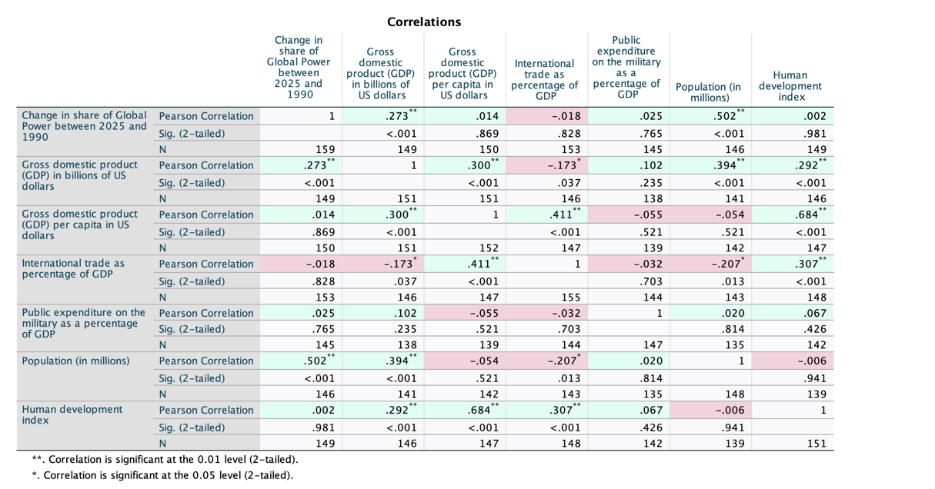

Figure B: GDP per Capita and Change in Global Power Share, 1990–2025

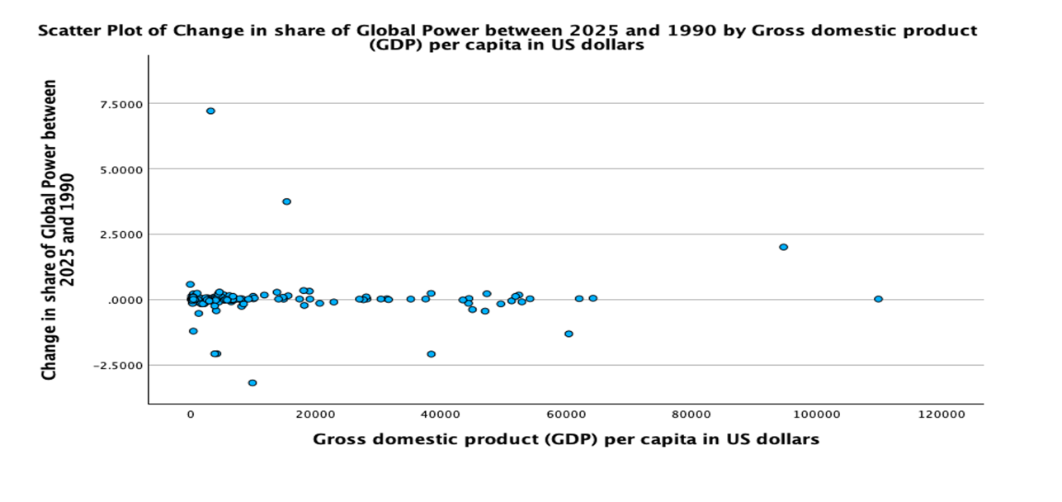

Figure C: Military Expenditure as a Percentage of GDP and Change in Global Power Share, 1990–2025

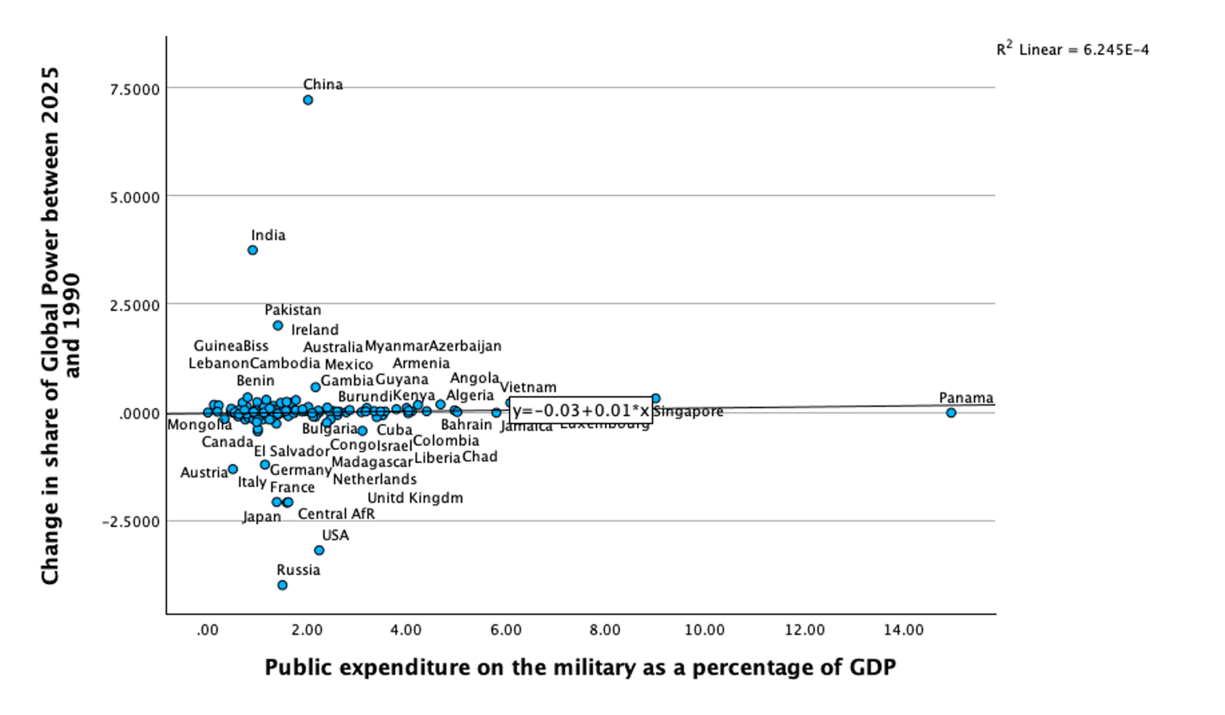

Figure D: Population Size and Change in Global Power Share, 1990–2025

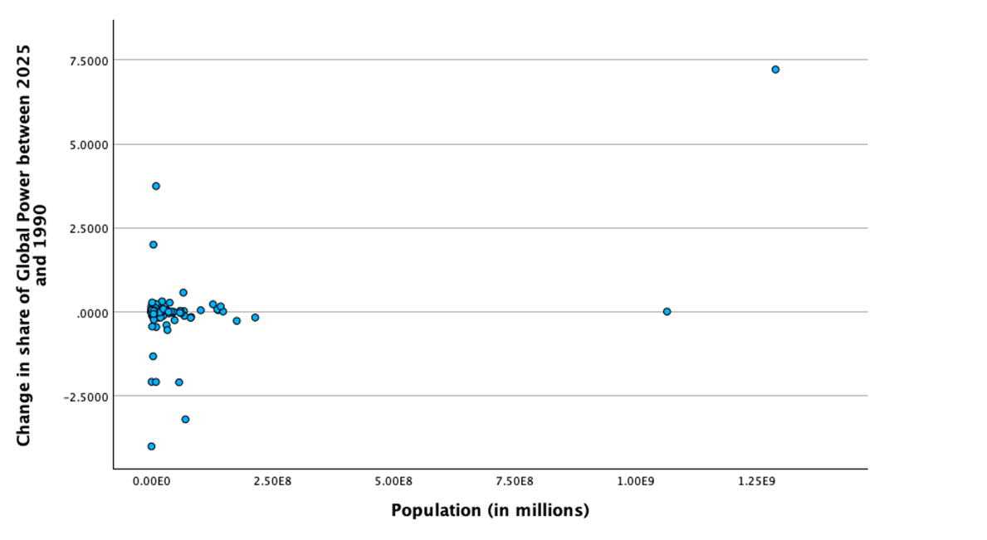

Figure E: International Trade as a Percentage of GDP and Change in Global Power Share, 1990–2025

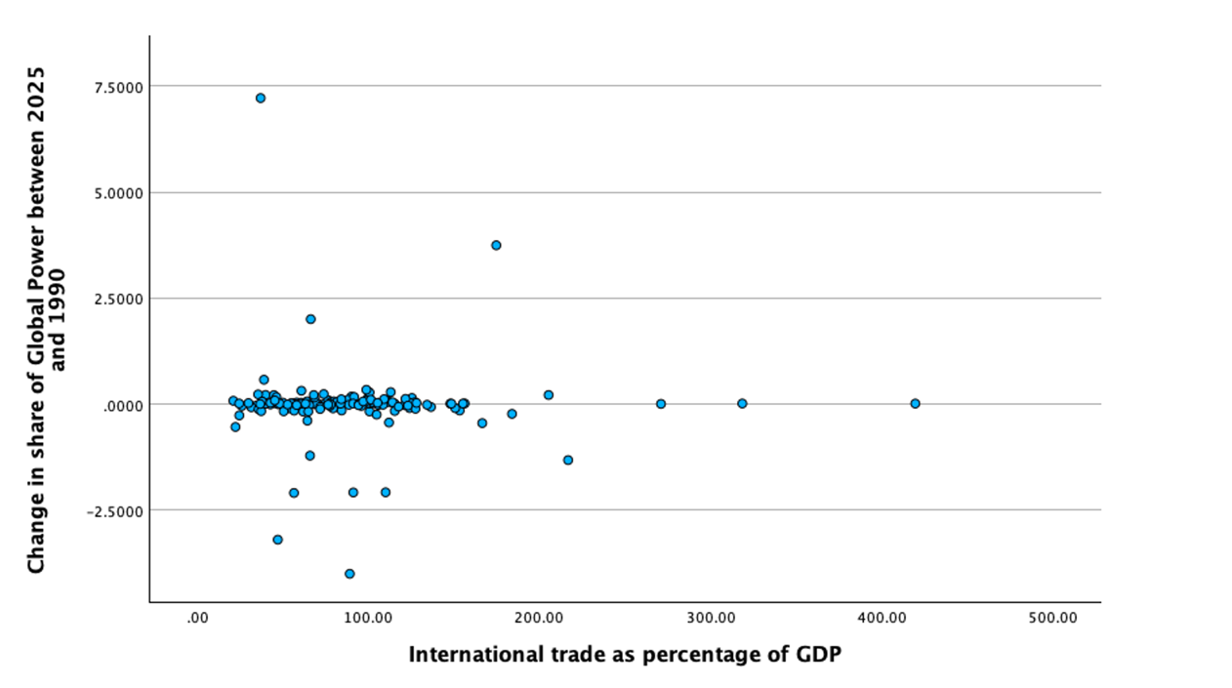

Bibliography
Babic, M., Fichtner, J., & Heemskerk, E. M. (2017). States versus corporations: Rethinking the power of business in international politics. The International Spectator, 52(4), 20–43.
Beckley, M. (2010). Economic development and military effectiveness. Journal of Strategic Studies, 33(1), 43–79.
Beckley, M. (2018). The power of nations: Measuring what matters. International Security, 43(2), 7–44.
Gallarotti, G. M. (2022). Esteem and influence: Soft power in international politics. Journal of Political Power, 15(3), 383–396.
Goldmann, K. (1977). Notes on the power structure of the international system. Cooperation and Conflict, 12(1), 1–20.
Lind, J. (2024). Back to bipolarity: How China’s rise transformed the balance of power. International Security, 49(2), 7–55.
Meierding, E., & Sigman, R. (2021). Understanding the mechanisms of international influence in an era of great power competition. Journal of Global Security Studies, 6(4).
Moyer, J. D., Sweijs, T., Burrows, M. J., & Van Manen, H. (2018). Power and influence in a globalized world. Atlantic Council.
Zikos, D., & Wurzel, U. (2023). Bringing economic and political power back in: A call for re-politicising development research. Economies, 11(93).
Education as a soft power resource: A systematic review. (2024). Heliyon.
Saikal, A. (2020). Iran’s national security and operational capability. Scandinavian Journal of Military Studies, 3(1), 1–14. https://doi.org/10.31374/sjms.29
Reuters. (2026, March 29). Brent heads for record monthly jump as Iran conflict widens. https://www.reuters.com/business/energy/oil-prices-jump-after-yemeni-houthis-attack-israel-widening-iran-conflict-2026-03-29/
Associated Press. (2026, March 29). Pakistan says it will host US-Iran talks, while Iran warns US ground troops would be “set on fire”. AP News. https://apnews.com/article/26caaef651be1cb4d482b29adaa2d600

