Push and Pull Factors in Migration from Latin America

Josiah Bloom
Bemidji State University

Political Science Senior Thesis
Bemidji State University
Dr. Patrick Donnay, Advisor
April 2026
Abstract
I examine push and pulls factors that shape migration to and from Latin America. I examine how political institutions, public policy, and economic conditions in one’s origin country can influence decisions on migration. I examine existing literature and analyze how factors such as economic inequality, the quality of one’s governance, violence, and immigration policy in destinations affect Latin American migration. In particular, I focus how these variables influence migration to the United States.

The findings suggest that while economic incentives play a crucial role in migration decisions, political factors may play a larger role in contemporary times. In general, immigration policies and labor demand in one’s destination countries act as pull factors, which often can be seen to sustain migration flows that overtake restrictive immigration measures. Migration networks also can reaffirm patterns over time.
From a policy perspective, the research highlights the importance of integrating economic theory and political approaches when analyzing migration.

Literature Review

Latin America as a region has been widely studied and put under a microscope throughout many of the social sciences, mainly political science, economics, and sociology. Many of the world’s top professionals about the topic of migration believe that decisions cannot be explained by only providing readers with the economic incentives that many people are in search of, but also by understanding the frameworks and the desire of certain political institutions, a stable governance structure, and policy. When looked at, we can see that many governments throughout the world, but specifically Latin America, lack those objectives or incentives. Many migration theories focus primarily on wage differences between the home country and the destination country of prospecting individuals, which suggest that those individuals are migrating to maximize economic opportunities. However, as we are entering the contemporary age of new information, research is beginning to demonstrate that migration outcomes are shaped through a complex web of structural inequality, institutional instability, violence and crime, and international policy regimes. In Latin America, those concepts are more relevant and more apparent than most countries as most countries migration patterns reflect government challenges such as economic inequality, limited opportunities, and a weak state system.

Push Factors
Economic theory regarding migration has given researchers one of the most influential explanations for migration. According to this economic theory, individuals will begin the process of migration when they expect their earnings in a destination country may exceed earnings in their country of origin. Hanson, Orrenius, and Zavodny (2023) equates the labor market, which brings workers to regions where more labor is present in fields such as agriculture or construction, to migration. These wage gaps where many Latin American countries are far behind their continental peers like the United States and Canada, create stronger economic incentives for an individual looking to migrate. This theory argues how the labor market in designation countries are one of, if not, the strongest reason for migration.
Although wage differences are a determining force behind migration, scholars and researchers have begun to recognize that the economic factors cannot fully explain such migration patterns. Clemens (2020) and Hanson, Orrenius, and Zavodny (2023) bring to light the concept of “emigration life cycle” and migration networks, where the suggestion arises that migration increases during early stages of economic development of a country or region. Another key point to this cycle is that if education levels begin to rise and the income in the household begins to improve, individuals now have adequate resources to be able to migrate. These cycles and networks allow access to transportation, community and communication, and easier entrance to labor markets. These authors suggest that the development in the cycle, may initially increase rather than reduce it. The findings by many contemporary research challenges traditional theory about migration solely being an economic factor.
There is also the theory of how political institutions may influence migration decisions by forming the distribution of opportunities within a society. Mayda (2010) finds similarities in patterns of migration flows that respond to economic conditions but also factors within a political realm such as democratic stability, civil liberties, and institutional quality. The research suggests that when a government is assessed as stable and effective, which very few countries are in Latin America, individuals may be more willing to chase after opportunities within their home country. On the contrary, governments who are perceived as corrupt, weak, and having limited political accountability, may reduce domestic opportunities and increase the incentives to migrate.
Societies throughout the entirety of the Latin American region have been plagued by economic inequality, and to this day it continues to be a defining characteristic of the region. Historically, Latin America has experienced one of the worst statistical levels of income inequality not only in the Americas, but throughout the world. Many studies suggest at the reason for this high level of inequality is due to the deeply rooted decisions influenced by political policies such as taxation, redistribution of wealth or land (agrarian reforms), and social welfare. Berens and Gelepithis (2021) demonstrate throughout their research that the high levels of inequality may give rise to the increase of public demand or support of redistributive policies that can reduce the severity of the economic disparities throughout the region. Many countries throughout Latin America have also had to deal with dictatorships throughout the Cold War Era and some of these policies, where we will begin to see in the Gini coefficient index, still linger in contemporary Latin America. Individuals throughout the region believe that political institutions in their home country are unable or unwilling to address inequality, to which they come to the conclusion that migration may become an alternative for achieving economic mobility.
Fairness and opportunity can also help shape the migration narrative. Busso, Ibañez, Messina, and Quigua (2025) point out that public attitudes toward redistribution policy in Latin America have been influenced by the perceptions of inequality and social mobility. Individuals will begin to see that economic advancement throughout their home country is limited and begin to view migration as the pathway toward new opportunities. Reyes and Gasparini (2022) pursue the theory that perceptions of fairness in policies and the trust in government have a great effect on migration patterns as low levels of institutional trust will encourage individuals to migrate rather to rely on policy reforms in a country, they feel deserted them.
Insecurity and violence also give us insight into additional factors that drive migration. Many countries throughout Latin America experience high levels of crime and gang violence. Hiskey, Córdova, Malone, and Orcés (2018) find that individuals that have experienced crime or are a victim of crime, are significantly more likely to consider migrating internationally as it acts as a powerful push factor due to being exposed to high level of violence and trauma. While economic factors certainly do have a large impact on an individual’s decision to migrate, it is argued that it can also be a strategy for safety and security.

Pull Factors
Policies that “tighten the belt” on migration also can shape patterns inadvertently. Massey and Pren (2012) believe that most immigration enforcement polices due have unintended consequences as these policies aim to deter migrants from crossing and apprehend individuals who start to cross. However, enforcement policies in the United States have shown to slow down the process of circular migration. Circular migration is where an individual comes into their destination country for a short period of time to work, receive healthcare, or attend to family and then return to their home country. These policies have had an adverse effect on its intended goal, as migrants who are usually following the patterns of circular migration, are encouraged to remain permanently once they have successfully crossed into the destination country. This shift in encouragement has altered original migration patterns rather than the objective goal of reducing migration.
Over the past few decades, we have seen major, large-scale political crises and as suspected, this can also produce new, significant migration patterns. One major example of this is the Venezuelan migration crisis which is representative of one of the most dramatic examples in this given timeframe. Bahar, Ibáñez, and Rozo (2021) show with the research provided that economic collapse, hyperinflation, and political repression in Venezuela had triggered one of the largest migration problems which have been affecting countries throughout Latin America. Millions of Venezuelans have relocated to neighboring Latin American countries such as Colombia, Chile, and Peru. According to UNHCR (2023), this displacement still represents one of the largest refugee crises in the world. This also reinforces that idea that may be looked at as a geographical statistic. If an individual ultimately decides to migrate, it may not be to the United States or Canada, but to neighboring countries where the lifestyle is similar but there is a better opportunity for an advancement of one’s livelihood than in their home country.
As referenced earlier, migration networks are a very critical aspect of sustaining migration flows. This theory of migration networks references that migration becomes self-reinforcing once a migrant community establishes connections between the destination and respective home countries Massey et al. (1999) believes that these networks are able to create a system that reduces the social and financial cost that follows migration. Due to the networks, migrants can easily establish a sense of community or even be provided with quicker opportunity for work as well as housing. Migration is very costly, however if one can be established through a certain migration network where friends or family have been established prior to one’s move, it can make it easier for the individual and ultimately encourage one’s movement. Portes and Rumbaut (2014) show the importance of having social capital within immigrant communities. In regard to migrant communities and networks, there are families and many community organizations that help new migrants with employment and housing. Donato and Sisk (2015) emphasize that the decision of migration is more commonly found at a household level or as a familiar unit rather than as an individual. Many families send one member across to generate remittances while the rest of the family stays in the home country. Usually, those members are the father or the eldest, male child. Remittances can be a crucial part of an individual or an individual’s family migration strategy. The World Bank (2023) shows remittances represent a huge source of income for many households across Latin America. Money that comes from countries with a stronger currency can go long ways in many Latin American countries, as it can pay for one’s education, healthcare, housing, and even help start small business developments. Due to remittances, migration can contribute economic stability in origin countries even as it reduces the domestic labor market. Many individuals even process cultural and linguistic factors when shaping their migration decisions. Adserà and Pytliková (2015) show that many migrants factor their destination as a decision to where language barriers are minimal and cultural similarities are available to help integrate into their new home. While many people may not think so, having shared language and cultural ties to an area or community can reduce the costs of migration by employment and networks be accessible in destination countries.
Acosta and Harris (2022) delve into how other Latin American countries shape their migration policies, as most of the policies are done as a regional framework. As discussed earlier, many Latin American countries have very accessible refugee programs. A factor that is frequently overlooked and can contribute doubt or encouragement to a country and their policy in regard to migration is how media coverage can influence the debate on migration policy and often deter or improve public perception on the subject. Media outlets frequently report on migration crises, border policies, and humanitarian issues related to flows and policies which have been even more relevant in recent years in the United States. This narrative can ultimately shape public opinion and even influence national political debates regarding immigration policy.
Overall, the literature that has been reviewed throughout this section can shine light on migration from Latin America and its results from a complex intersection between economic theories and incentives, social networks, policy, and even political institutions. As reviewed, economic inequality, governance failures, violence, and limited social mobility are viewed as a push factor in the field of migration, while labor demand, networks, and policies can often be referred to as a pull factor. To be able to understand migration, one will need to have a historical and comprehensive understanding of economic and political perspectives as well as analyzing the dynamics of migration.

Methods
The data that is shown throughout this section of the thesis uses quantitative analysis from all 33 countries in the Caribbean and Latin American region to examine the push and pull factors that drives migration in these regions. The data employed is data from multiple internationally recognized sources such as the United Nations Department of Economic and Social Affairs International Migrant Stock, the World Bank World Development Indicators, the United Nations Office on Drugs and Crime, the International Organization for Migration, and Transparency International. The data is the most recent available, as of 2024. The research allows readers to look at the diversity of factors in migration, not just economic conditions or theory although that is the most widely accepted theoretical standard to look through the lens into migration and can still be of focus on the regions throughout Latin America and the Caribbean.
The primary dependent variable which is used is the net migration rate, which allows an insight into the average annual balance of people entering one country and leaving that country per 1,000 in population it is from the period of five years between 2020 to 2025 it is provided by the World Bank and the United Nations World Population Prospects. A negative net migration rate refers to more people leaving a country than entering. Using the net migration rate accounts for the population size of one country. For example, if this study were to use raw emigration numbers and compare Brazil which has a rough population of 215 million people, to St. Kitts and Nevis which have an estimated 50,000 people, the data would disproportionately skew in favor of Brazil due to the large population. Another assessment of the net migration rate is the time average. I use the five-year average rather than a single-year view to reduce the distortion of migration peaks and valleys. The five-year assessment is able to provide a more normalized view of a country’s migration structure.

Hypothesis One: GDP per capita and Net Migration Rate: Lower GDP levels in Latin American and Caribbean countries are associated with stronger emigration pressure, as measured by net migration rates.
(See Figure A)
The first hypothesis states that countries who have a lower GDP per capita would experience higher negative net migration rates, which show that economic push factors being able to persuade individuals to migrate for better economic opportunities in other countries. This hypothesis is used in regard to the neoclassical economic theory of migration, primarily talked about in the literature of Hanson, Orrenius, & Zavodny (2023). This theory argues that an individual will make the decision to migrate when they are searching for or expecting higher earnings in a destination country. Throughout the regions of Latin America, the wage gap is very prevalent. due to the income differences between countries within the region and a destination country. Countries who are represented in the lower end of the GDP per capita in the data, including Haiti, Nicaragua, Honduras, and Bolivia, represent some of the largest income gaps in regard to one’s destination country which strengthen the economic theory by providing the economic incentives for emigration.
The results provided by the bivariate correlation analysis show strong support for hypothesis one. The Pearson correlation between GDP per capita and net migration rate is r=.501 with a significance level of p=.003, which indicates a moderate to strong positive relationship that is statistically significant at the 0.01 level. When a country’s GDP per capita increases, it is seen to increase the rate of positive net migration. This confirms that wealthy countries retain and gain individuals more effectively than poorer countries. Figure A highlights the strength of this hypothesis with countries like Uruguay, Barbados, and Chile which all have high GDP and more positive migration rates, while comparing them to countries like Haiti, Nicaragua, and Honduras which contract both negative variables. One notable outlier throughout this study is Venezuela. Venezuela is known as being subjectively unreliable and unstable when providing its country’s economic statistics. Venezuela also has had one of the largest emigration waves in the history of modern-day Latin America, with roughly eight million people leaving Venezuela. However, the timeline of that wave and the statistics provided in this research are separated by only a few years. Nonetheless, the statistics and overall migration patterns remain consistent and support the hypothesis. The finding is also consistent with the study directed by Hanson, Orrenius, and Zavodny (2023) who argue that labor markets between Latin America and the United States have been known to be the strongest driver of emigration throughout the region.

Hypothesis Two: Homicide Rate and Net Migration Rate: Higher homicide rates in Latin America are associated with more negative net migration rates, acting as a significant push factor for emigration.
(See Figure B)
Hypothesis two refers to revealing if countries with higher intentional homicide rates would show more negative net migration rates, which may be able to propose that violence and citizen insecurity could be a significant push factor which drives emigration from Latin America. With this hypothesis, research is conducted beyond the scope and limitations of the economic explanations for migration and allow for the question to be asked if personal safety and the threat of violence are significant motivators in the search for a better life. In Latin America, this variable is relevant due to the region’s particular history regarding some of the world’s highest rates of violent crimes and gang-related crimes. The base of Central America, which includes El Salvador, Honduras, and Guatemala, seems to have attracted a sort of spotlight due to the regions high gang-violence, extortion, and even forced gang recruitment which have contributed to large numbers of displacement disregarding the previously referenced economic theories or conditions.
The analysis conducted in Figure B brings to light the negative trend across most of the 33 countries throughout the study, when referred to with the net migration rate and the homicide rate. The evidence is clear, that countries with higher homicide rates, fall under the negative end of net migration with countries like Jamaica, Venezuela, El Salvador, and Honduras which show some of the highest homicide rates with deeply negative migration rates. One country to be able to examine at length would be El Salvador. While the country claims to have drastically lowered their crime rates, remember that this study is from a five-year period. El Salvnation’ss one of the regions highest homicide rates while simultaneously showing some of the lowest negative net migration with rates of 7.0 per 1,000 along with being on the pedestal for having one of the regions worst murder rates, which is a direct example of how violence could personally interfere with a nations migration rate as a push factor. No Pearson correlation was used for this range of data due to outliers that would distort the coefficient, Figure B allows the direct relationship in confirmation of the hypothesis. The finding is supported by Hiskey, Córdova, Malone, and Orcés (2018) who verifiably and empirically demonstrate the variable with crime victimization and how it can increase the probability of emigration decisions in Central America, which allows the study to be able to frame violence as an independent push factor rather than just a background variable.

Hypothesis Three: Gini Coefficient and Net Migration Rate: Income inequality, measured by the Gini coefficient, predicts migration patterns more effectively than national wealth.
(See Figure C)
Hypothesis three allows introduces the concept of countries with higher levels of income inequality, which is measured by the Gini Coefficient, would be able to prove more negative net migration rates. This is the suggestion that economic inequality drives emigration without regard to the country’s overall wealth, so ultimately disregarding a country’s GDP. The hypothesis looks into the research done and provides the argument of if the distribution of a nation’s resources matters as much to the quantity of the resources available when looking at a country’s migration rates. It is possible that a country has an enormous GDP per capita but safeguard those resources for the elite in one’s country, which leaves the majority of the country’s population with no access to upward mobility. So, the hypothesis allows individuals to comprehend that if an individual in a wealthy country has limited resources and no ability to gain economic strength, that individual may view emigration as a viable pathway to secure those resources even when the research is not able to accurately predict that scenario due to the strength of that country’s GDP per capita.
The Pearson correlation where the Gini coefficient is used in comparison to net migration rate was r=.452 and a significance level of p=.023, which provides the research with a positive relation that is significant at the level of 0.05 and provides the supported warranted for the hypothesis to be relevant in this field. One contradiction that may come with this research is that only 25 of the 33 countries in the dataset have openly available Gini coefficient data which the research permits caution for the interpretation of the results. Nonetheless, the correlation positively indicates the association between both higher inequality and higher net migration rates but should be approached with caution due to many subjectively high-inequality countries like Colombia and Peru are at the receiving end of large waves of Venezuelan migrants which can distort the real net outward emigration numbers. Despite that contradiction, the research and numbers support the research by Busso, Ibáñez, Messina, and Quigua (2025) who provide the theory of Latin American citizens in such high-inequality regions are more likely to view emigration as an alternative path to domestic economic advancement due to the structurally impaired abilities.

Hypothesis Four: Corruption Perception Index and Net Migration Rate: Countries with lower CPI scores experience stronger emigration pressure.
(See Figure D)
Hypothesis four is using comparison between countries that have lower Corruption Perceptions Index scores, which mean a country is corrupt as the lower a country’s number is in the score, the more corrupt, and if they would show more negative net migration rate which supports one of the main arguments of the thesis in describing the argument of institutional failure and weak governance as push factors in which reduce an individuals confidence in their domestic opportunities. This hypothesis relies heavily on the theory of migration which believes that the quality of governance and the public trust in institutions will shape the domestic opportunity that is available for its population. For example, if an individual shows lack of trust in ones institutions and perceive their government is corrupt or not acting in the interests of the majority and instead the interests of the elite, they are less likely to have the confidence in the product their country has to offer in regard to education or even aspects like inequality, which will increase one’s appeal in the outward migration of their home country in order to advance their social productivity or economic stability.
The Pearson correlation between the two variables was r=.326 and with a significance level p=.064. This relationship is relevant to the hypothesis with less corrupted countries will tend to have higher positive net migration rates, such as Barbados and Uruguay, than its counterpart such as Nicaragua and Venezuela. However, the significance level of .064 falls just above the threshold of p<.05, which means that the result does not meet significance, and should be interpreted with caution. This may be due to the fact that corruption in Latin America can be directly correlated and intertwined with economic underdevelopment rather than being a standalone variable which can be seen in the correlation between Corruption Perception Index and GDP per capita at r=.684 and p<.001. This ultimately means that the independent effects of corruption on migration are difficult to isolate from other stronger effects more specifically GDP which accurately sides with Mayda (2010), where the study is found that institutional quality influences migration when it is connected with economic conditions rather than an independent variable.

Hypothesis Five: Correlation between Push Factors and Net Migration Rate: Countries in Latin America that have low GDP per capita, high-income inequality, and high corruption experience stronger emigration pressure.
(See Table A)
This hypothesis focuses on the countries who experience low GDP per capita, high-income inequality, and high corruption would showcase more negative net migration rates while suggesting that the push factors compound one another rather than being significant by themselves. This hypothesis is referenced to the structural approach in the study by Massey et al. (1999) which argues that migration is best seen as being a response to multiple differing factors, rather than an independent action. This implies that no single variable can fully explain the exasperated migration argument but being able to combine differing variables such as the economic argument, distribution of wealth and resources, and failures of one’s governance and utilize this as a necessary response rather than being simply an attractive offer.
The correlation graph supports this argument as the variables and their respective predictors, as mentioned in the third hypothesis in this section, such as GDP per capita emerged as the strongest predictor while followed by Gini coefficient and Corruption Perception Index. The relationship between GDP and the Corruption Perception Index present themselves as strong variables as long as they are together combined which further push the entire argument of the thesis that the economic factor by itself, is not a confident factor to look at and rather to look at the push and pull factors as a unit of measurement when comprehending migration and why it happens as no one single variable could fully predict waves alone.

(See Table A)
Another analysis was provided through the research and that is of multiple linear regression and was conducted with the dependent variable being net migration rate and GDP per capita, Gini coefficient, homicide rate, and the Corruption Perception Index as the independent variables. The Gini coefficient came out as the highest significant predictor with standardized beta of .409 and p=.020, which allows the confirmation of how income inequality has an independent effect on migration even with all the other variables which are controlled. The homicide rate had a beta of -.356 and p=.071 suggesting that violence is an important push factor but maybe not as large as seen. GDP per capita lost significance in the regression at p=.371 even while being the highest bivariate predictor, which now shows that the effect it has on migration may be coupled with other structural variables. Now with the final variable, the Corruption Perception Index, it had shown no independent significance at p=.773, which stays in line with the interpretation of how corruption is due to its relationship with economic conditions rather than being a unique variable. Overall, the regression analysis keeps concrete the central argument that income inequality is the most reliable predictor of net migration rates and patterns in Latin America when combined with multiple push factors.

Conclusion
The research conducted set out to view the structural push and full factors that drive migration throughout Latin America and the Caribbean by testing out multiple hypotheses that was drawn from the datasets of 33 countries. Those analyses were correlation, scatterplots, and regression analysis. The findings of the hypotheses provided meaningful and subjectively positive support for the central argument of the thesis which is that migration is not a phenomenon that one may only view one variable to predict its future or patterns, but a web consisting of many significant variables that each play their role in the prediction of migration. Those variables consist, and not limited to, economic factors, institutional security, personal security, and even the level of governance. We are able to predict certain patterns of migration using the measurable data from such countries, which confirm that no one factor can be a sole predictor as previously thought by migration experts.
The most important finding of the study is how income inequality is a crucial factor used in predicting migration. The Gini coefficient, which studies income inequality, was statistically significant in both analyses conducted such as the bivariate correlation at r=.452 and p=.023, and in the multivariate regression being the only variable to retain significance with a beta of .409 and p=.020 when all other variables were controlled. In short, these analyses provided the argument that economic resources within a region is a far more reliable factor than the general wealth of that region alone, which challenges decades of economic-migration theories which suggest the general wealth of a region alone is the sufficient variable disregarding many statistically significant variables which suggest how the regions resources or wealth is produced. GDP per capita had the strongest bivariate correlation at r=.501 and p=.003, lost its significance in the regression analysis which suggests that its effect on migration comes from it being coupled together by other variables and not by itself. Homicide rate also had its share of significance at p=.071 with a beta of -.356, however it is to be suggested that like GDP per capita, it is only relevant when it is combined with other factors.
There are many contradictions of this study that are now going to be acknowledged. The data set covers a total of 33 countries while variables such as the Gini coefficient only represent data from 25 of those, which significantly reduced the power of the inequality analysis. Additionally, the net migration rate is checked in at a five-year average and cannot fully explain certain relevant information such as the Venezuelan migration crises which predated the five-year gap of this study. Future studies can expand on this data and take the time to extend the time period or even correlating different variables such as migration corridor data and democratic quality, will further expand on the base question and argument of this study.
Despite the limitation that this study has, it makes an impact in regard to decades old theory about migration due to the suggestion of income inequality being a key factor, or even by suggesting that migration is a multi-window lens. This theory helps strengthen certain aspects of research done by Massey et al. (1999) and push back against purely economic theories such as Hanson, Orrenius, & Zavodny (2023) which focuses on labor markets and wage differences without addressing other important variables. In regards to policy, this research suggests that efforts to counter or address migration from Latin America must go beyond investments or allyship in the promotion of reforms in one’s country, to tackling the interconnected web of structural conditions that may determine if an individual is to seek new opportunities in their home country, or elsewhere.

Appendix
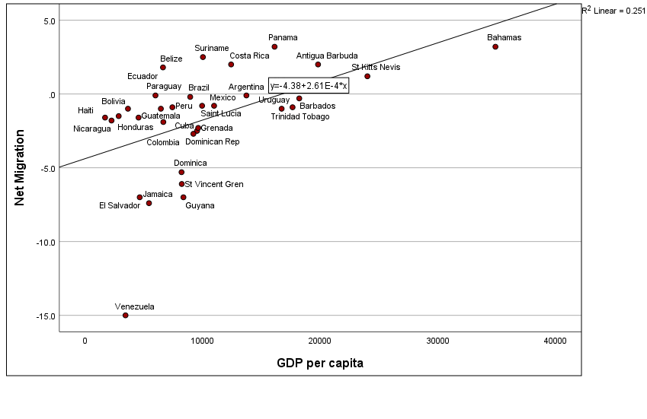
Figure A: Pull

: 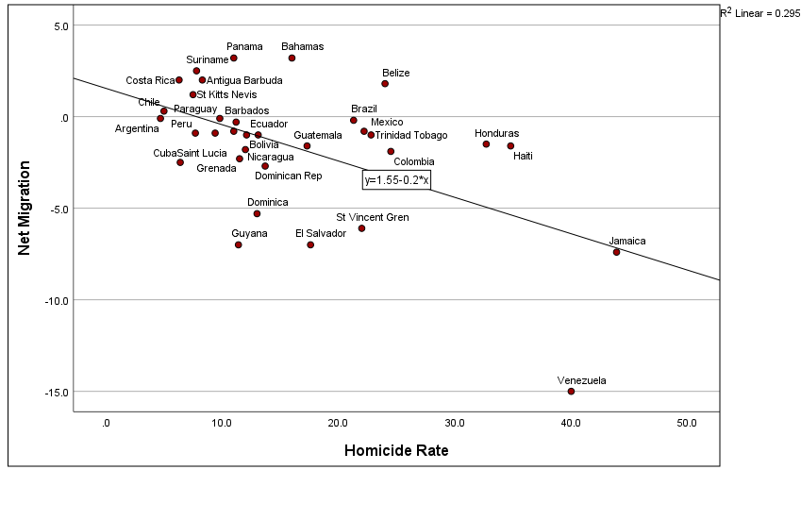
Figure B: Push
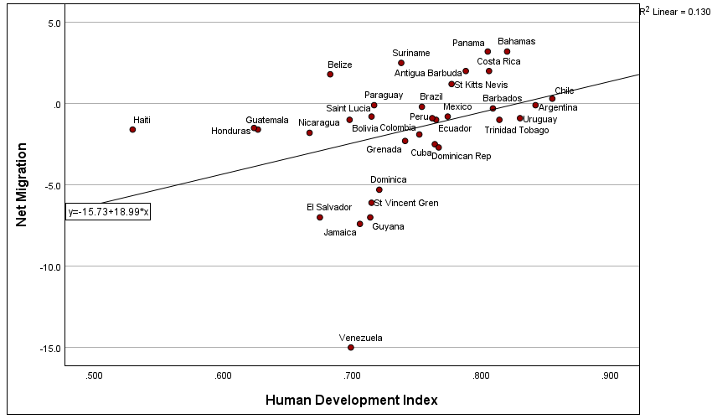
Figure C: Pull

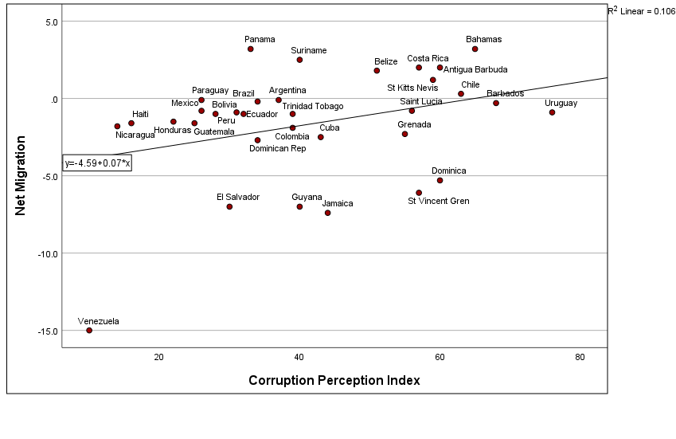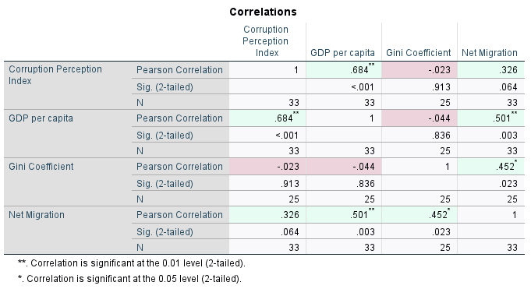
Figure D: Pull
Table A
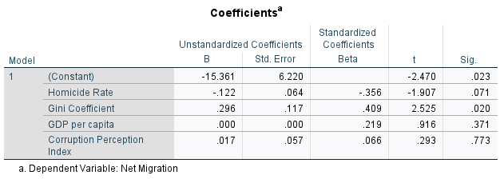
Table B

References
Acosta, D., & Harris, J. (2022). Regímenes de política migratoria en América Latina y el Caribe: inmigración, libre movilidad regional, refugio y nacionalidad. https://doi.org/10.18235/0004362
Adserà, A., & Pytliková, M. (2015). The Role of Language in Shaping International Migration. The Economic Journal, 125(586), F49–F81. https://doi.org/10.1111/ecoj.12231
Bahar, D., Ibáñez, A. M., & Rozo, S. V. (2021). Give me your tired and your poor: Impact of a large-scale amnesty program for undocumented refugees. Journal of Development Economics, 151, 102652. https://doi.org/10.1016/j.jdeveco.2021.102652
Berens, S., & Gelepithis, M. (2021). What do people want? Explaining voter tax preferences. Edward Elgar Publishing EBooks. https://doi.org/10.4337/9781788979429.00037
Busso, M., Ibáñez, A. M., Messina, J., & Quigua, J. (2025). Preferences for redistribution in Latin America. Oxford Open Economics, 4(Supplement_1), i534–i545. https://doi.org/10.1093/ooec/odae015
Clemens, M. A. (2020). The Emigration Life Cycle: How Development Shapes Emigration from Poor Countries. IZA Institute of Labor Economics. https://doi.org/10.2307/resrep60909
Debusmann Jr, B. (2024, February 7). Three reasons why so many migrants want to cross from Mexico to US. BBC News. https://www.bbc.co.uk/news/world-us-canada-68208637
Donato, K. M., & Sisk, B. (2015). Children's Migration to the United States from Mexico and Central America: Evidence from the Mexican and Latin American Migration Projects. Journal on Migration and Human Security, 3(1), 58–79. https://doi.org/10.1177/233150241500300103
Hanson, G., Orrenius, P., & Zavodny, M. (2023). US Immigration from Latin America in Historical Perspective. The Journal of Economic Perspectives, 37(1), 199–222. https://www.jstor.org/stable/27192415
Hein De Haas. (2020). Age of Migration: International population movements in the modern world. Guilford.
Hiskey, J. T., Córdova, A., Malone, M. F., & Orcés, D. M. (2018). Crime Victimization, US Deterrence Policy, and the Emigration Decision in Central America. Latin American Research Review, 53(3), 429–447. https://doi.org/10.2307/26744323
International Organization for Migration. (2024). Migration trends in the Americas: Q4 2024 quarterly report. IOM. https://lac.iom.int
Kitroeff, N., & Turkewitz, J. (2023, May 11). What's Driving Record Levels of Migration to the U.S. Border? The New York Times. https://www.nytimes.com/2023/05/11/world/americas/title-42-migration-us-border.html
Massey, D. S., Arango, J., Hugo, G., Kouaouci, A., Pellegrino, A., & Taylor, J. E. (1999). Worlds in Motion. Oxford University Press. https://doi.org/10.1093/oso/9780198294429.001.0001
Massey, D. S., & Pren, K. A. (2012). Unintended Consequences of US Immigration Policy: Explaining the Post-1965 Surge from Latin America. Population and Development Review, 38(1), 1–29. http://www.jstor.org/stable/41857355
Mayda, A. M. (2010). International migration: a panel data analysis of the determinants of bilateral flows. Journal of Population Economics, 23(4), 1249–1274. https://doi.org/10.2307/40925859
Portes, A., & Rumbaut, R. G. (2014). Immigrant America: A Portrait (4th ed.). University of California Press. http://www.jstor.org/stable/10.1525/j.ctt7zw0nw
Reyes, G., & Gasparini, L. (2022). Are fairness perceptions shaped by income inequality? Evidence from Latin America. The Journal of Economic Inequality, 20. https://doi.org/10.1007/s10888-022-09526-w
Transparency International. (2025). Corruption Perceptions Index 2024. https://www.transparency.org/en/cpi/2024
UNHCR. (2024). UNHCR global trends: Forced displacement in 2023. United Nations. https://digitallibrary.un.org/record/4051778?v=pdf
United Nations Department of Economic and Social Affairs, Population Division. (2024). International Migrant Stock 2024. United Nations. https://www.un.org/development/desa/pd/content/international-migrant-stock
United Nations Office on Drugs and Crime. (2023). Global study on homicide 2023. UNODC. https://www.unodc.org/unodc/en/data-and-analysis/global-study-on-homicide.html
United Nations Population Division. (2024). World Population Prospects 2024. United Nations. https://population.un.org/wpp
Why migration is in such a mess once more. (2023, November 9). The Economist. https://www.economist.com/international/2023/11/09/why-migration-is-in-such-a-mess-once-more
World Bank. (2024). Migration overview. World Bank. https://www.worldbank.org/en/topic/migration/overview
World Bank. (2024). World Development Indicators. World Bank. https://databank.worldbank.org/source/world-development-indicators

