The Effects of Unionization and Workers Ownership on Political Participation

Matthew Voss
Bemidji State University

Political Science Senior Thesis
Bemidji State University
Dr. Patrick Donnay, Advisor
April 2026

Abstract
Since the 1960’s, there have been questions on the effects of worker owned and governed workplaces. Specifically, I am looking to question how worker ownership and greater worker autonomy affect political participation. Early research on this question focused on mentality, interviews, and the Spillover Thesis, which is the idea that experience with workplace democracy can “spill over” into engagement with public political participation. More recently, large surveys such as the GSS and ESS have allowed for research into less obvious effects, such as better living conditions, which itself results in higher political participation.

For my research, I will be taking the 2010 ESS data and comparing factors such as union membership and feelings of autonomy in the workplace and measuring them against factors of political participation such as voting, volunteer work, and interest in politics. I predict that there’s a correlation between workers autonomy and higher political participation, however not all factors may be significant. This information can be used by unions and workers in attempts to leverage support from political parties, and vice versa. The information can also be used to encourage democratic participation by detailing the factors that workplace participation has on civic participation and standard of living.

Introduction
One of the oldest battles in politics is the idea of participation, of deciding who does vote versus who doesn’t, or even who is able or unable to vote. Many politicians attempt to get laws that increase their vote percentage codified, for example politicians who benefit from lower voter turnout may limit the number of places one may turn in a mail in ballot, as they did in Texas (McCullough, 2020). Politicians who benefit from greater turnout enforcing automatic registration or laws encouraging mail in voting. Such tactics also take place outside of the legal realm. One situation that seems to have an impact on someone's propensity to turn out and vote is their experience at work.
For the vast majority of people, the workplace is one of the least democratic parts of their lives. Rarely a vote is had that affects anything beyond a mere surface level, and in the vast majority of workplaces you don’t get to choose your superior any more than you get to choose if you have a job or not. However, voting is far from the only way to get your voice represented in a workplace. Unions often act as a collective voice for employees, and have learnt to “cultivate both prounion political identities and basic political skills”(Kerrissey & Schofer, 2013). Unions also provide other benefits such as increased income (Fichtenbaum, 2011) which in turn can lead to a higher propensity to vote (Palmieri, 2024).
Although they’re not as numerous as unions, worker owned businesses share many of the same effects on their members propensity to vote, as well as their financial wellbeing. Some worker owned businesses such as workers co-ops, have the added benefit of requiring a democratic process in order to operate. Another form of worker owned business worth touching on are companies with an Employee Stock Ownership Plan, or ESOP. These companies are similar to workers co-ops in the fact that workers own the company, but differ in governance, usually having a typical hierarchy with no elections.
Literature Review
The Effect of Worker’s Co-ops on Political Participation
Some of the first research done on political participation in cooperatives was by Carole Pateman in her 1970 book Participation and Democratic theory. In this book she sets the basis for what’s become known as the ‘spillover thesis’. The spillover thesis implies that engaging with politics and democratic mechanisms in one aspect of your life, such as your job, can provide a sense of political efficacy. Political efficacy is “the feeling that individual political action does have, or can have an impact upon the political process” (Campbell et al., 1954, p. 187). The idea was that by giving opportunities in the workplace to participate in democracy, it will help workers build up confidence and lead to higher rates of political participation.
Research since Pateman’s work has focused on expanding what the spillover thesis may apply to, as well as expanding sample sizes, as Pateman’s original empirical analysis looked at a single co-op. There have also been concerns of self selection, or that those who worked there chose to work there because they wanted a more politically active work environment. That would’ve explained both why they participate more in voting and work at a company that values voting. Cooperatives can also be more popular depending on the history of the region they’re in, and that history may also include higher rates of democratic participation (Vieta et al., 2024).
There are detractors to the spillover thesis, or at least those who believe Pateman’s proposition is oversimplified. In his 2006 paper Political Participation and the Workplace: The Spillover Thesis Revised, Neil Carter argues that Pateman’s “simple” spillover thesis is missing the whole picture, being based off of only one empirical example. He finds 2 factors differentiate co-ops from each other: size, and origin (Carter,2006).
Regarding origin, there are many ways for a co-op to be formed such as being forced upon workers by an owner who wishes for the business to change upon their departure, thus endowing their employees with the business (Carter, 2006). There are also co-ops created as the last line of defense against economic downturn, or co-ops created out of passion for a uniquely democratic business model, where most, if not all of the starting employees are self-selected (Carter, 2006). Carter also finds there to be 5 factors of informal control, including organizational degradation, expectations from the worker-owners, external economic environment, absence of job autonomy which causes alienation and greater conflict brought upon by workers having a greater say (Carter, 2006). These effects can completely mitigate or in some examples reduce the efficacy that these worker owners feel, and even lower their electoral turnout. Although Carter’s article in some ways narrows what can qualify for the spillover thesis, studies in the same vein as his opened the door for workplace democracy and ownership to broaden their scope past cooperatives and towards other forms of control over their own work.
Effects of ESOPs on Political Participation
Although the spillover effect originally focused only on the rights of cooperatives to democratically make decisions and control their work environment, today the thesis applies to more than co-ops, and efficacy via governance only makes up one part of what “spills over” from worker ownership. The other aspect that makes a co-op worker owned is the literal ownership of the company, which states that the employees own shares of the company, usually in the US through a cooperative or an ESOP (Ben‐Ner & Jones, 1995; Palmieri, 2024). Unlike a cooperative, ESOPs rarely have overtly democratic features such as elections, instead usually only having votes on decisions surrounding the shared company stock (NCEO, 2026). Instead, ESOPs focus on the “return rights”, or the right of the worker-owners to have a share of the companies profits, not just the wage they are paid for working (Ben‐Ner & Jones, 1995).
At first glance, ESOPs do not seem to fit the mold for what the spillover thesis found. After all, at the core of Pateman’s argument was the ability of democratic participation increasing efficacy. Many ESOPs do not even have unions, much less the ability to democratically make decisions. However, it should be noted that even without governance powers, ESOPs still gain a certain level of efficacy based off of governance rights, due to a feeling of greater freedom over their work (Palmieri, 2024). In addition, Carter’s findings broaden what can cause efficacy, making it worth looking at other potential ways that the spillover thesis may still exist.
One of these is looking at what effects different employee owned business models may create that in themselves lead to a higher propensity to vote. For example, having a higher income makes someone more likely to vote (Laurison, 2016). In the same way co-ops encourage higher wealth through dividends, ESOPs increase wealth through giving their worker owners a simple and inexpensive route to obtaining assets (Baskaran, 2015; Palmieri, 2024). Other studies have shown that low wealth decreases political participation (Emmeneggar, Et al., 2017), and that employee ownership increases wealth (Kruse et al., 2010). In addition, worker owners have much higher job security, higher than levels found in traditional employment and even unions (Wiefek, 2017). This in turn also leads to higher rates of voting (Palmieri, 2024).
Around now, it is also important to point out the political preferences for the relevant groups. Unions are well known to have their political basis in left wing politics, although in recent years with the rise of the populist right across the world, there has been a slow shift to the right (Arndt & Rennwald, 2016). There is also a left wing historical basis for co-ops, which Pateman (1970) observes. The reason to bring this up now is the Republican Party bias observed in American worker owners by Palmieri (2024) throughout presidential elections in 2008-2016. Although this is correlated more so with the increased income and wealth that comes with owning stock and in more traditional businesses, being a C-suite member with the option to buy stock thus becoming a worker owner, there is still possibly a far looser connection between ESOPs and traditional left wing politics than there is between left wing politics and Co-ops or unions.

The effect of unions on political participation
Unlike the two previously mentioned forms of companies, unions usually have no ownership of the companies that the workers they represent work for. However, they still end up affecting the operation of the businesses they find themselves in, giving the workers a certain level of control over the governance of their workplace, through the negotiations between union representatives and the owners. Unions are known for their aggressive political mobilization, and opening a door for workplace democracy without it being engrained in the company (D’art, 2007).
Like worker owned businesses, unions have been shown to increase voter participation (Jirjahn, 2025). However, the effects of the spillover theory on political participation do not appear to be as strong as with worker owned businesses, particularly ESOPs (Palmieri, 2024). They also have many of the same issues as co-ops, in the way of having their efficacy effects hampered by economic conditions usually outside of their control (D’art, 2007). However, there can also be sources of hindrance that do not exist in a worker owned company, that primarily being the owners. In order to prevent having to bend to the demands of a union, owners may be proactive by attempting to set nonunion member wages higher than union, or use other methods (oftentimes legally dubious at best) in order to discourage unionization (Budd, 2014). However, it is in this opposition that unions find some of their most fervent battle cries in the fight for better working conditions, once again targeting an out group that is directly threatening them (Arndt & Rennwald, 2016). Despite this, unions are still showing results. Their income is still higher than nonunion workers, and their participation with the union structure seems to grant them more faith in the democratic structure (Turner et al., 2019).

Methodology
The data I am using to analyze my hypotheses are both part of the European Social Survey (ESS). The ESS is conducted every two years by the European Union, using surveys given to over 50,000 residents across Europe. I chose Round 5, released in 2010 and round 10, released in 2020. These were chosen due to the inclusion of factors surrounding democratic participation, as well as union membership and other variables surrounding workplace conditions.

In addition, I created 2 stratified groupings of income and feelings of workplace freedom. The income groupings are based on the bottom 30%, a 31% to 70% range, and those in the top 71% and higher. The workplace freedom question was on a 1-10 scale, as well as a “very little freedom” and “a lot of freedom” answers. I grouped those similarly,with very little freedom and 1-3 in one category, 4-7 in another, and 8-10 and a lot of freedom making the last category. These were used in the second and third hypothesis to test both their factors as effects of union membership as aspects of workplace autonomy.

My first hypothesis is that those who are union members are more likely to vote than non union members. To test this, I looked at a crosstabs comparing current or past union membership to turnout during the most recent general election. I ran a Cramer’s V test, which measures the strength of a correlation on a 0-1 scale, as well as the significance, or if the correlation isn’t just due to chance. This latter value is also known as the p-value. The p value for this first hypothesis is less than 0.001, which indicates certain significance. The value for Cramer’s V is .138, which shows a modest relationship. This information is included in figure 1.
Figure 1
Percent of last national election turnout, by union membership
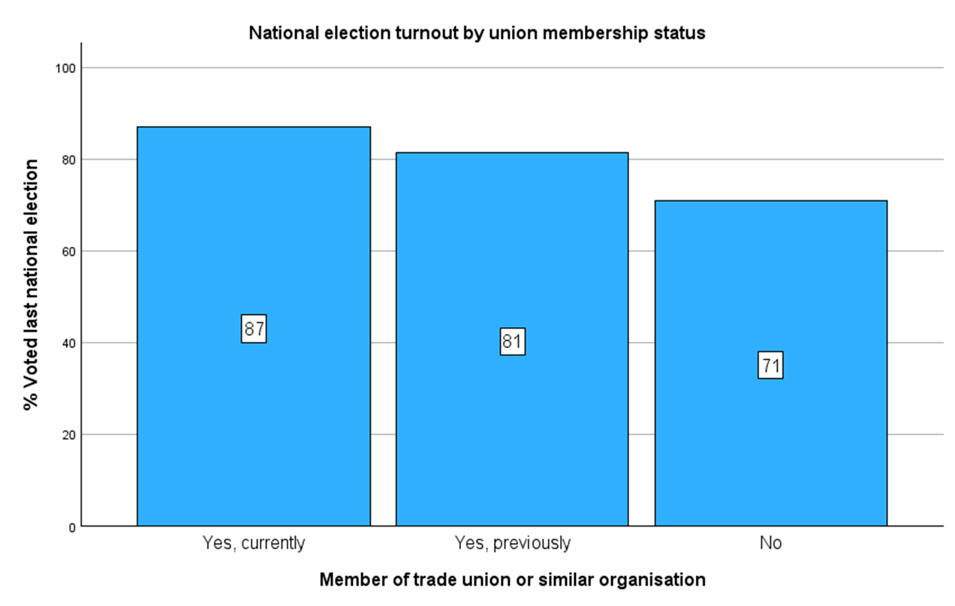
In terms of turnout percentages, the data showed that turnout in the most recent general election for non union members was 73.7%, whereas turnout for union members was 89.4%. One explanation for this nearly 16% gap could be simply the impact of class consciousness. This can also help explain the turnout in former union employees being 82.6%, still higher than those who have never been unionized. It should be noted that although there is a correlation, it does not necessarily mean that there is a connection, although there is prior research to back this up. In addition, there are other effects associated with union membership that may provide insight into connected correlations. These other aspects I will refer to as aspects of worker autonomy, as they both demonstrate some level of economic and civic freedom in regards to the workplace.
One of these effects is showcased in my second hypothesis, which states that higher levels of income are correlated to higher voter turnout, and union membership is correlated to higher levels of income. This could imply that higher income is one of the factors that makes unionized voters turn out at a higher rate. This acts as a hypothesis for economic freedoms associated with greater worker autonomy, as a greater amount of pay goes to the workers, thus giving them the ability to save and have more money to freely use (Palmieri, 2024). For this hypothesis I ran 2 tables, one to show the connection between union membership and income, and another to show the connection between income and voter turnout. Along with running these tables, I ran the same chi square and Cramer’s V test as with the first hypothesis for both tables. As mentioned, the data I used for “income” is a stratification of the ESS 5’s “Income from main job by decile” question.

Figure 2
Percent of Union Membership Status by Income
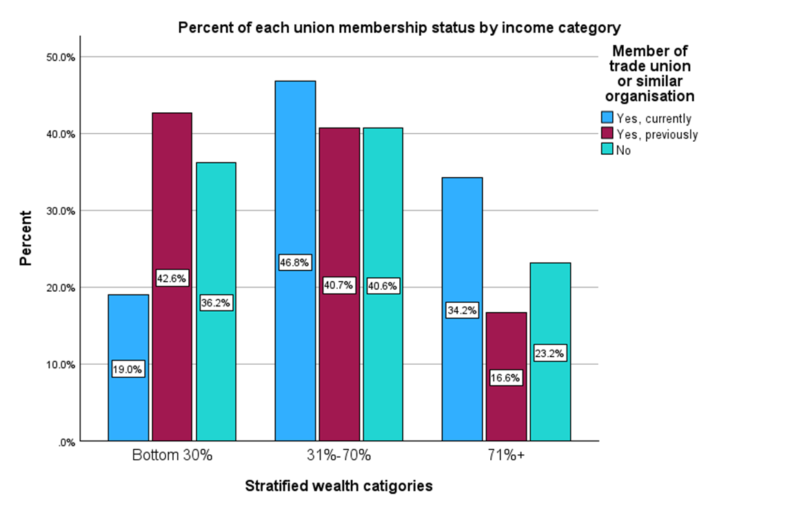
For the test of union membership's connection to income, I received <0.001 for the Chi squared test, and .130 for Cramer’s V, showing some correlation. Although some of this correlation shows evidence for unions providing higher incomes, the correlation is not incredibly strong, and there is some evidence to show that never being in a union may also raise income, at least when compared to former union members. This may also be due to older former union members being retired or working less intensive jobs.

Figure 3
National Election Turnout by Union Membership and Income
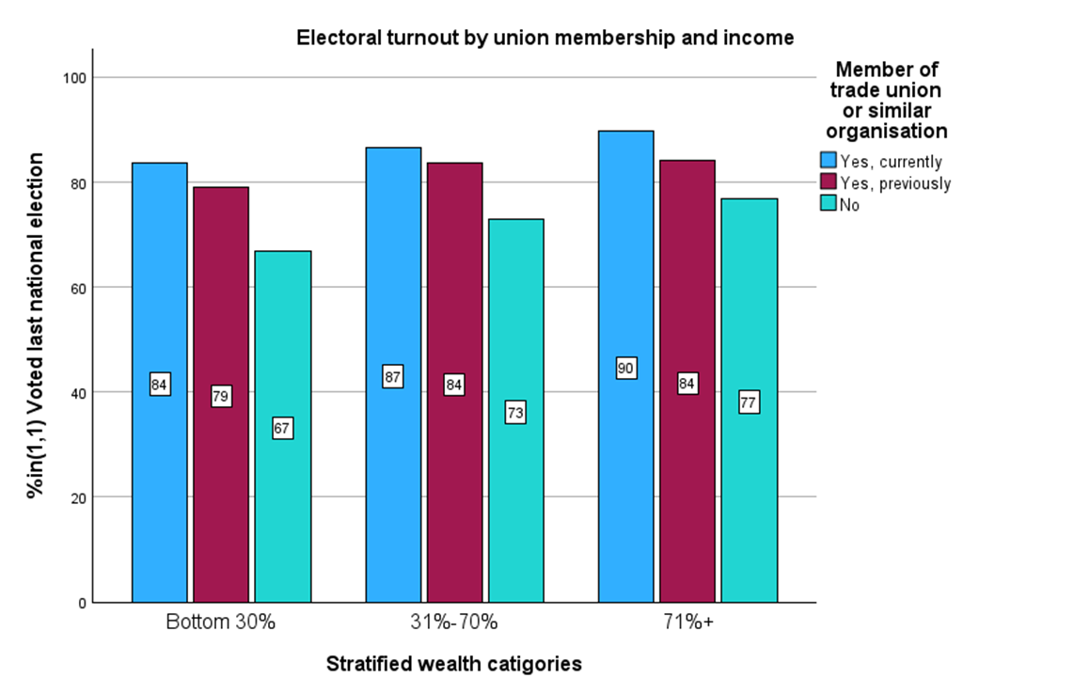
The second test, comparing income and voter turnout provides a Cramer’s V value of 0.86, showing a much more mild correlation than in hypothesis 1. However the significant Chi score of <.001 is still present. Also, unlike the disparity seen in the previous test between unionized voters and formerly unionized voters, there is once again a clear trend with former union turnout being between unionized and never unionized turnout in all 3 income groups. To me, this points to income not being a strong indicator of vote turnout. However, this effect can also be explained in some other ways, such as a potential correlation with older people being more likely to vote and be former union members. Regardless, the correlation between income and turnout being substantially weaker than the correlation between union membership and turnout, combined with former union membership being a stronger indicator than current income, suggests that income may not have a large impact as an aspect of workplace freedom influenced by unionization.
My third hypothesis focuses on perceptions of workplace freedom, predicting that greater freedom in day to day workplace decisionmaking will result in greater voter turnout, and that union membership increases favorable perceptions of workplace freedom. In the way hypothesis 2 acts as a hypothesis for economic rights, this hypothesis is a look at a “civic” workplace right that affects their autonomy. The day to day workplace freedom is a stratified data set created from the opinions on day to day workplace freedom question in ESS 10. In a similar fashion to the second hypothesis, the first test was ran on the relationship between union membership and workplace freedom.
Figure 4
Opinions on Workplace Autonomy by Union Membership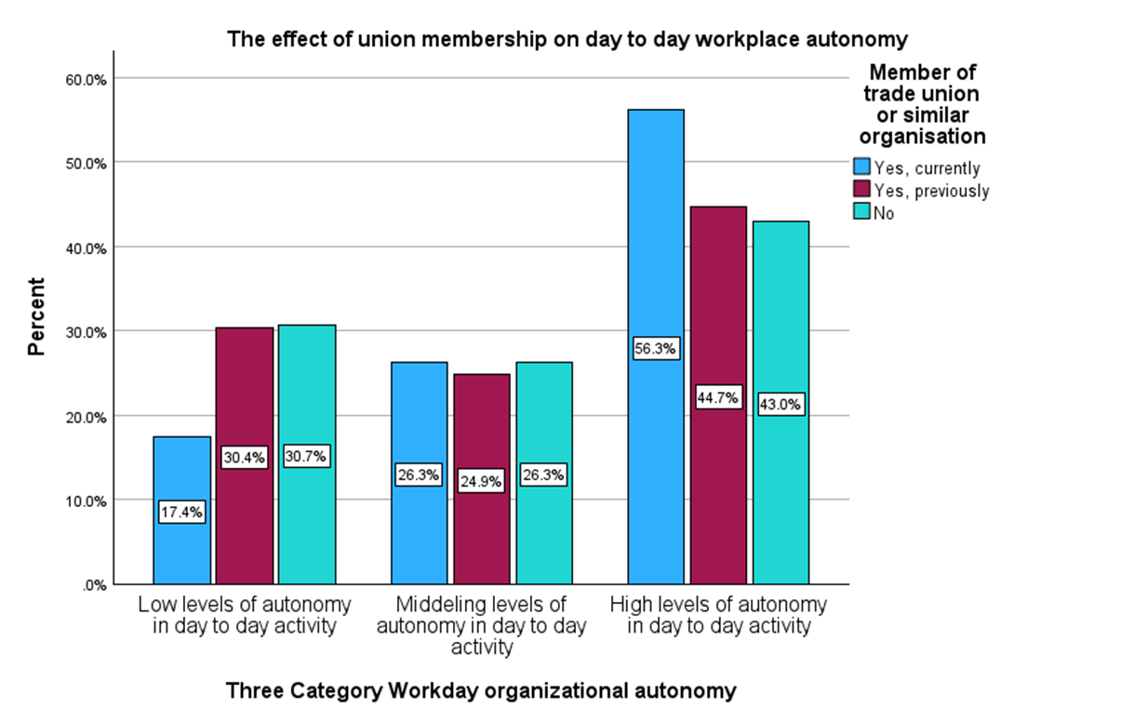
The first test gave a chi squared value of >0.001, and a Cramer’s V of 0.077, which is the weakest correlation as of yet. This lack of correlation points to the hypothesis being weak, yet still statistically significant due to the chi square test. The weakness of the first part of the hypothesis is interesting, as you may expect a unionized workplace to be more courteous with their employees' time. Indeed that is the case according to the numbers, but the lack of a significant correlation may be due to the day to day workplace freedom question being opinion based.
Figure 5
National Election Turnout by Workplace Autonomy and Union Membership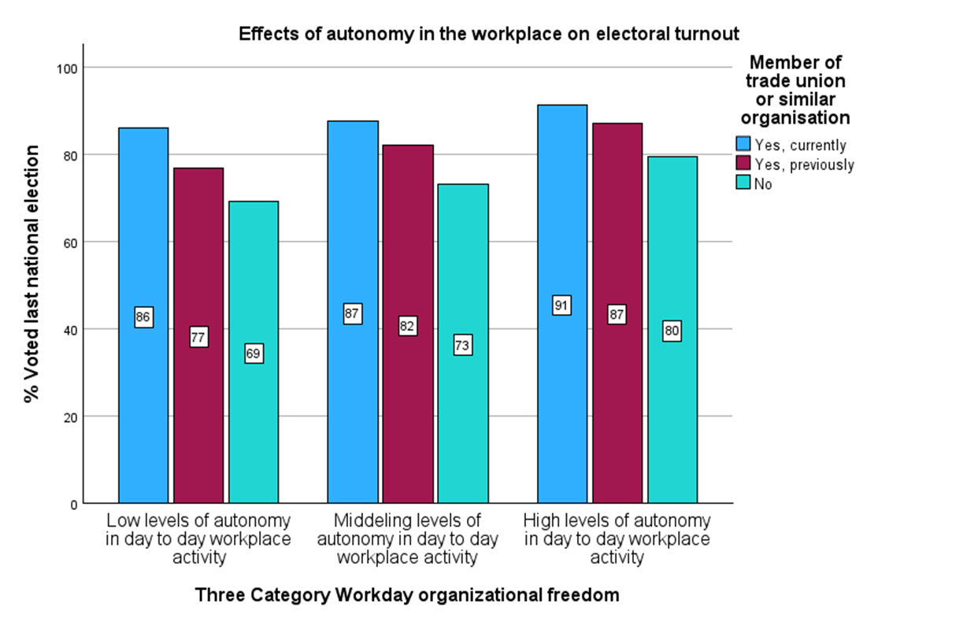
The second test has a chi squared value of >0.001, and a Cramer’s V of 0.112. The Cramer’s V of the second test signifies a somewhat strong, yet still mild relationship between workplace freedom and voting turnout. This may be due to the idea that if someone believes they have more control over their life, they may be more willing to exercise their faith in the government by participating in politics.If the second hypothesis worked in its first half and failed in its second, the third hypothesis failed in its first half and succeeded in its second.

The fourth hypothesis goes back to the premise of the first, and predicts that those who are union members are more likely to contact their representatives recently. I used the question in ESS5 concerning contacting a politician or government official in the last 12 months as the dependent variable. This hypothesis considers more involved methods of political participation, which may show more faith in the system than just simply voting.

Figure 6
% of people who contacted a government official in the last year, by union membership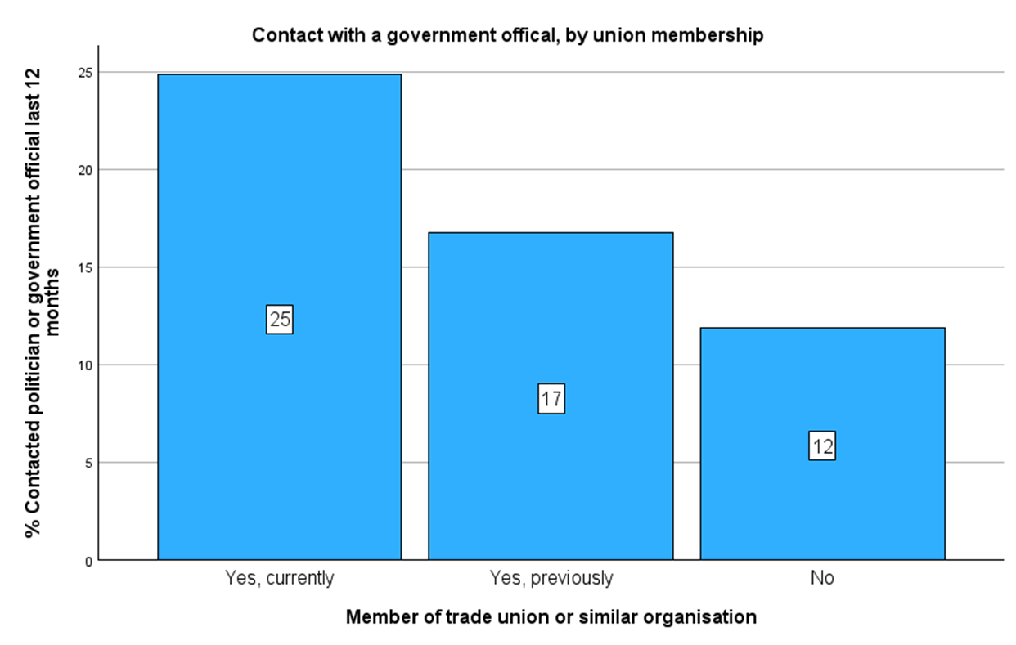
The chi square value is once again significant at >0.001. Cramer’s V for this final test is 0.123, which shows a relationship slightly weaker than hypothesis one’s relationship between union membership and voting. In addition to potentially showing more faith in the system, union workers usually encourage their members to be mobilized and politically active, including being willing to contact their representatives with questions and concerns they may have. The raised percentages of previous union members, which has been noticeable in each of these graphs and tables also makes sense here, as a habit of political mobilization may very well stick around even when the external encouragement is no longer there.

Conclusion
With my tests, I attempted to show the connection between unions, factors that unions effect, and political action. These factors stem from some of the same ideas seen brought to a greater fruition in worker owned businesses, particularly co-ops. This includes the increased income and feelings of control brought about by the workers having greater control and investment within their workplace. By evaluating how and why worker owned businesses and unions succeed in increasing political participation, we can determine how to increase efficacy and participation further. Perhaps, unions and worker owned businesses could use the data to encourage parties to pander for their causes. As an example, the slightly Republican voting nature of ESOPs and their higher participation rate could lead to the party, which has shown more economically populist tendencies since 2016, encouraging ESOP growth with policy, to act as a counterbalance to the affinity unions and co-ops have to the democrats and left wing parties in general. They could also go the other way and crack down on unions, following in the footsteps of previous republican presidents, and be able to use less political participation as an effect as a tool to win elections. The door is also open to further research into the effects of workplace autonomy on other types of efficacy, such as measures of happiness. The analysis done on unions, along with previous research, pushes the idea that unions can be effective machines to push the spillover effect much like worker owned businesses.

Bibliography
McCullough, J. (2020, October 27). Texas counties will have only one drop-off location for mail-in ballots. The Texas Tribune. https://www.texastribune.org/2020/10/27/texas-voting-elections-mail-in-drop-off/
Palmieri, M. L. (2024). Employee share ownership: An exploration of its economic and political impacts. Kent State University.
Kerrissey, J., & Schofer, E. (2013). Union membership and political participation in the United States. Social Forces, 91(3), 895–928. https://doi.org/10.1093/sf/sos187
Wang, T. (2024, March 27). Union impact on voter participation-and how to expand it. Ash Center. https://ash.harvard.edu/resources/union-impact-on-voter-participation-and-how-to-expand-it/
Fichtenbaum, R. (2011). Do unions affect labor's share of income: Evidence using panel data. American Journal of Economics and Sociology, 70(3), 784-810.
Pateman, C. (1975). Participation and democratic theory. Cambridge university press.
Campbell, A., Gurin, G., & Miller, W. E. (1954). The voter decides.
Vieta, M., Cheney, G., Noyes, M., & Do, E. (2024). Revisiting the ‘spillover thesis’ in participatory workplaces and Worker Cooperatives. The Routledge Handbook of Cooperative Economics and Management, 272–291. https://doi.org/10.4324/9781003449850-22
BEN‐NER, A., & JONES, D. C. (1995). Employee participation, ownership, and productivity: A theoretical framework. Industrial Relations: A Journal of Economy and Society, 34(4), 532–554. https://doi.org/10.1111/j.1468-232x.1995.tb00387.x
NCEO. (n.d.). What voting rights do ESOP participants have?. National Center for Employee Ownership. https://www.nceo.org/employee-ownership-faq/what-voting-rights-do-esop-participants-have
Laurison, D. (2016). Social class and political engagement in the United States. Sociology Compass, 10(8), 684-697.
Baskaran, P. (2015). Introduction to worker cooperatives and their role in the changing economy. J. Affordable Hous. & Cmty. Dev. L., 24, 355.
Emmenegger, P., Marx, P., & Schraff, D. (2017). Off to a bad start: Unemployment and political interest during early adulthood. The Journal of Politics, 79(1), 315-328.
Wiefek, N. (2017, May). Employee ownership and economic well-being: Household wealth, job stability, and employment quality among employee-owners age 28 to 34. NCEO.
Kruse, D. L., Freeman, R. B., & Blasi, J. R. (2010). DO workers gain by sharing? employee outcomes under employee ownership, Profit Sharing, and broad-based stock options. Shared Capitalism at Work, 257–290. https://doi.org/10.7208/chicago/9780226056968.003.0009
D’Art, D., & Turner, T. (2007). Trade Unions and political participation in the European Union: Still providing a democratic dividend? British Journal of Industrial Relations, 45(1), 103–126. https://doi.org/10.1111/j.1467-8543.2007.00604.x
Gittleman, M., & Kleiner, M. M. (2015). Wage effects of unionization and occupational licensing coverage in the United States. ILR Review, 69(1), 142–172. https://doi.org/10.1177/0019793915601632
Turner, T., Ryan, L., & O’Sullivan, M. (2019). Does union membership matter? political participation, attachment to democracy and generational change. European Journal of Industrial Relations, 26(3), 279–295. https://doi.org/10.1177/0959680119844926

