Contents
Contents 1
Student Employment 1
How to Access Student Employment 1
Enter Time Worked 2
Add Time Worked 2
Submit Time Worked 3
Modify or Delete Time Worked 4
View Position Details 9
View Daily Totals 10
Earnings 10
Example Earnings PDF 12
Earnings Advice Screen Fields 12
Direct Deposit Account Setup (non BankMobile schools only) 16
Payment Preference Selection (BankMobile schools only) 20
Tax Forms - W-2 and 1098-T 21
1098-T Tuition Statement 24
W-2 Wage and Tax Statement 27

Student Employment
Administrative Staff can use this document to help guide student employees through what they see as they are navigating the Student Employment pages in Student eServices.

Minnesota State is an affirmative action, equal opportunity employer and educator.

How to Access Student Employment
In Student eServices > Student Employment located on the left-side navigation bar

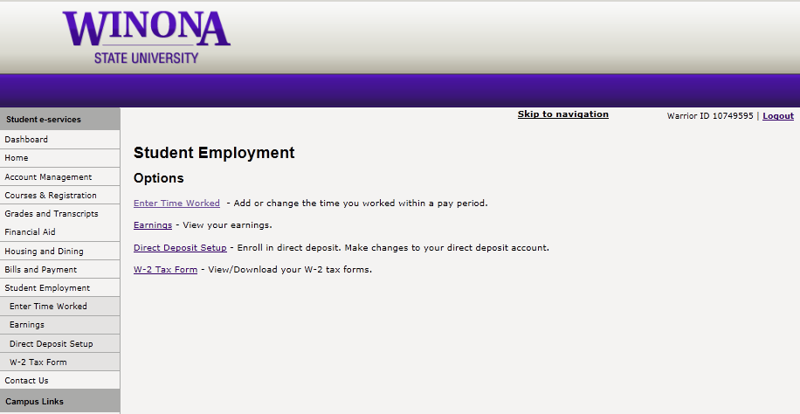

Enter Time Worked
The Student eTime web application is used to enter time worked by the student employee via the web or mobile device.

Add Time Worked
- Select Enter Time Worked
- Select Add Time for the position that time worked hours should be entered.
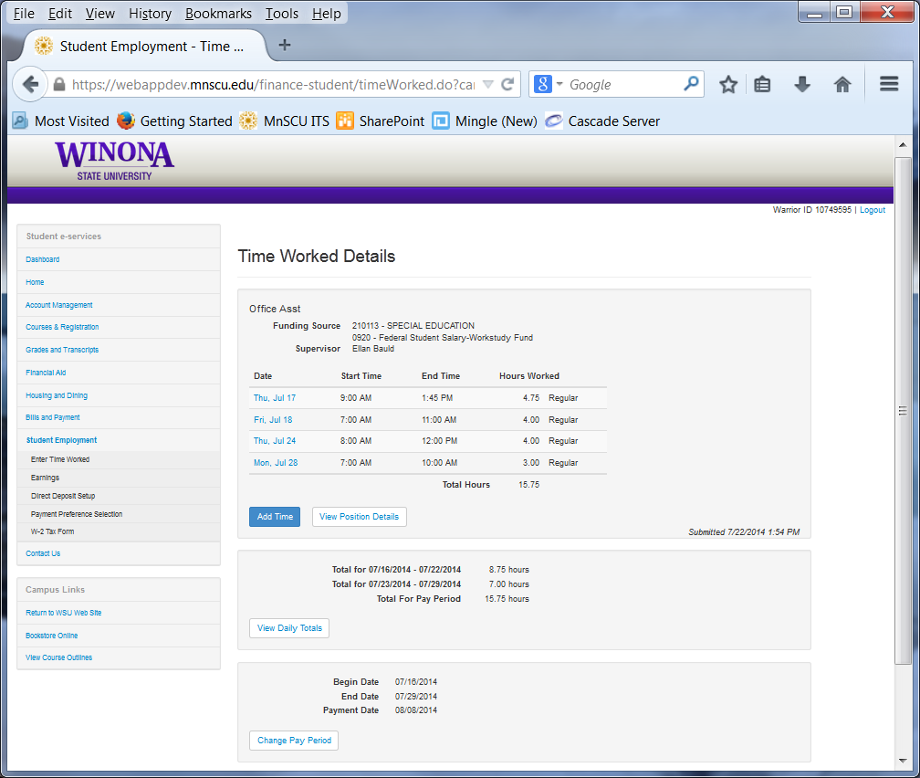
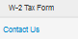
- Use the Date drop-down to select the date. All dates within the pay period will display.
- Use the Start Time drop-down to select the start time. Time is rounded to 15 minute intervals.
- Use the End Time drop-down to select the end time.
- Lunch and/or dinner breaks are NOT automatically calculated. If 8:30 – 5:00 is entered the system would calculate 8.5 hours. If a lunch was taken, the student should enter their hours as 8:30 – 12:00 and then 12:30 – 5:00.
- A comment can be entered up to 1000 characters and is viewable when you hover over the dialogue bubble.
- Either hit Add Time to add the time or Cancel to be brought back to the Time Worked Details page.
NOTE: If time worked is entered during a time class is scheduled, a warning message will be given and providing a reason will be required. The student will need to pick one of the following reasons:
- Class Cancelled
- Student Excused
- Other (requires a Comment)

Submit Time Worked
The Submit Time button will display on work authorizations where time is allowed and entered and has not been submitted. If more than one position has time entered, the Submit Time button will display on each position and can be submitted all at one time or separately.
- Select the check box next to the statement “I certify the hours reported are correct and that I have fulfilled my job obligations” for each position to be submitted.
- Hit the Submit Time button.
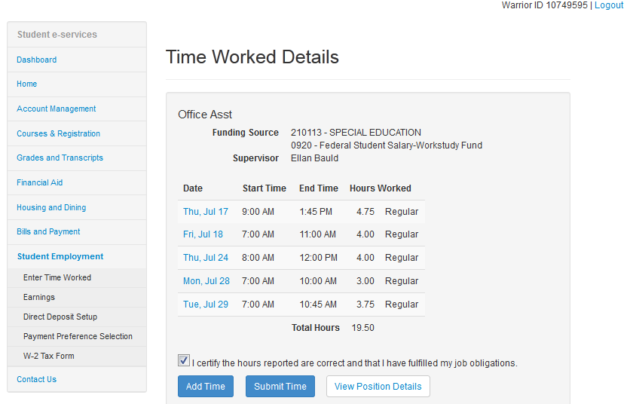
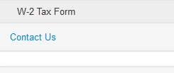
- Once submitted, the system checks to see if the payroll has already been processed for the pay period. If it has then the following informational message displays to the student: “Time worked records submitted successfully but payroll has already been processed for this pay period. This payment will be included the next time payroll is processed. In most cases, you will receive payment by mm/dd/yyyy.” (Payment Date from the next unprocessed pay period) example if next unprocessed pay period is 7/29/2014 then it would display 8/8/2014.
- If more time is added, changed or deleted after it has been submitted but before the pay period has been processed, the Submit Time button and check box will display again to be processed.
- Once submitted, the supervisor will be able to review and approve the time worked.

Modify or Delete Time Worked
NOTE: Only records that have NOT been processed can be modified or deleted by the student.
- Select the Date of the record to be Modified or Deleted
- Choose Modify to update the record and Save
- Choose Delete to remove the record
If the record has already been processed but needs to be deleted or hours reduced, the student will need to inform the Student Payroll Staff who will work with the System Office, Tax Services Unit who can process an Overpayment Reimbursement.
Add Time Worked to an Overnight Shift
Enter the shift with the end time midnight then go to the next day and add the remaining time worked with the start time midnight. For instance the shift is from 10 pm on 8/14 until 2 am on 8/15 - Add Time on 8/14 from 10 pm to midnight and then on 8/15 Add Time from midnight to 2 am.
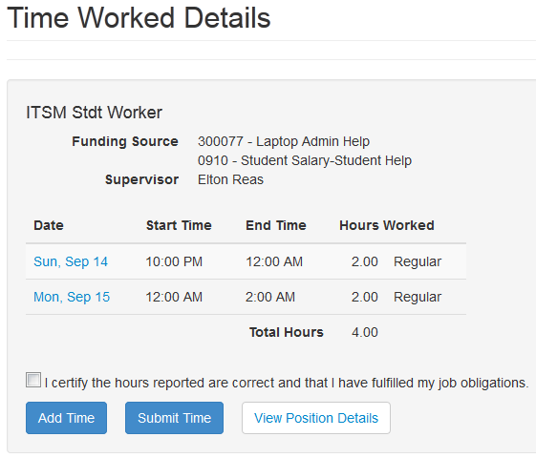
If an overnight shift is worked on the last day of the pay period the time worked for the one day in the future pay period can be entered during that current pay period by selecting the calendar icon or clicking in the field to the right of View or Add Time for a Date within a Prior Pay Period and choosing the date. It will however, be paid with the next pay period.

View a Prior Pay Period
- Select the calendar icon or click in the field to the right of View or Add Time for a Date within a Prior Pay Period
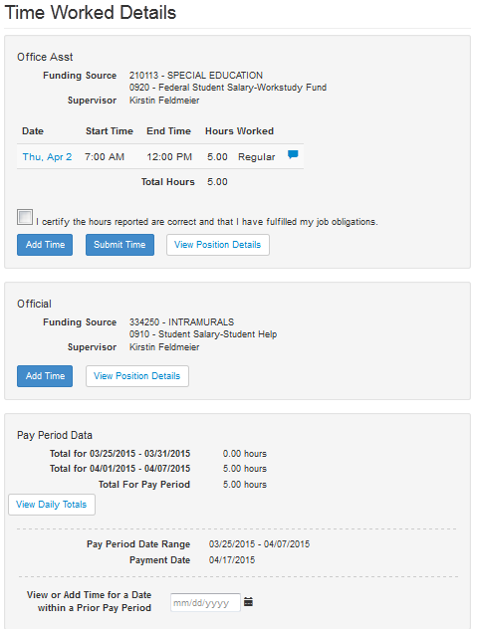
- Select a date within that prior pay period.
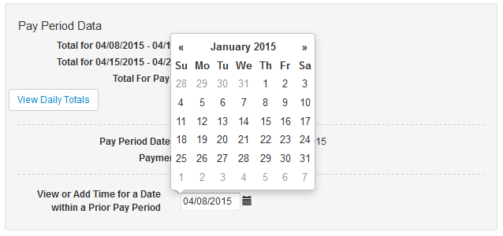
The Time Worked Details from that pay period displays
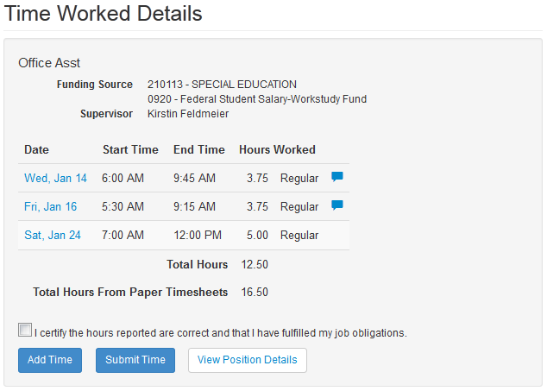
Add Time Worked to a Prior Pay Period
If time worked was forgotten or missed getting entered, it should be entered in the pay period in which the work occurred, NOT the current pay period. The system allows students to add time to a previous pay period even if it has already been processed as long as the pay period is open and unlocked. The system will display the date and times that were previously paid but does NOT allow the student to change the date and times of these records.
The application only allows entry of new dates and times such as additional hours that need to be paid. If the student needs to reduce the number of hours paid due to being overpaid, they will need to work with the Student Payroll Student Staff who will work with the System Office, Tax Services Unit who can process an Overpayment Reimbursement.
- To add time to a prior pay period, select the calendar icon or click in the field to the right of View or Add Time for a Date within a Prior Pay Period.
- Select the date.
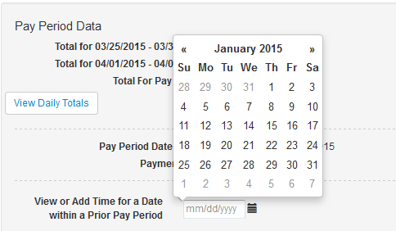
- Select Add Time
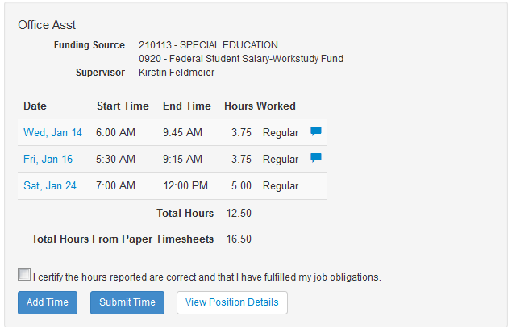
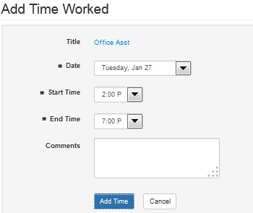
- Use the Date drop-down to select the date. All dates within the pay period will display.
- Use the Start Time drop-down to select the start time. Time is rounded to 15 minute intervals.
- Use the End Time drop-down to select the end time.
- A comment can be entered up to 1000 characters and is viewable when you hover over the dialogue bubble.
- Hit Add Time to add the time
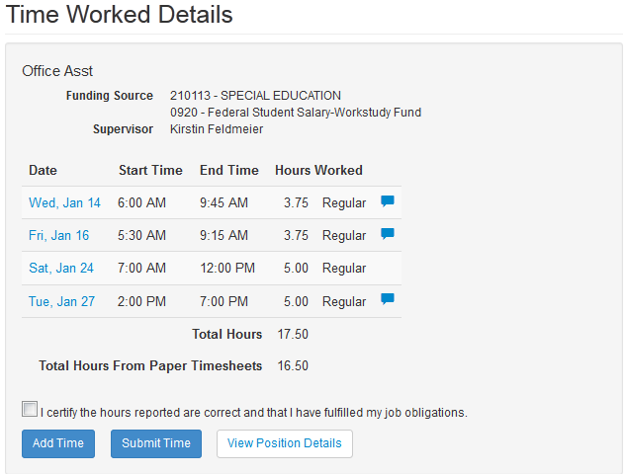

View Position Details
Select the View Position Details button to display the information.
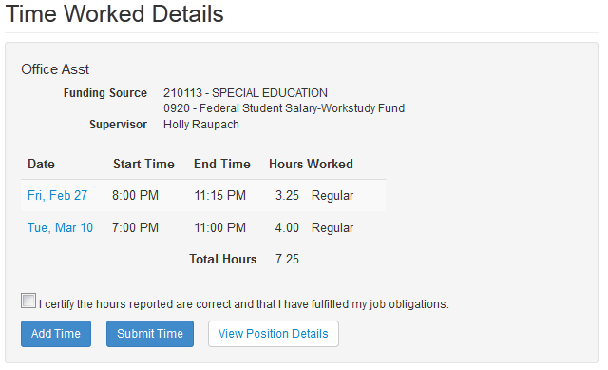

View Daily Totals
Select the View Daily Totals button to display total hours worked by day in the pay period.

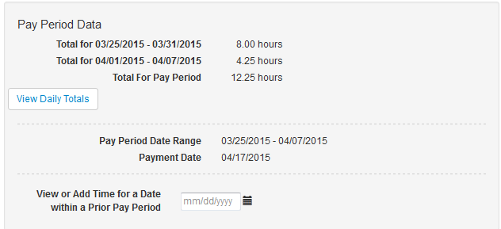
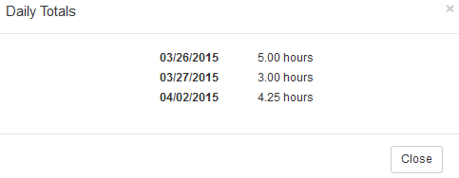

Earnings
Student Employment Earnings PDF can be accessed by a student employee to view their electronic payroll advice when paid though direct deposit or check.
- Click the Earnings link under Student Employment in the left hand navigation bar.
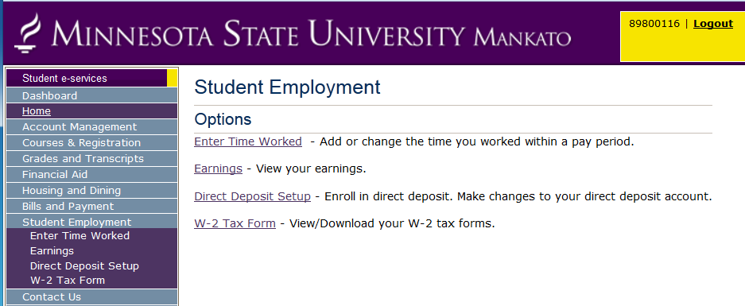
- The Earnings Search page displays.
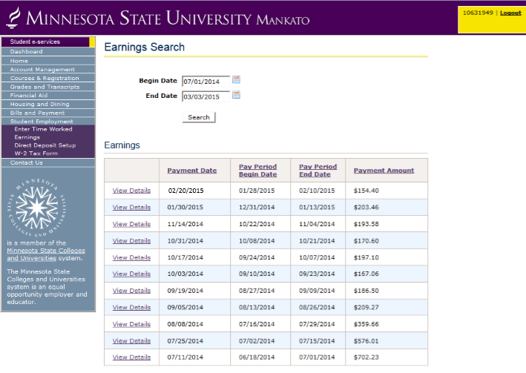
- Enter the date range of advices you would like to view. The default Begin Date is one year before the current date and the End Date is the current date. The dates can be changed either by entering a new date in the mm/dd/yyyy format or by clicking the calendar icon and selecting the desired date.
- Click the Search button to retrieve a list of that student's payroll advices within the date range.
- Payroll Earnings for pay periods within the date range are displayed in descending payment date order. The sort order can be changed by clicking any of the underlined column headings to be ascending or descending.
- Select View Details next to the Payment Date to see the Student Payroll Earnings for that period.

Example Earnings PDF
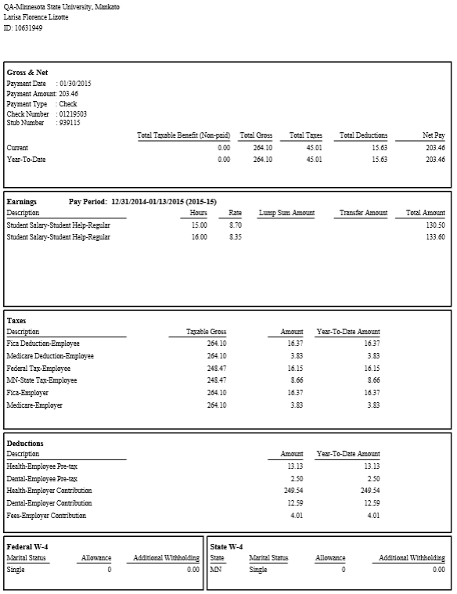

Earnings Advice Screen Fields
Field Name | Description
At the top: | - Institution  - Student Employee Name  - Tech ID
Gross & Net section: | - Payment Date: The date the payment was made to the student.  - Payment Amount: The amount received by the student after taxes and deductions.  - For Direct Deposit payments made by institutions using an external provider, the following message is displayed:  Important: If you receive your funds electronically, verify that your financial institution has posted them to your bank account prior to using those funds.  - For Direct Deposit payments made by institutions not using an external provider, the following message is displayed:  Important: Prior to using the funds, verify that your financial institution has posted them to your bank account.  - Payment Type: Direct Deposit, Check  If your institution uses an external provider to distribute funds, the Payment type will display "Payment Processed via External Provider" and will contain the link to the External Provider’s website for your institution.  - Account Type: (Direct Deposit payments only) Checking or Savings  - Check Number: (Checks payments only)  - Stub Number: Used for reference in ISRS  - Current and Year-to-Date amounts of: Total Taxable Benefit (Non-paid), Total Gross, Total Taxes, Total Deductions, and Net Pay
Earnings section: | - Description: What this payment is for  - Hours: The number of hours worked (hourly positions only).  - Rate: The student's hourly rate (hourly positions only).  - Lump Sum Amount: The total amount earned (used if not an hourly position).  - Total Amount: The sum of hourly pay and lump sum pay.
Taxes section: | Description, Taxable Gross, Current Amount and Year-to-Date Amount of each of the following:  - FICA  - Medicare  - Federal Tax  - State Tax
Deductions section: | - Child Support  - Garnishments  - Employee Paid Insurance (Health, Dental)  - Employer Contribution Insurance (Health, Dental, Basic Life, Fees)
Federal W-4 section: | - Marital Status  - Allowance  - Additional Withholding
State W-4 section: | - State  - Marital Status  - Allowance  - Additional Withholding

If paid by check the student also receives a paycheck stub.
Student Employee Paycheck Stub Example Screen Print
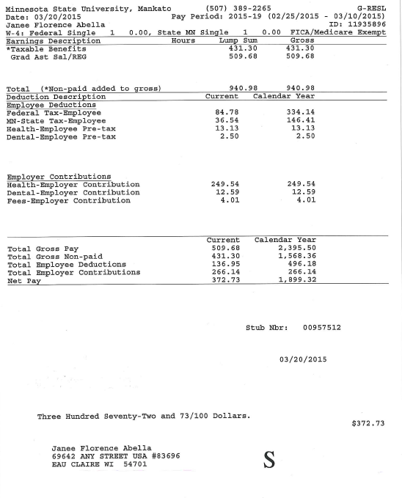
Student Pay Stub Screen Fields
Field Name | Description
At the top: | - Institution  - Institution’s Phone Number  - Date  - Pay Period  - Student Employee Name  - Tech ID  - W-4 Tax Information  Federal W-4 section:  - Marital Status  - Allowance  - Additional Withholding  State W-4 section:  - State  - Marital Status  - Allowance  - Additional Withholding
Earnings Section: | - Earnings Description: What this payment is for  - Hours: The number of hours worked (hourly positions only).  - Lump Sum Amount: The total amount earned (used if not an hourly position).  - Gross  - Total Amount: The sum of hourly pay and lump sum pay.
Deductions Section: | - Deduction Description  Employee Deductions  Examples:  - Child Support  - Garnishments  - Employee Paid Insurance (Health, Dental)  - FICA  - Medicare  - Federal Tax  - State Tax  Employer Contributions  - Employer Contribution Insurance (Health, Dental, Basic Life, Fees)
Gross & Net section: | - Current and Calendar Year Payment Amount:  - Check Number: (Checks payments only)  - Stub Number: Used for reference in ISRS  - Current and Calendar Year-to-Date amounts of: Total Gross Pay, Total Gross Non-paid (Taxable Benefit), Total Employee Deductions, and Total Employer Contributions  - Net Pay: The Current and Calendar Year-to-Date amounts received by the student after taxes and deductions.

Direct Deposit Account Setup (non BankMobile schools only)
A student employee can setup and maintain their direct deposit account through Student eServices.
Adding a Direct Deposit Account
- To add an account select Direct Deposit Setup
- Select Add Direct Deposit Account
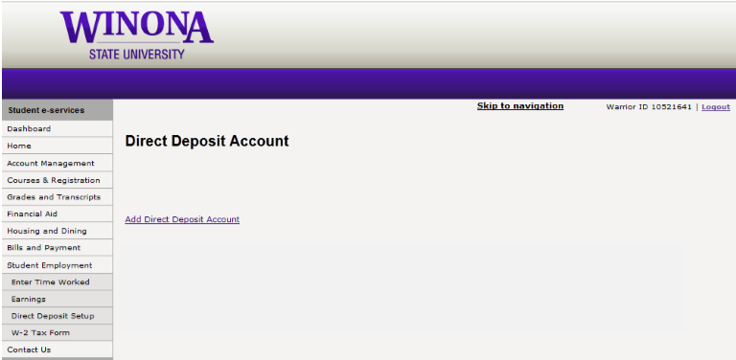
The New Direct Deposit Account page appears
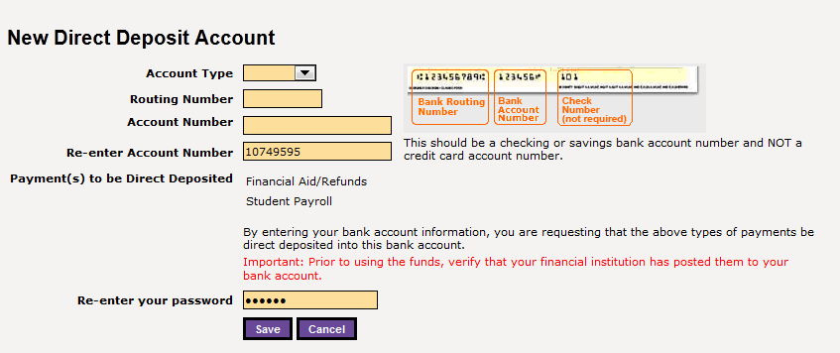
- Enter the requested information
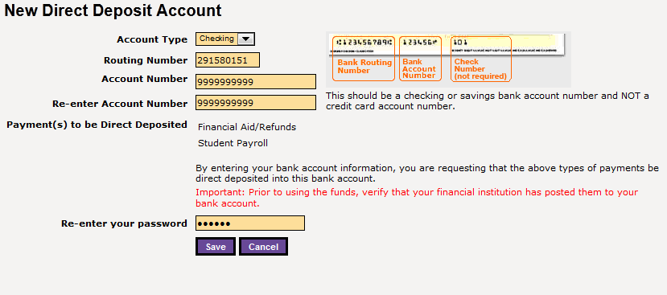
- Select the [Save] button
Once added the account will be in a Pending Status until the next day. It should then become Active.
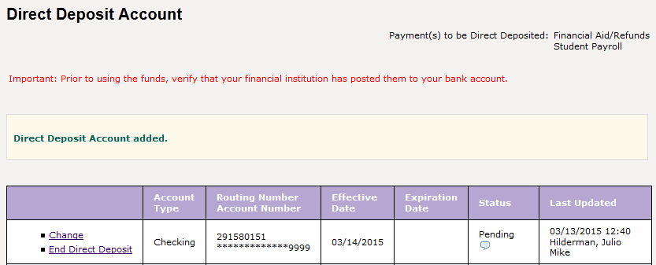
Changing a Direct Deposit Account
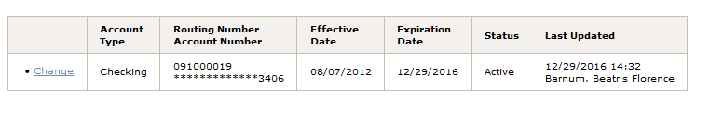
Click the [Change] button for the record to be updated.
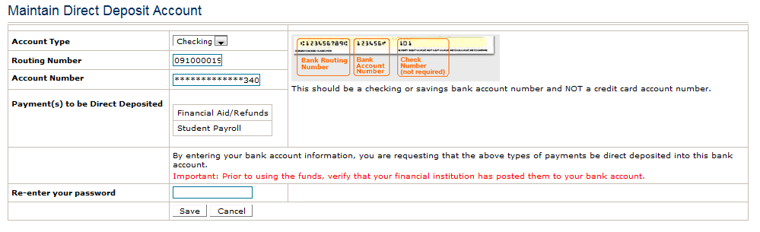
Enter the corrected information. Note that the Re-enter Account Number field will display if a change to the account number was made.
Re-enter your password
Click [Save] and the system redisplays the Direct Deposit Account screen.
A message displays noting the update has been applied.
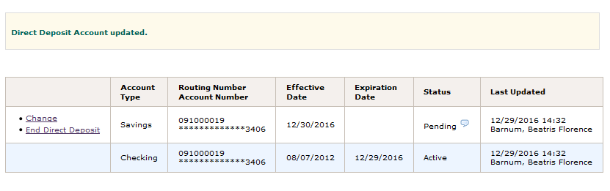
NOTE: The changes will be effective the next day. Once you have made the update, the changed version of the account will be the active record. If there were deposits made under the old version, it will be listed as an expired record, as seen above in Image 2. If there were no deposits made under the old version, it is replaced by the new version and will not be listed.
Ending a Direct Deposit Account
Click the [End Direct Deposit] button on the record to be ended.
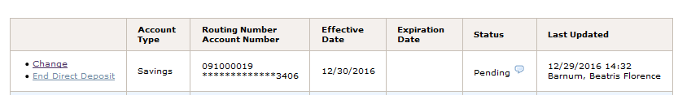
Re-enter your password
[Save]
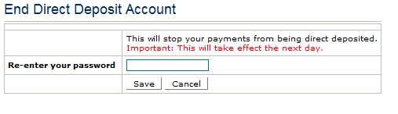
A Confirmation box is displayed:
Click the Ok Button to end direct deposit.

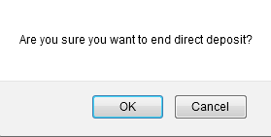
A message displays noting the account ended.
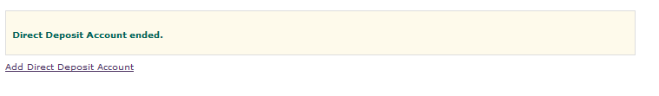

Payment Preference Selection (BankMobile schools only)
Schools serviced by BankMobile will not have the option to select Direct Deposit and maintain their account. They will see a Payment Preference Selection.
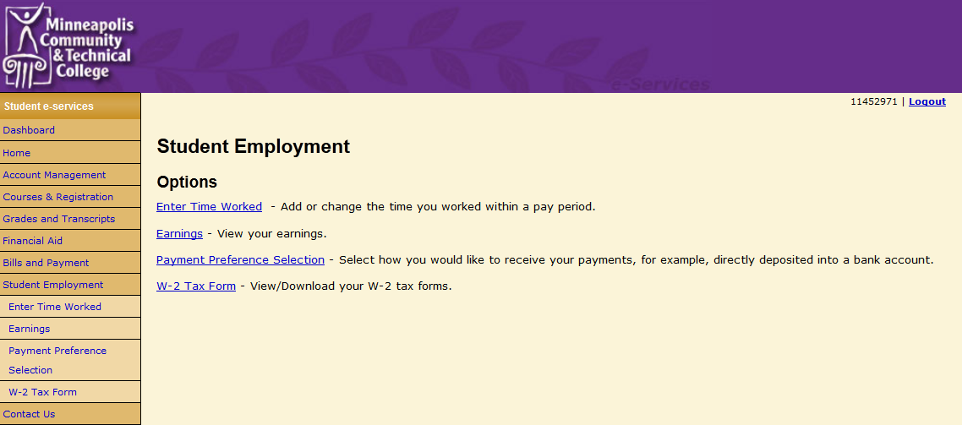

When selected will take them to a page with the option to Visit BankMobile’s Website

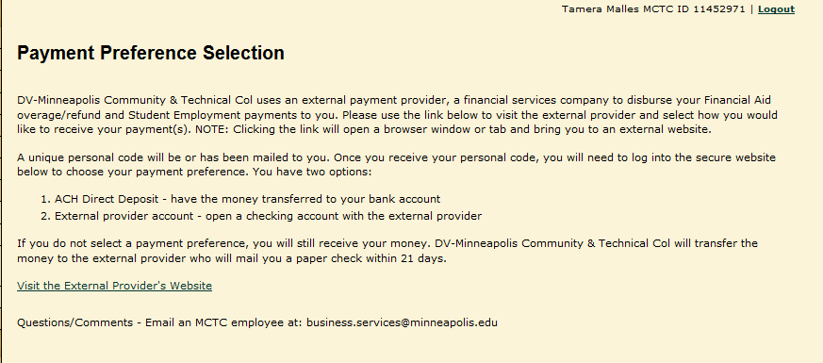

Tax Forms - W-2 and 1098-T
Students can sign up to receive their W-2 Wage and Tax Statement and 1098-T Tuition Statement electronically.
Action Items will appear on the Student eServices Dashboard
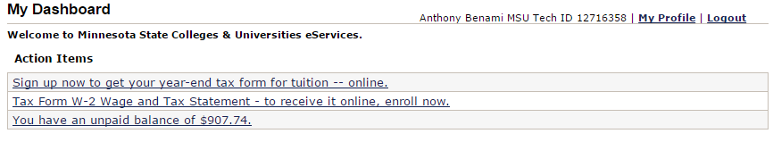
Also under Student Employment
Select W-2 Tax Form

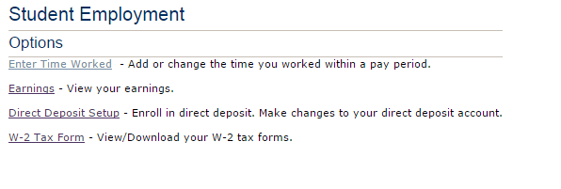
Then Enrollment for Electronic Tax Form(s)

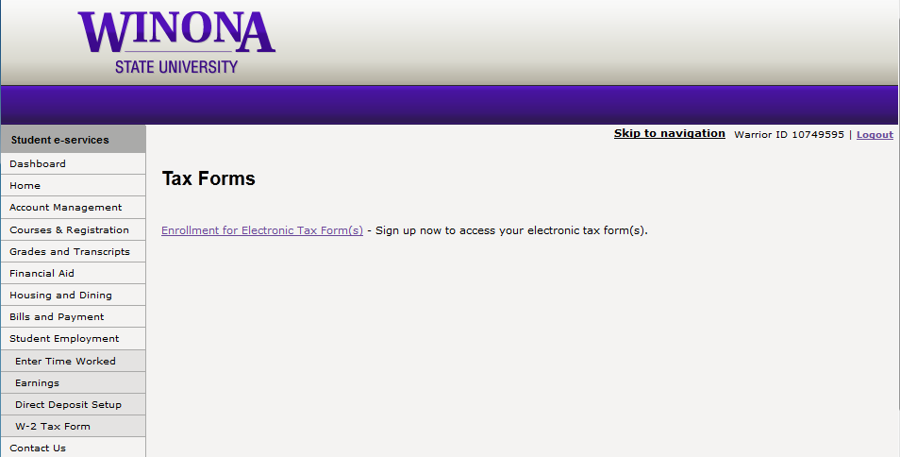
Select and [Confirm]
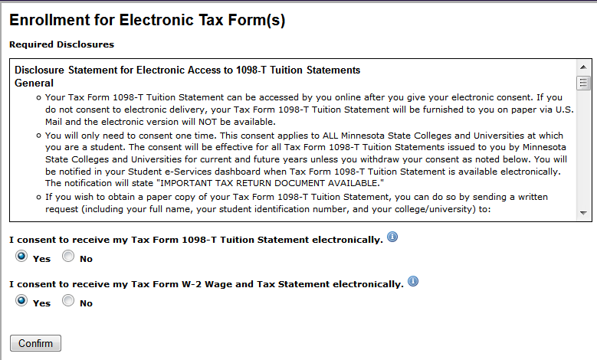
Enrollment completed

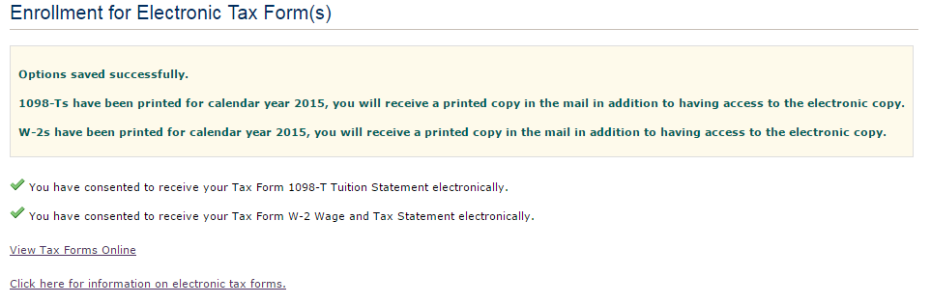
Select View Tax Forms Online to view the forms or from the Student eServices Dashboard under Bills and Payment select 1098-T Tax Form
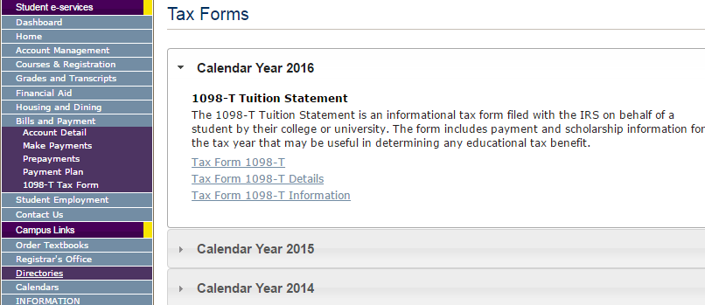

1098-T Tuition Statement
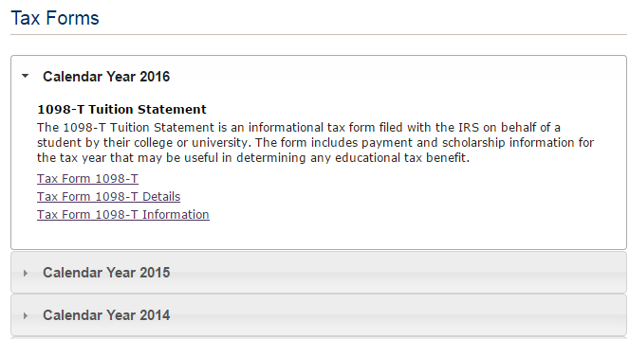

Tax Form 1098-T
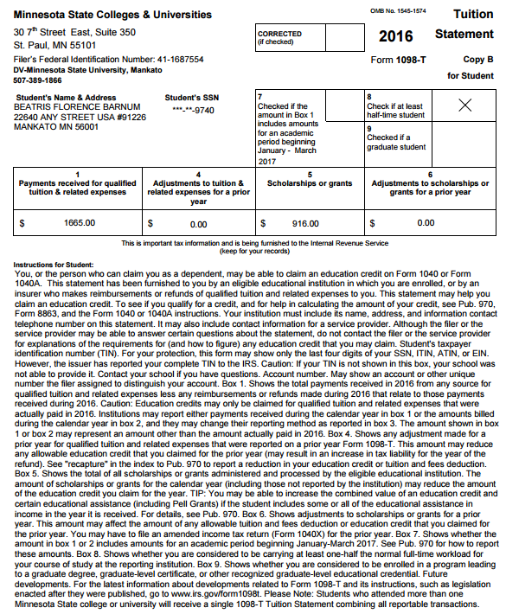

Tax Form 1098-T Details
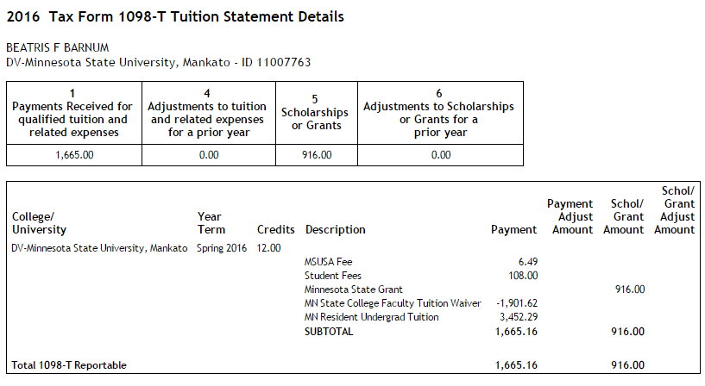
Tax Form 1098-T Information
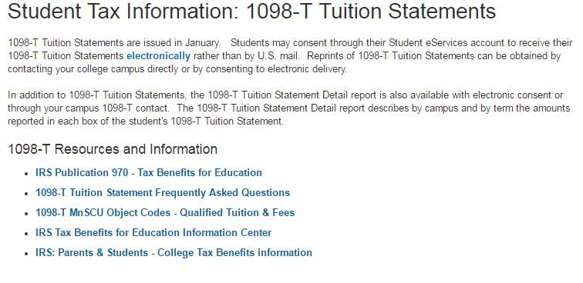

W-2 Wage and Tax Statement
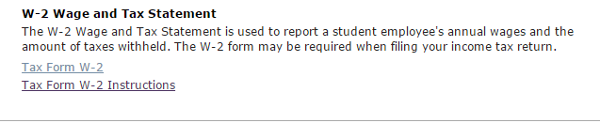
Tax Form W-2
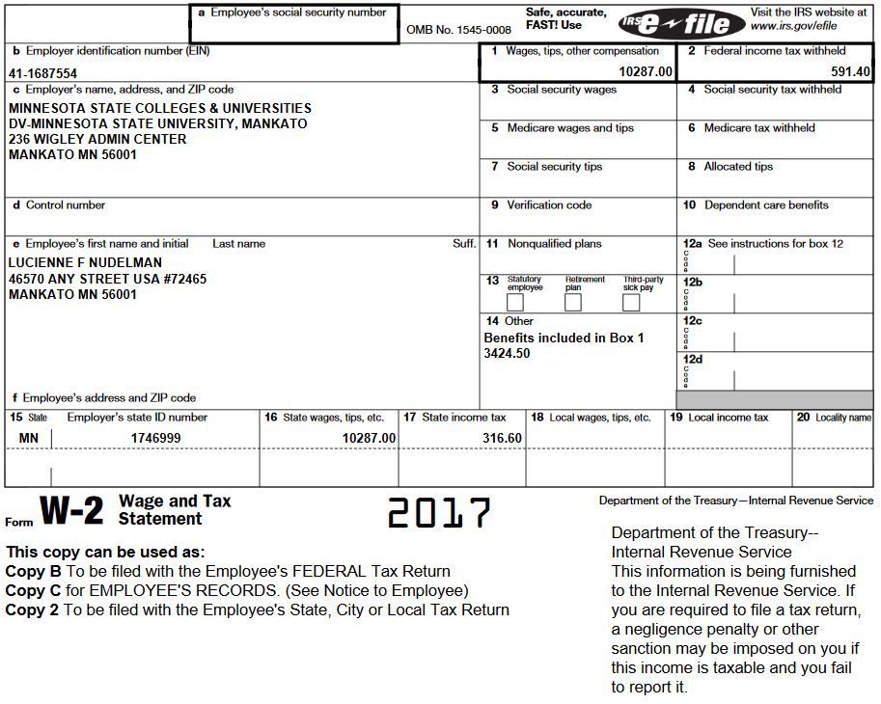

Tax Form W-2 Instructions
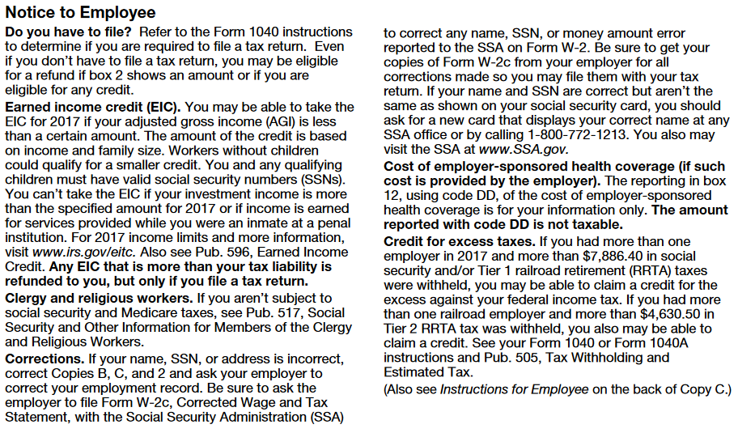

Select Click here for information on electronic tax forms.
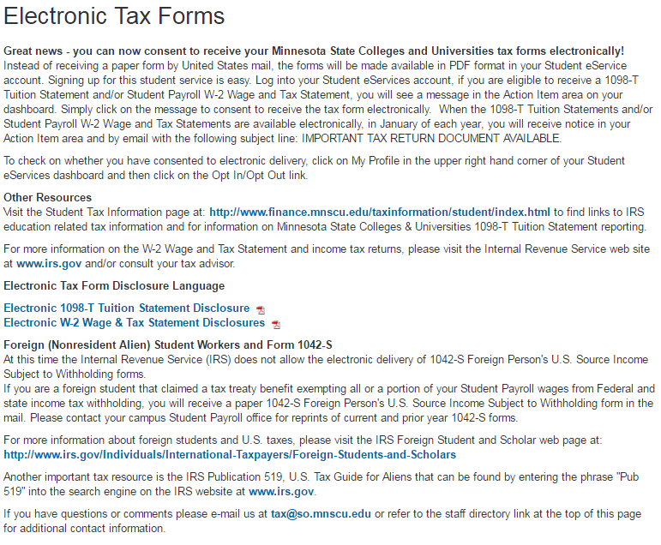

Need Help?
For additional assistance, please submit a ticket via the Minnesota State IT Service Desk portal: https://servicedesk.minnstate.edu

Minnesota State is an affirmative action, equal opportunity employer and educator.

