Contents
Introduction 1
Do This First! 2
Security 2
How to Access Grant/View Proxy Access 2
Grant/View Proxy Process Example 2
Proxy Access Granted To Steps – 3
Proxy Access Received By 5
Modify Proxy Access 6
Additional Documentation 7
Need Help? 7

Introduction
Student eTime Supervisor Proxy Access allows a supervisor to grant another employee access to approve their employees’ time worked. This process would be used when the supervisor is out of the office and not available to approve the time worked by the student employees’ they supervise.
The Grant/View Proxy Access page displays the proxy access records that the Student Payroll Supervisor has granted to other employees first and then displays the proxy access that the employee has received from other Student Payroll Supervisors. If the person is an employee who has been granted proxy access but has never been a Student Payroll Supervisor, they wouldn’t see the Proxy Access Granted To section.
NOTE: The system will not allow an employee’s proxy access to have overlapping dates for a supervisor. There can be overlapping dates for a supervisor for different people but not the same person. Also, the employee can have overlapping dates for proxy access as long as they are for different supervisors.
NOTE: The Student Payroll Supervisor could grant an employee indefinite proxy access so that another employee could always approve their student employees’ time worked. This would be done by the Supervisor setting the proxy access’s end date to 12/31/9999.

Do This First!

Security
Supervisors assigned on a work authorization will see the Grant/View Proxy Access menu item.

How to Access Grant/View Proxy Access
Log into Employee Home
Select Student Payroll Supervisor
From the Approve Time Worked page, use the Student Payroll Supervisor drop-down menu to select Grant/View Proxy Access
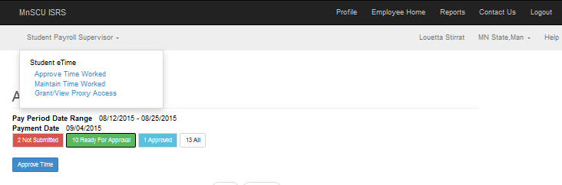

Grant/View Proxy Process Example
The page would be blank when first landing on it unless there are current or future proxy records. Past proxy records won’t display unless expanded to see history.

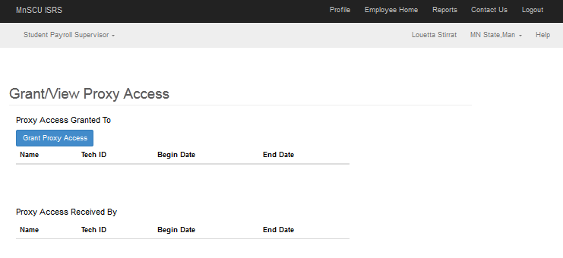
A Student Employee Supervisor will be able to setup proxy access for another employee to approve the time worked for the student employee they supervise.

Proxy Access Granted To Steps –
Select the [Grant Proxy Access] button
Enter the Employee’s Tech ID if it is known
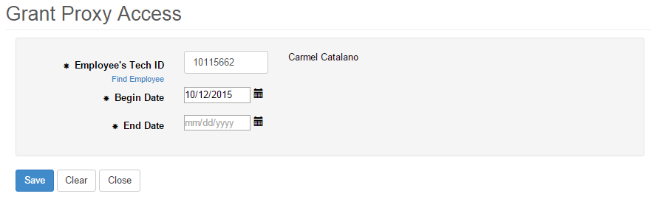
Or there is the option to select Find Employee to search for an employee by name
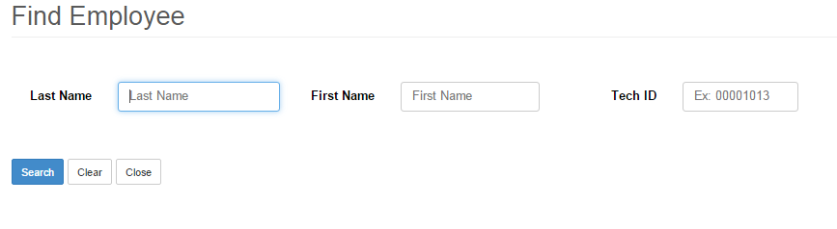
Enter at least 1 character in the Last Name field for a search. A portion of Last Name or Tech ID must be populated to do a search.
Additional characters can be entered to limit the search results. A wild card is assumed at the end of the Last and First Name.
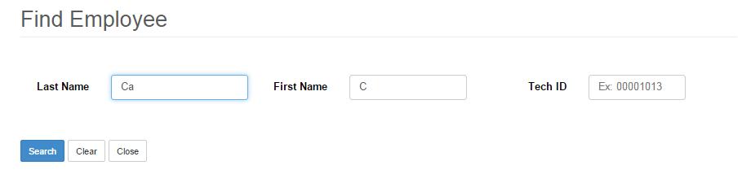
[Search]
Results will display in ascending order alphabetically by Last Name. The sort order can be changed to descending order by selecting the arrows next to the Last Name or First Name.

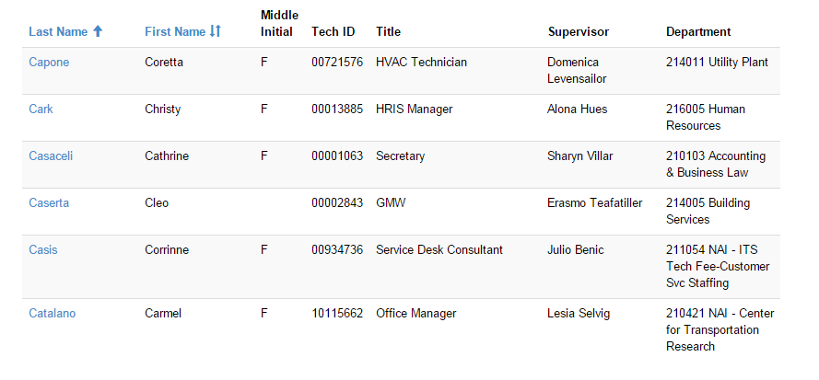
Select the correct employee by clicking on the last name of the employee’s record.
Enter the Begin and End Date for the time period they should have access to approve the student employees’ time worked records for the Student Payroll Supervisor
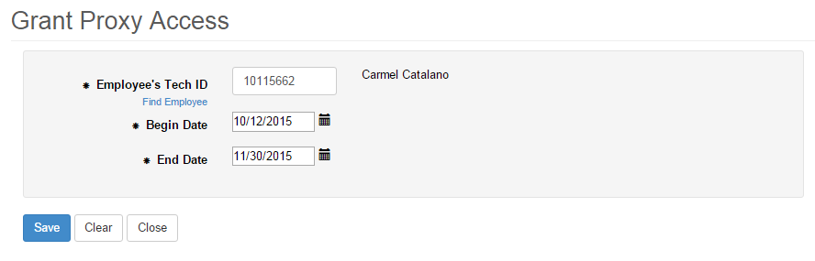
[Save]
A message is given that the proxy record was added successfully
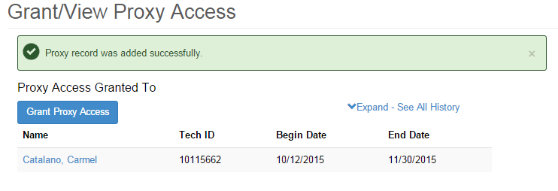

Proxy Access Received By
The employee can view which supervisors has given them proxy access to approve the time worked for the student employees they supervise.

In the example below the Supervisor Louetta Stirrat has received proxy access rights from Ngoc Firle 12/01/2015 - 12/31/2015.
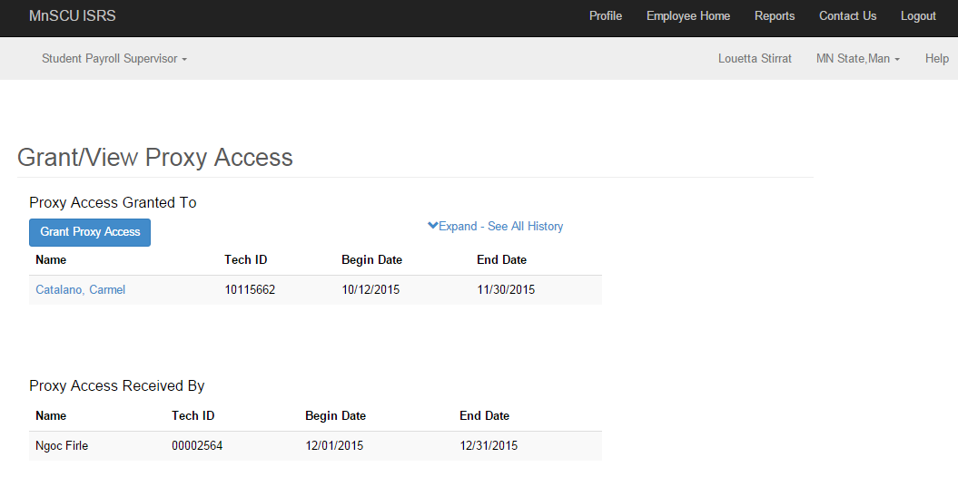

Modify Proxy Access
NOTE: Modifications can be made to proxy records. Deleting will only be allowed if the proxy person has NOT approved any time worked. If they have approved time worked, then deleting wouldn’t be allowed but modifications would be.
Select the name of the employee of the record that needs to be modified
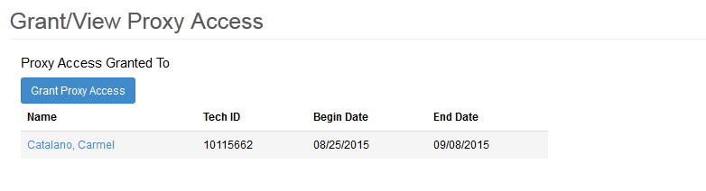
This brings you to the Modify Proxy Access page
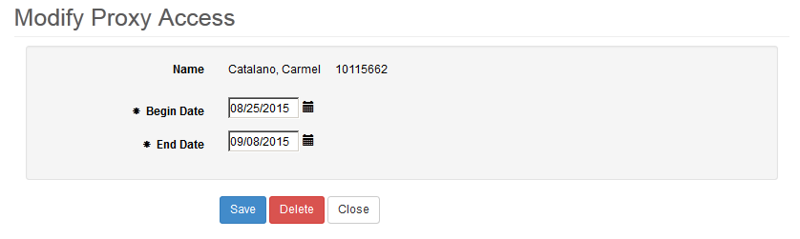
Either make a change to the Begin Date and/or End Date and select [Save] or select [Delete] to remove the record

Additional Documentation

Need Help?
If you need additional assistance, please contact the MnSCU Help Desk: https://itsmnscu.custhelp.com or call 877-GO-MNSCU (877-466-6728), Monday through Friday, 7:00 AM to 5:00 PM.
The Minnesota State Colleges and Universities system is an Equal Opportunity employer and educator.

