Contents

Student Employee Introduction 1

Security 1

Access 1

Add Time Worked 2

Submit Time Worked 6

Modify Time Worked 9

Delete Time Worked 12

Need Help? 15

Student Employee Introduction

This guide provides basic steps the student performs in their portion of the web based Student eTime application.

Student employees will use the Student Employment > Enter Time Worked option in eServices to record their hours worked and submit them to their supervisors to review and approval each pay period.

Security

Student Employee: No specific security is needed but the ability to login to Student eServices.

Access

Student Employee: Can access the application on their computer and/or mobile device through Student eServices > Student Employment located on the left-side navigation bar > Enter Time Worked.

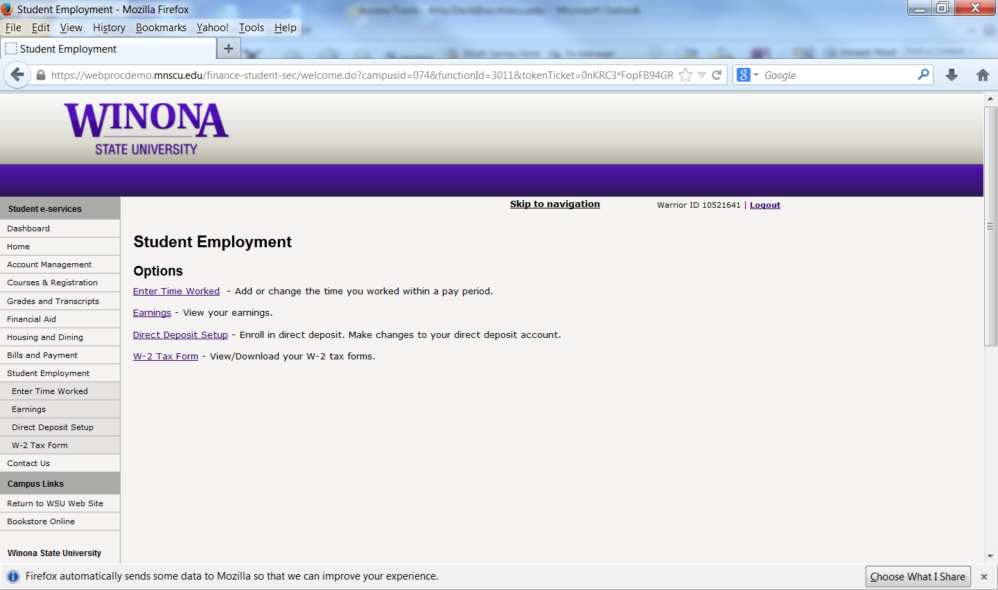

Add Time Worked

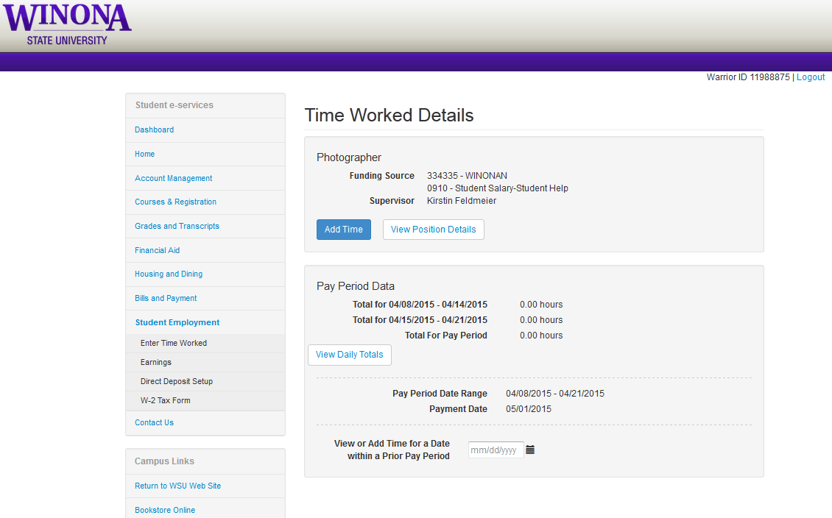

Select [Add Time]

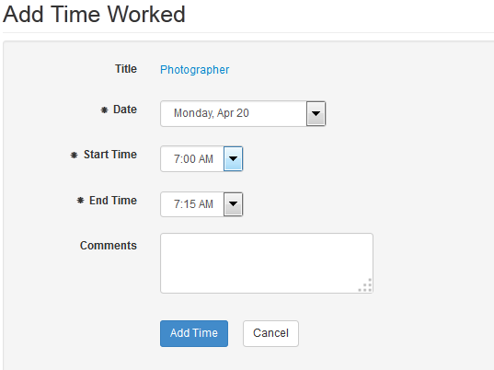

Select the Date in the pay period

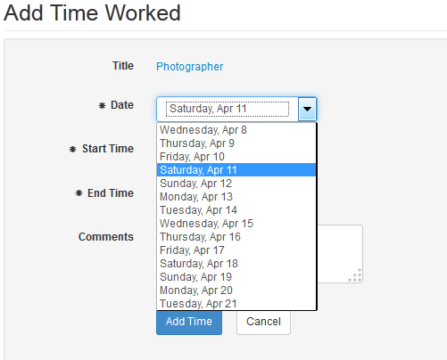

Select the Start Time

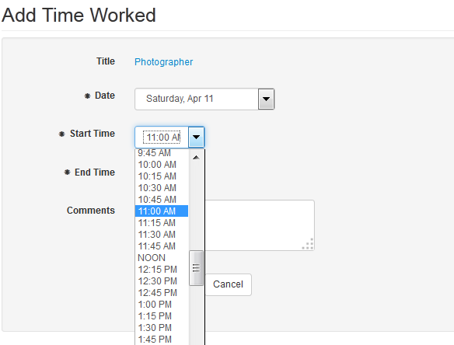

Select the End Time

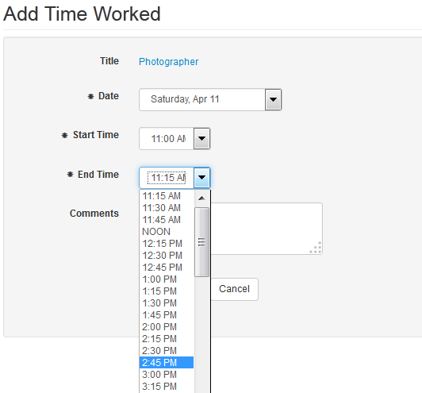

The hours entered display

Click [Add Time]

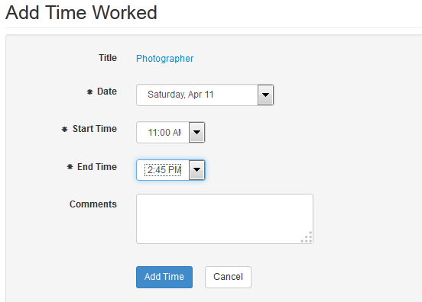

A message displays that the time was added successfully.

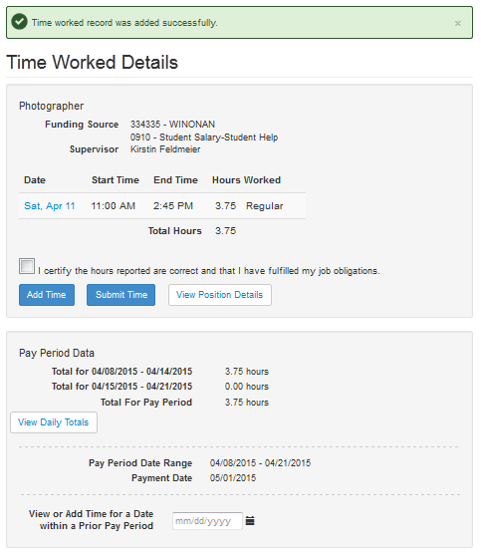

Submit Time Worked

At the end of each pay period the student employee will submit the hours so their supervisor can go and approval them.

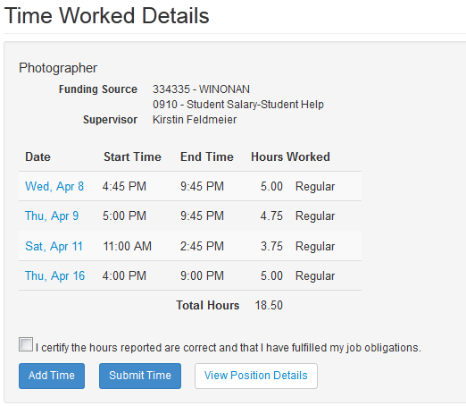

Select the check box next to the statement “I certify the hours reported are correct and that I have fulfilled my job obligations” for each position to be submitted.

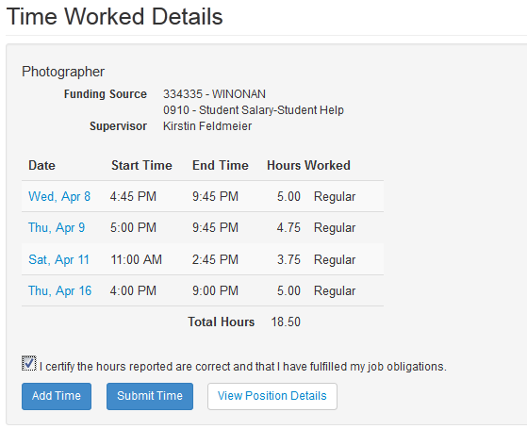

Click the [Submit Time] button



A message displays that the time was submitted successfully. In addition to a *Submitted timestamp* in the bottom lower right corner

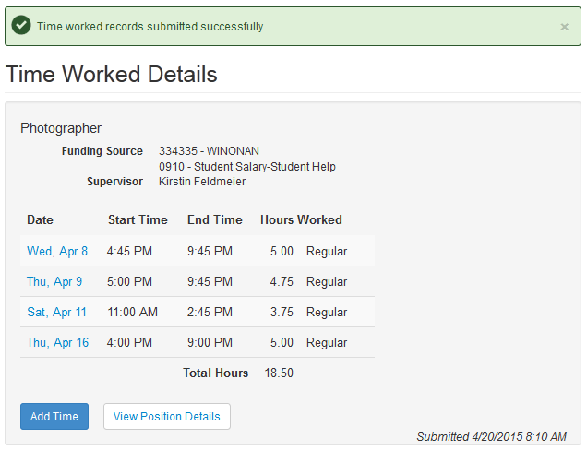

Modify Time Worked

If the time entered needs to be change, the student can modify the record.

**Note:** Only records that have not been processed can be modified.

Select on the Date that needs modification

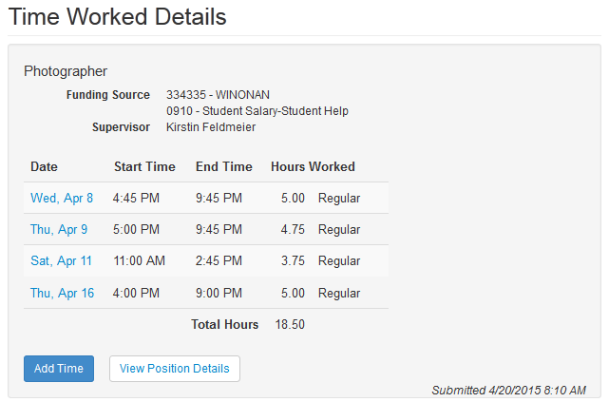

That day’s details display

Select [Modify]

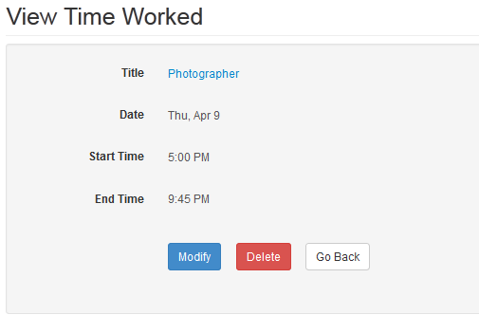

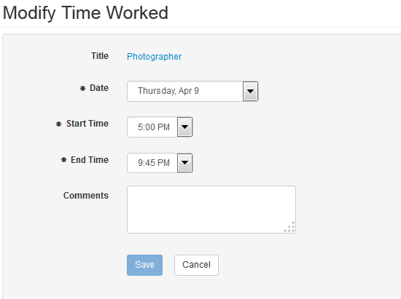

Make the change

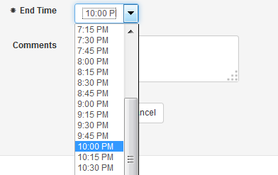

The End time is now correct

Select [Save]

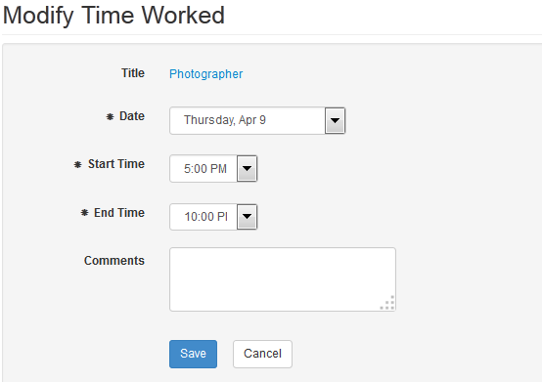

A message displays that the time worked was added successfully

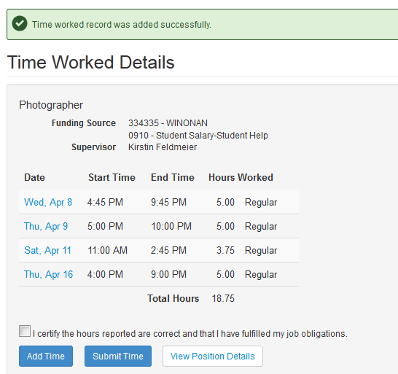

If the hours were already submitted, they will need to be submitted again

Delete Time Worked

If time worked was entered in error, the student can delete it.

**Note:** Only records that have not been processed can be deleted.

Select the Date of the record that needs deleting

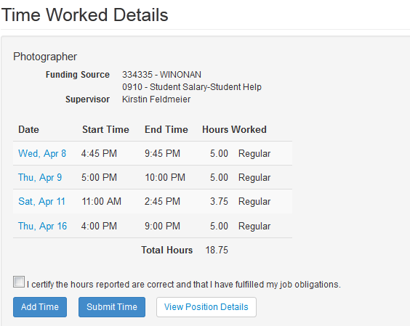

That day’s details display

Select [Delete]

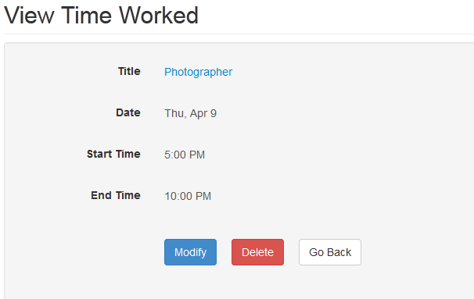

A message displays that the record was deleted successfully

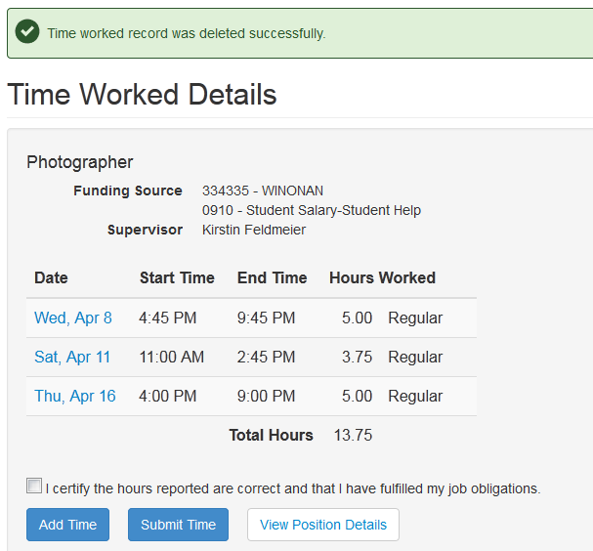

If the hours were already submitted, they will need to be submitted again

Need Help?

If you need additional assistance, please contact the [MnSCU ITS Service Desk](https://itsmnscu.custhelp.com/) or call 877-GO-MNSCU (877-466-6728).

The Minnesota State Colleges and Universities system is an Equal Opportunity employer and educator.