Contents
Student Payroll Supervisor Introduction 1
Security 2
Access 2
Approve Time Worked 3
Screen Buttons Options 3
Approve Time – Ready For Approval 3
Modify Time Worked 9
Maintain Time Worked 12
Add Time Worked 17
Delete Time Worked 27
Supervisor Proxy 32
Supervisor Proxy Access Drop-down List Screen Print 32
Drop-down List of Supervisor Proxy Access Examples 33
View Position Details 37
Need Help? 38

Student Payroll Supervisor Introduction
This guide provides basic steps the supervisor performs in their portion of the web based Student eTime application. Supervisors of a student employee or an employee that has proxy access, will be able to review and approve the time worked the student submitted for the pay period. In addition, if necessary modify and delete the student’s time worked.
At the end of each pay period the Student Payroll Supervisor web application located on Employee Home will be used to review and approve the time worked records for the student employees they supervise.
Minnesota State is an affirmative action, equal opportunity employer and educator.

Security
Student Payroll Supervisor: no security web role is needed. If the supervisor is assigned on the work authorization or employees who have proxy access during the time period should have access to the supervisor application and functions.
Off-campus Supervisor not an employee of the college/university – not all schools have them:
no security web role is needed. If they are assigned as a supervisor on a work authorization then they will have access to the supervisor application and functions through a URL separate from Employee Home.

Access
Student Payroll Supervisor: can access the web administrative application from anywhere (on-campus, off-campus, home etc.) via ISRS Employee Home > Employee Applications > Student Payroll Supervisor.
For optimal browser performance use Firefox 25.0 or greater, Chrome, Safari. Internet Explorer is NOT recommended.
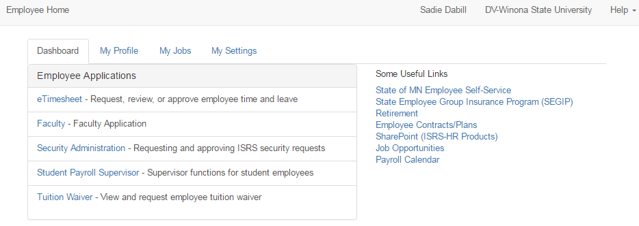
Off-campus Supervisors that are NOT employees of the college/university: Not all school will have off-campus supervisors. Skip this section if that is the case. If you do, they will NOT be able to access the application via Employee Home. They will gain access using a Guest StarId and password through the following separate URL: https://eservices.minnstate.edu/finance-student/supervisor/approveTimeWorked.do
In order to get a Guest StarID created the off-campus supervisors will need a Tech ID if they don’t already have one. This is done through the Person Demographic Maintenance Screen (PS9999UG) in ISRS Uniface by someone at the campus with PERSON_HIGH security. The off-campus supervisor will need to provide first name, last name and a Personal/Work email address to be included when the record is added so they can activate their StarId. Student Payroll Staff will need to take note of the Tech ID that is generated to enter it in the Supervisor field on the Student Employee Work Authorization Entry (PR0024UG) screen.
Once the PERSON record is created a Guest StarId needs to be manually assigned by the System Office. Student Payroll Staff will need to send in a MnSCU ITS Service Desk ticket titled: Student eTime Off-Campus Supervisor with the following information: the off-campus supervisors Tech ID, Name, and Personal/Work email address. After the Guest StarId is created we will respond with instructions that need to be given to the off-campus supervisor to activate it.

Approve Time Worked
The application by default opens the Approve Time Worked page and Ready For Approval button.
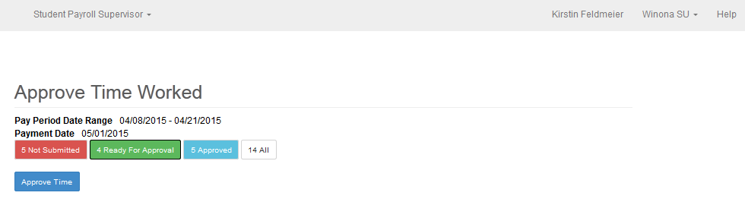

Screen Buttons Options
- Not Submitted (red) Displays time worked records entered by the student employees that have not yet been submitted.
- Ready For Approval (green) Displays time worked records that have been submitted by the student employee but are pending approval for the current pay period or a prior pay period.
- Approved (light blue) Lists the records that have already been approved.
- All (white) Lists the combined records in Not Submitted, Ready For Approval, Approved

Approve Time – Ready For Approval
Review the records for accuracy.
If the supervisor is assigned proxy rights a drop-down appears under Approve Time Worked with the option limit search results
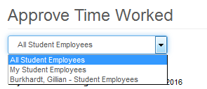
The bottom right corner displays the Submitted status, in addition to the date/time and the name of the person whom it was submitted by.
NOTE: For any work authorizations, where the expended amount is greater than 80% of the work authorization’s maximum amount, the following informational message will be displayed to the supervisor/proxy: “This student has earned $X,XXX.XX of the $X,XXX.XX allowed for this position.” This will include the current pay period’s pending hours. This is being done to warn the supervisor/proxy that they are close to earning the maximum amount allowed.

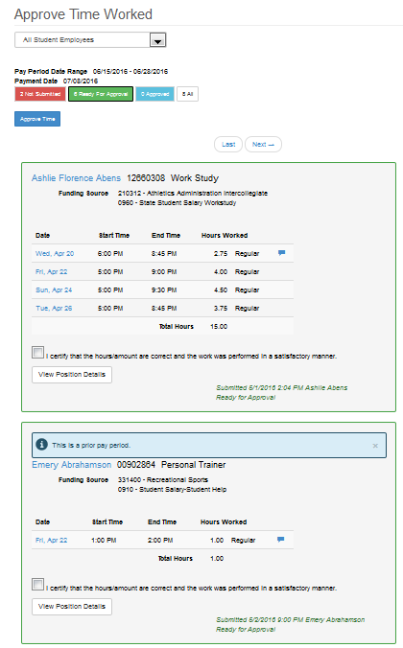
If no changes are needed, to approve the time worked records, click the check box before the statement “I certify that hours/amount are correct and the work was performed in a satisfactory manner.” The box will need to be check for all records to be approved. Up to five records per page display and can be approved at one time.
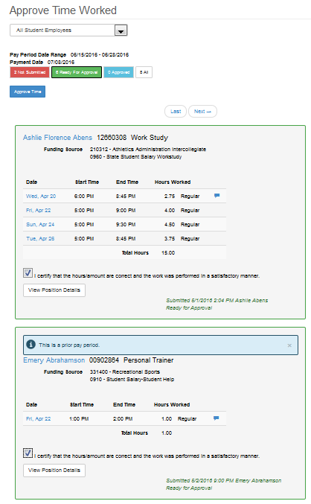
Select the [Approve Time] button.
A message display that the records have been approve successfully
Once this is completed it is reflected in the Student Payroll Administration Application.
To view the records select the Approved button
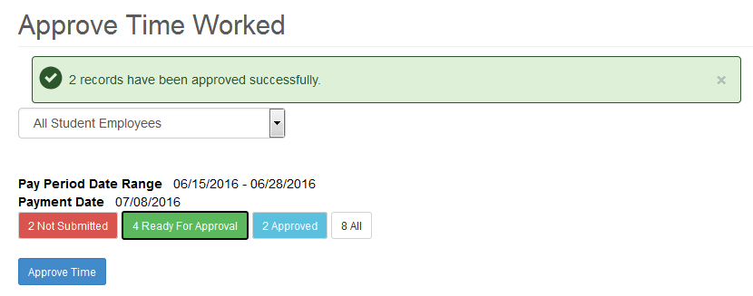
The records display and in the button right corner the Approved status with the time/date and the name of the person whom approved it
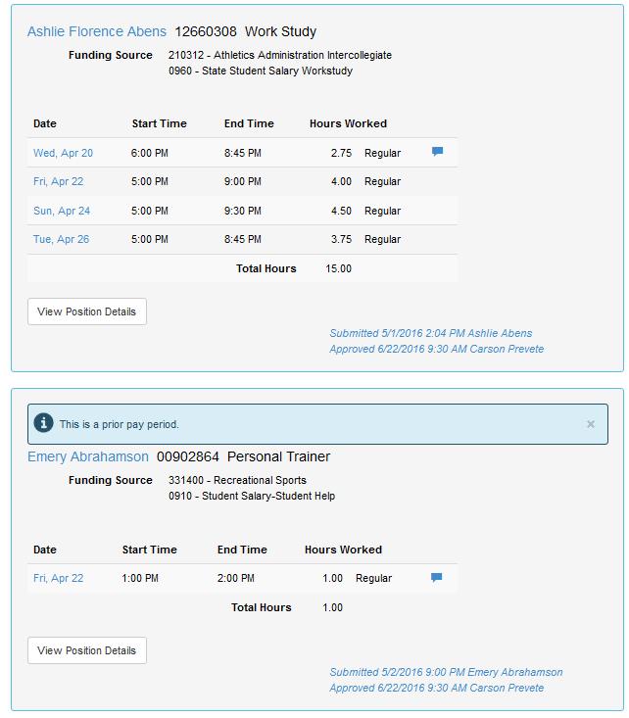
Along with the submitted and approved timestamp, once a time worked record is processed the Processed status displays with the date/time completed.
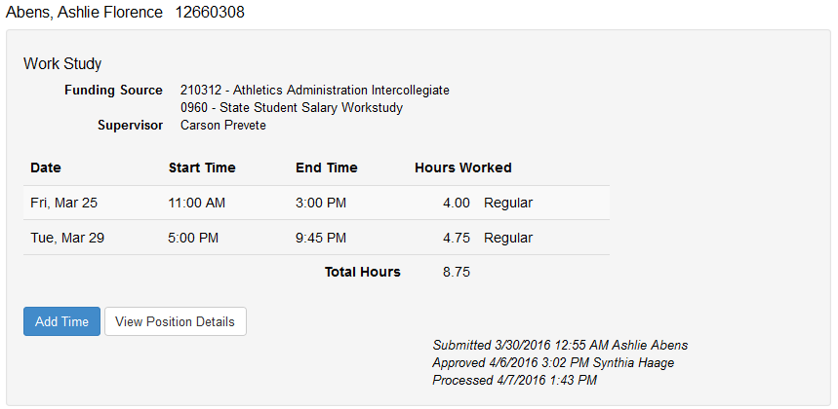
Not Submitted – Displays the time worked records that have been entered by the student employees they supervise but not yet submitted for approval. The supervisor will want to follow up with the student to have them get their hours submitted.
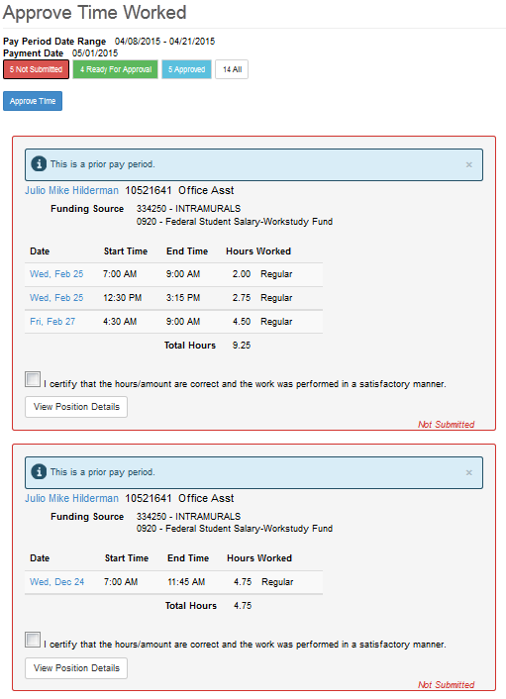

Modify Time Worked
In general, the student should be the one to make updates to their time worked records. It is at the discretion of each school to decide whether the supervisor should modify, add or delete a student’s time worked record. The system does provide the functionality.
Note: Only records that have not been processed can be modified.
There are two ways to modify a record
The first way is if the student record is already pulled up, select the date of the record that needs to be changed
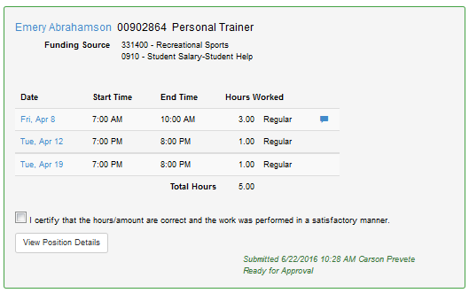
This brings you to a Modify Time Worked page
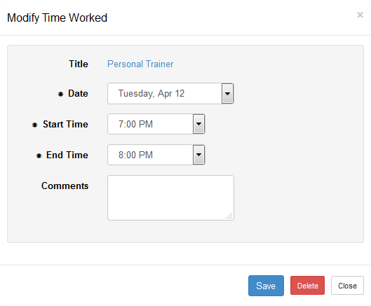
Update the record
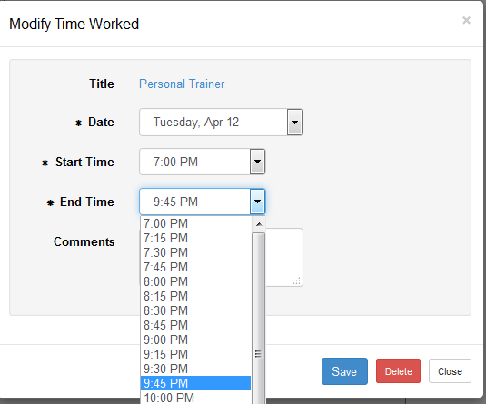
Select [Save]
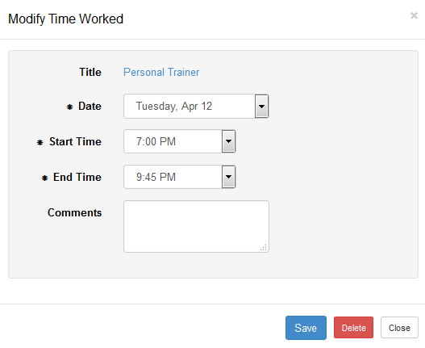
A message will display that the change was successful. Along with an updated Submitted status in the lower right corner with the date/time and person whom submitted it
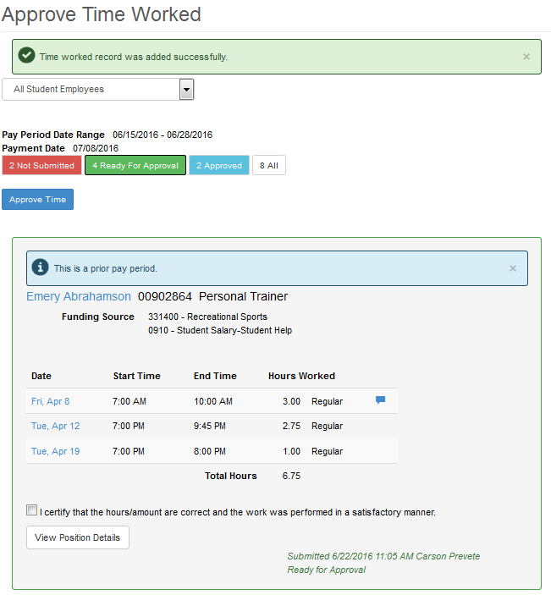

Maintain Time Worked
The second way to modify time is to use the Student Payroll Supervisor drop-down in the upper left corner
Select Maintain Time Worked
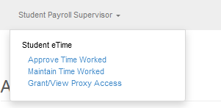
This brings you to the Maintain Time Worked page
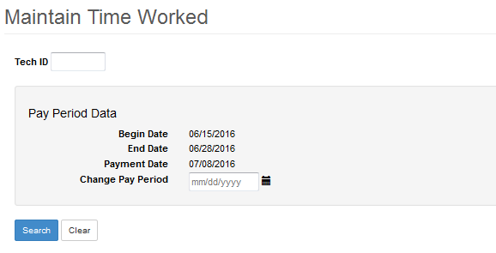
Enter in the Tech ID of the student
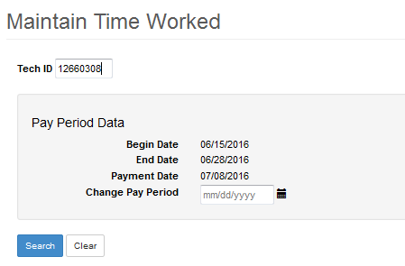
Click [Search]
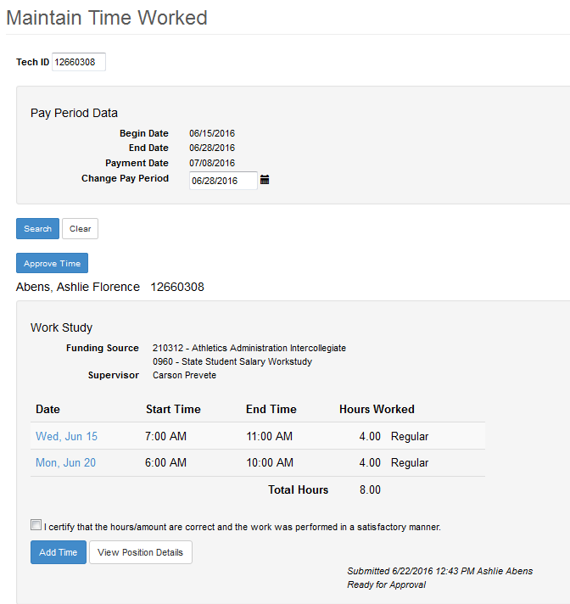
Select the Date
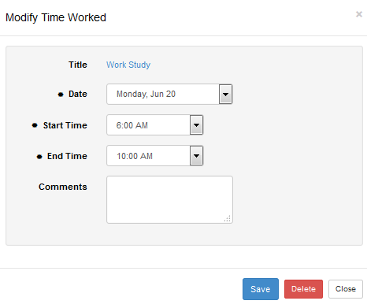
Make the update
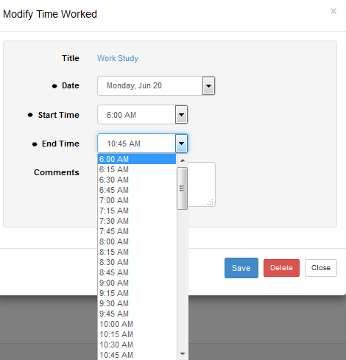
The updated record displays
Select [Save]

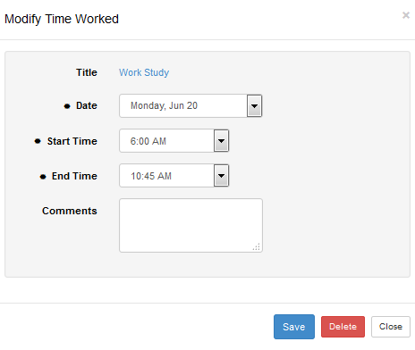
Message that the time changed successfully displays. Along with an updated Submitted status with the date/time and person whom submitted it
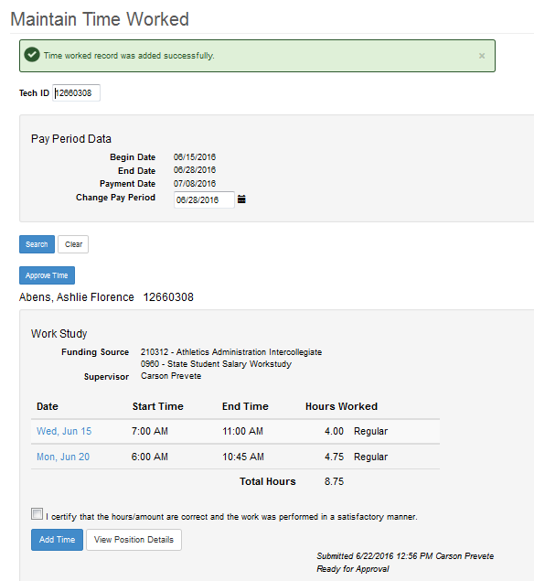

Add Time Worked
There are two ways to add a record
First way is if the student record is already pulled up, select the student’s name
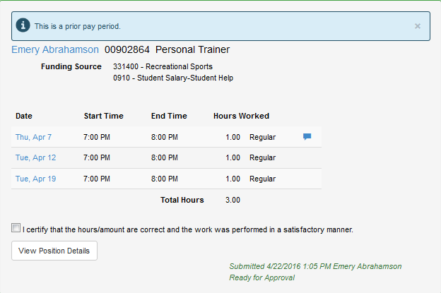
This brings you to the Maintain Time Worked page for the student
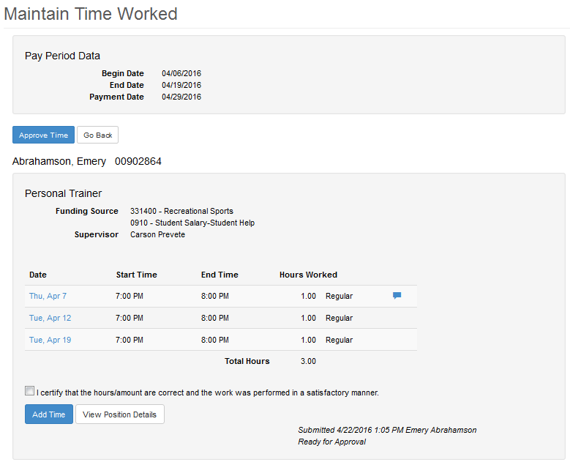
Select [Add Time]
This brings up an Add Time Worked page
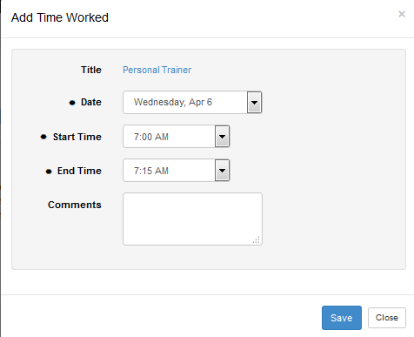
Select the Date
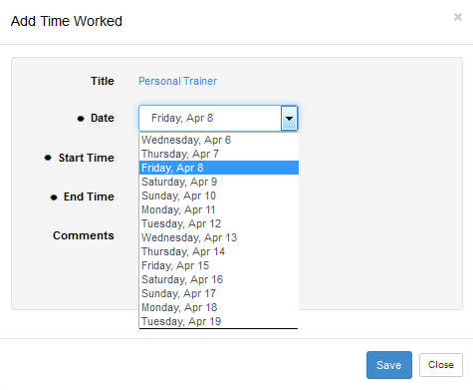
Select the Start Time
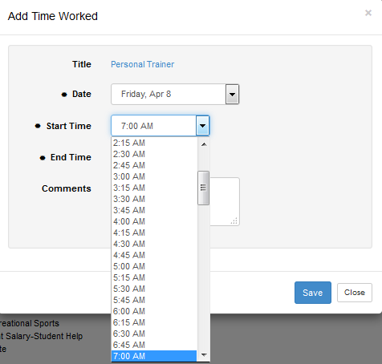
Select the End Time
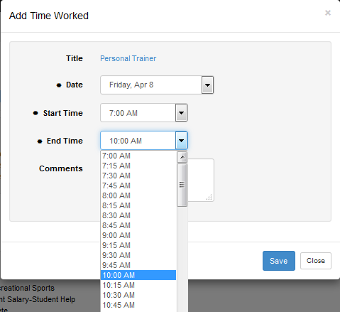
Select [Save]
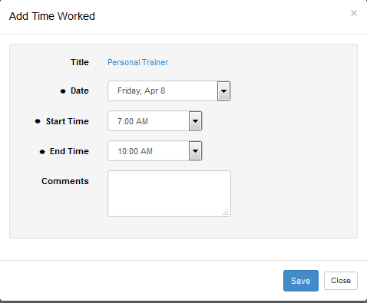
A message displays that the time added was successful
Also in the lower right corner an updated Submitted status with the time/date and person whom submitted it
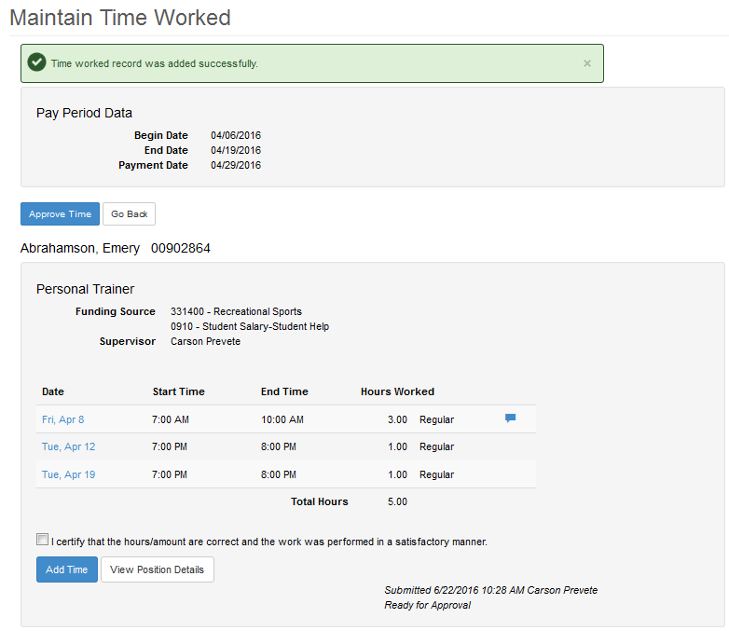
The second way to add time is to use the Student Payroll Supervisor drop-down in the upper left corner
Select Maintain Time Worked
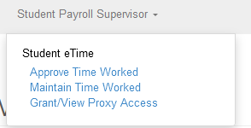
This brings you to the Maintain Time Worked page
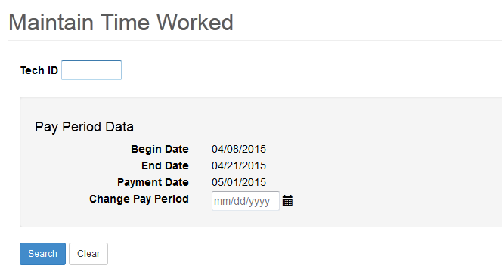
Enter in the Tech ID of the student
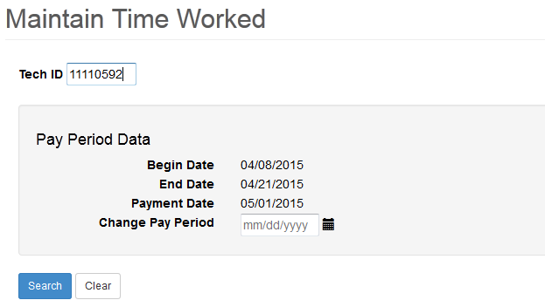
Click [Search]
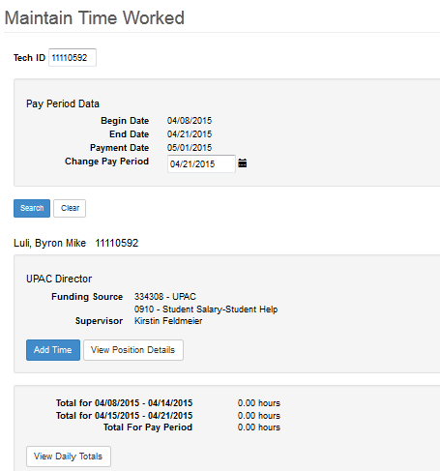
Select [Add Time]
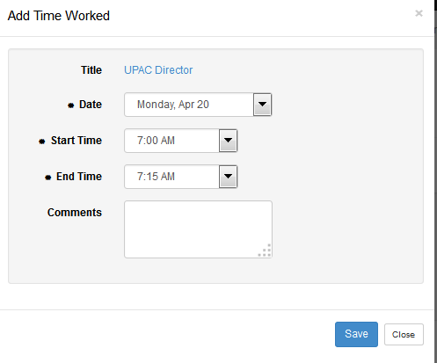
Select the Date
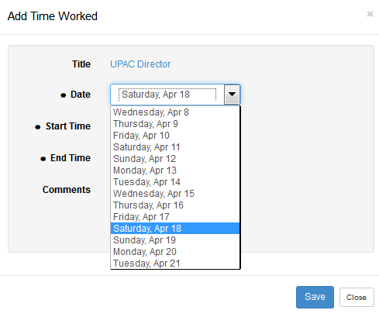
Select the Start Time
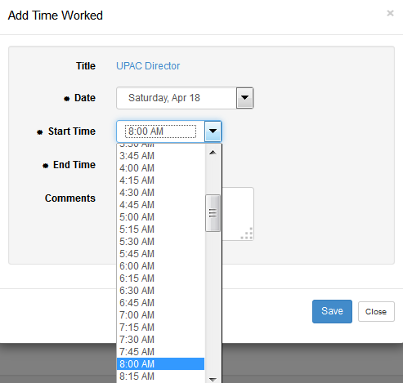
Select the End Time
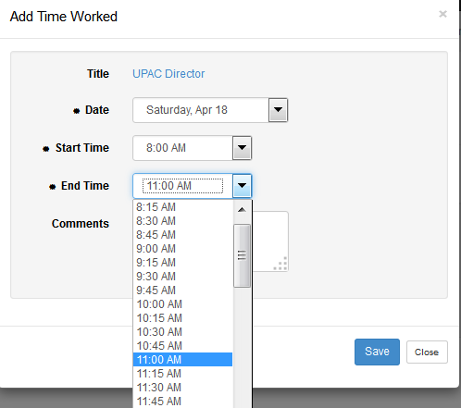
Select [Save]
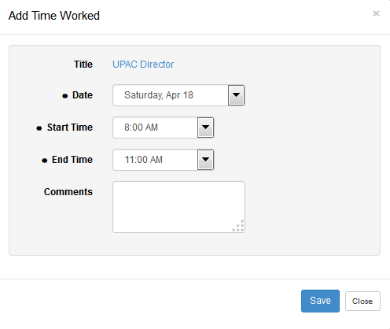
Message that the time added successfully displays
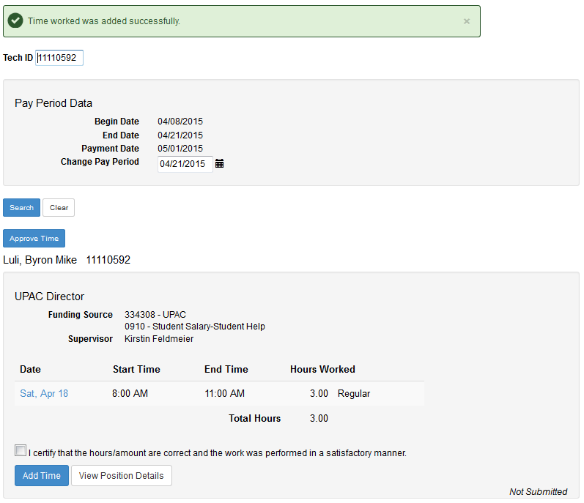

Delete Time Worked
NOTE: If a pay period has been closed and there are pending hours that have never been paid, the supervisor can delete these records.
There are two ways to delete a record
The first way is if the student is already pulled up
Select the Date of the record.
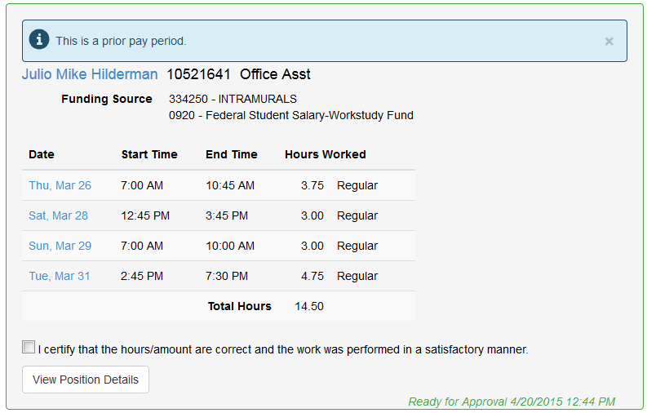
This accesses the Modify Time Worked page
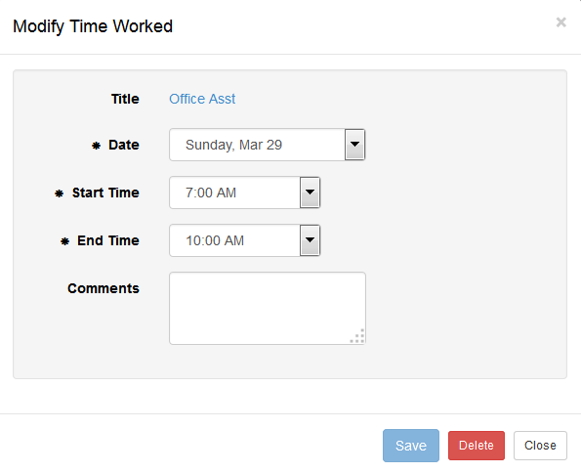
Select [Delete]
The second way to delete time is to use the Student Payroll Supervisor drop-down in the upper left corner
Select Maintain Time Worked
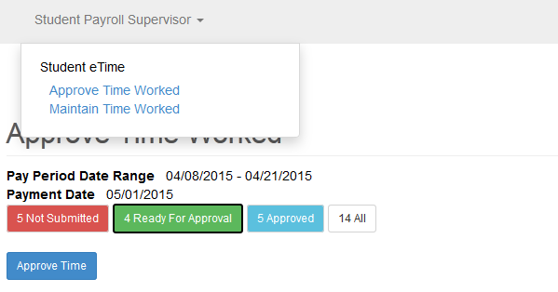
This brings you to the Maintain Time Worked page
Enter in the Tech ID of the student

Click [Search]
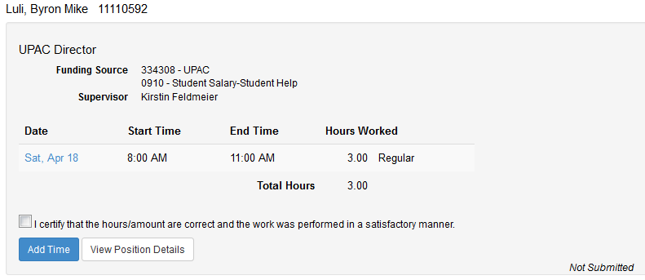
Select the Date
Click [Delete]

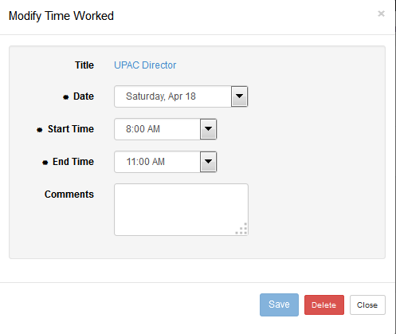
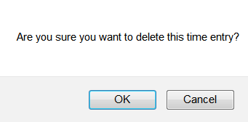
Select [OK]
Message that the time deleted successfully displays

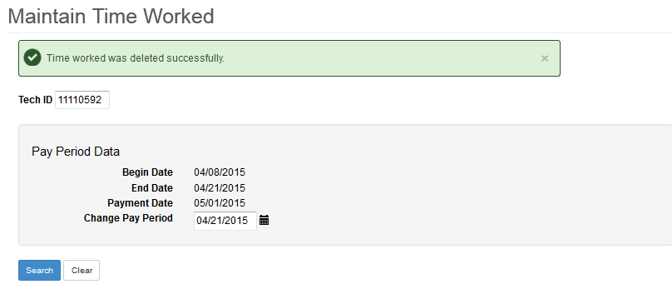

Supervisor Proxy
Student eTime Supervisor Proxy Access allows a supervisor to grant another active employee, which may or may not already be a supervisor, access to approve their employees’ time worked. This process would be used when the supervisor is out of the office and not available to approve the time worked by the student employees’ they supervise.
Employees that are currently granted Supervisor Proxy will have the same functionality in the application as a supervisor but will have an added drop-down list displayed on the Approve Time Worked page. The list will vary based on if they already a supervisor and the number of proxy rights they have been granted.

Supervisor Proxy Access Drop-down List Screen Print
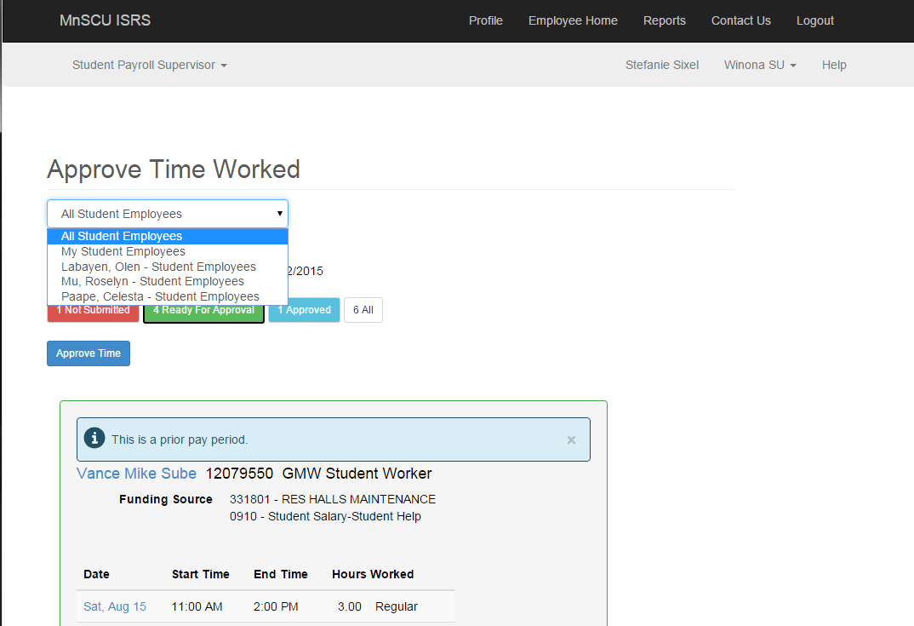
Drop-down Selections | Description
All Student Employees - This is the default selection. When this is selected, the Student Payroll Supervisor’s student employees plus the student employees they have proxy access to will be displayed. | Displayed first is the Student Payroll Supervisor’s own employees, alphabetical order by student employee’s last name.  Then displayed is the student employees they have proxy access too. These will be grouped by each Student Payroll Supervisor. The records will be in alphabetical order based on Student Payroll Supervisor’s last name and then alphabetical order by student employee’s last name.  For the student employees they have proxy access to, the Student Payroll Supervisor’s first and last name will display on each individual position.
My Student Employees | When this is selected, ONLY the Student Payroll Supervisor’s student employees will be displayed. The student employees they have proxy access to will NOT be displayed.  Displays in alphabetical order by student employee’s last name.
List the last name and first name initial of any Student Payroll Supervisors that have given proxy access to this Student Payroll Supervisor. Format: Spurgeon, Jared - Student Employees | When this is selected, ONLY the student employees they have proxy access to for a specific Student Payroll Supervisor will be displayed.  Displays in alphabetical order by student employee’s last name.  Displays the Student Payroll Supervisor’s first and last name on each position.

Drop-down List of Supervisor Proxy Access Examples
Supervisor who has their own employee + proxy access Example
NOTE: The top record does not have the Supervisor field displayed since it is one of the supervisors own employees where the bottom record shows the Supervisor who granted proxy rights.

Supervisor who has proxy Access, Approved selected, 1st student employee is their own employee, 2nd is a one whom they have proxy access too Example
NOTE: Supervisor name doesn’t display on own employee
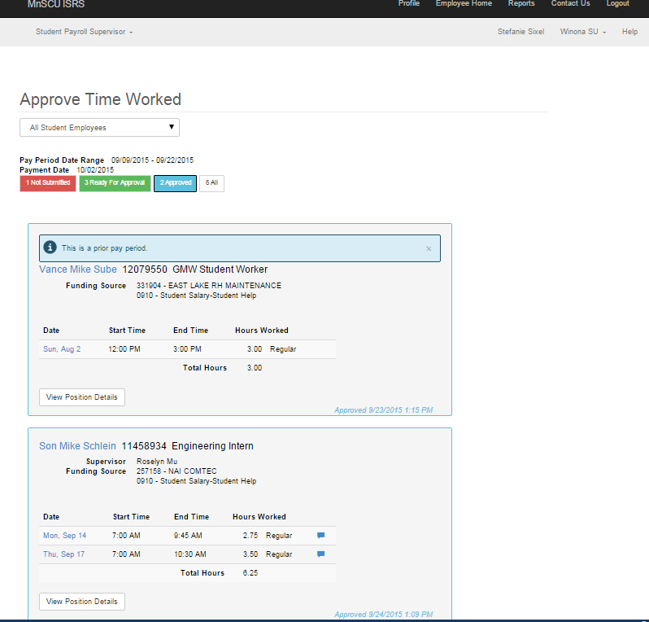
Employee (not a Supervisor) that has proxy access to more than 2 supervisors Example
NOTE: No My Employees in drop-down list:
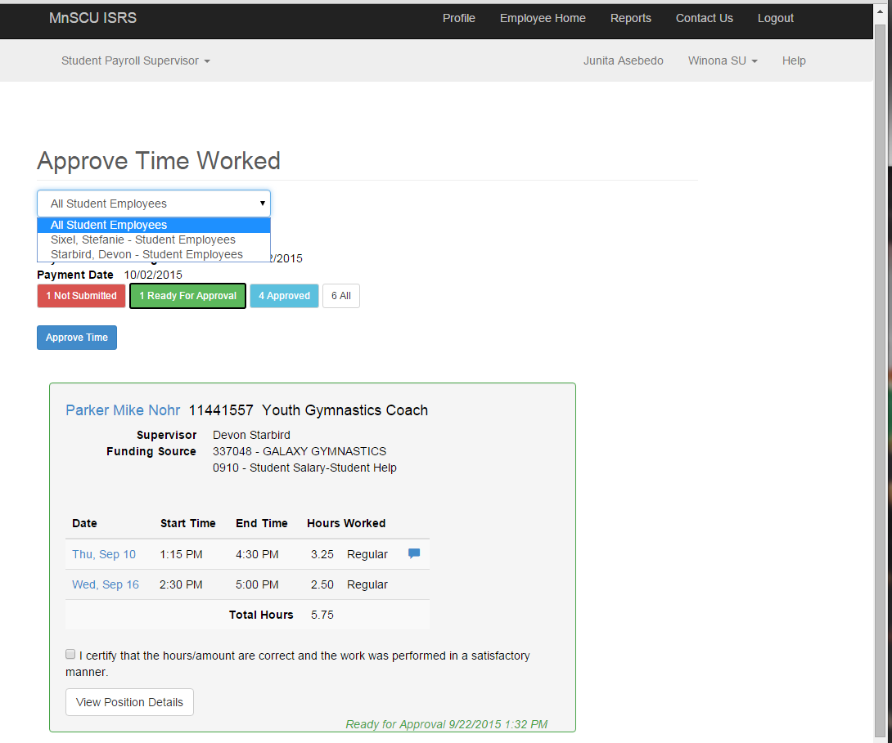
Employee (not a Supervisor) whom has proxy access to 1 other supervisor Example
NOTE: All Employees or My Employees not in drop-down list. There are two screen shots showing this. One has the drop-down selected to show only Devon Starbird displaying:
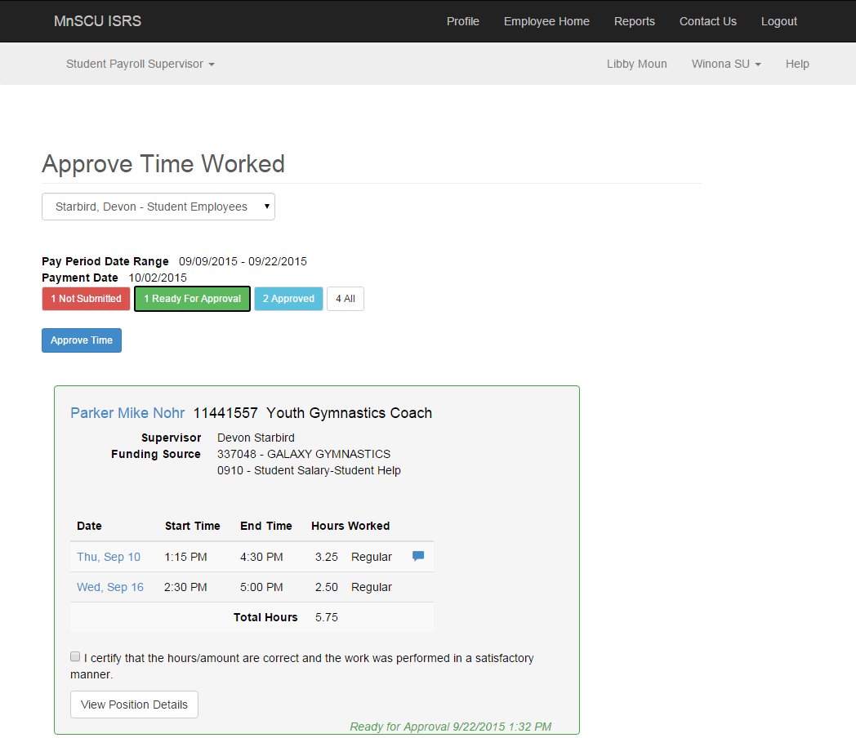

View Position Details
Select [View Position Details]
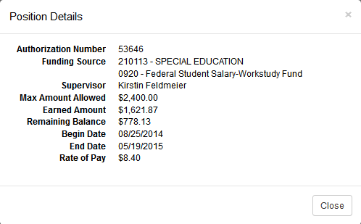
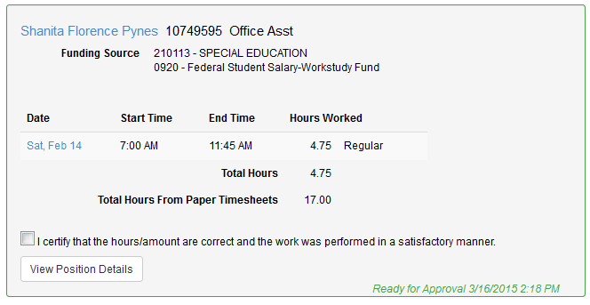
The following information displays:
- Authorization Number – Work authorization number
- Funding Source – Reporting cost center and description
Object code and description
- Supervisor – Supervisor’s first and last name
- Max Amount Allowed - The maximum total amount that the student employee can earn under this work authorization
- Earned Amount – Expended amount or the total amount to date that has been paid against this work authorization
- Remaining Balance - the difference between the max amount allowed and the earned amount
- Begin Date – Start Date
- End Date – Expire Date
- Rate of Pay – Pay Rate entered or rate of pay based on pay code

Need Help?
For additional assistance, please submit a ticket via the Minnesota State IT Service Desk portal: http://servicedesk.minnstate.edu/CherwellPortal/MNSO

Minnesota State is an affirmative action, equal opportunity employer and educator

