Introduction
Student Employee Wage Notice functionality creates written notification of information to student employees regarding their employment to ensure that requirements specified in Minnesota State Statute 181.032 are met consistently for all student employees of Minnesota State.
Using a system batch process, Student Employee Wage Notices are generated and made available to student employees through the Student e-Services Dashboard. Supervisors can view, track and mark notices as received through the View Student Employee Wage Notice functionality in the Student Payroll Supervisor application.

View Student Employee Wage Notice
After a Student Employee Wage Notice has been created for a student employee under your supervision, the record will appear in this section. Supervisors should review this list regularly to identify student employees that have not yet acknowledged their notice, or have requested to receive the notice in an alternate language.
Identify Alternate Language Requests
If, while reviewing the Student Employee Wage Notice, the student submits a request to receive the notice in an alternate language, a Y will be populated on the record under the “Alt Lang Request” column. It the responsibility of the supervisor to provide the Alternate Language Request form and ensure the student is able to complete the request.
Record Notice as Received
If a hard copy Student Employee Wage Notice is signed and returned, the supervisor can record the notice as received by clicking the check box in the “Received by” column. Once the supervisor confirms receipt of the notice, their name will be listed on the record as having received the notice. Hard copies of signed Wage Notices must be retained by the institution.
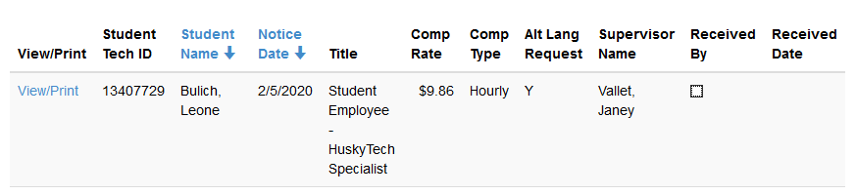

Need Additional Help?
Additional resources can be found through the Help link within the application.

