Using Starfish to Raise a Student Concern Flag

- In an emergency situation where you believe the student is in immediate danger or is an imminent threat to themselves or others, please immediately contact Campus Security and Safety at 3888 or call 911.

For employees with no other role in Starfish:

- Log into MyBSU using your StarID credentials
- Select Starfish from the drop-down menu under your name in the upper left-hand corner
- Log into Starfish using your StarID (do not include @bemidjistate.edu) and your StarID password
- Click Students button in the Starfish toolbar
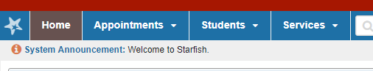

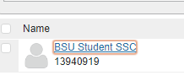

- Click on BSU Student SSC

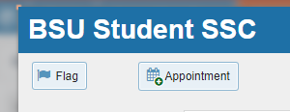

- Click the Flag button

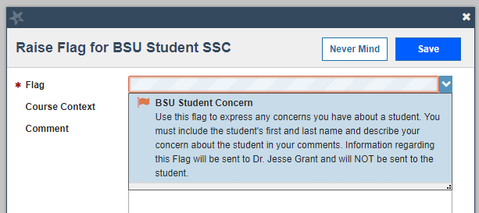

- Click the BSU Student Concern flag

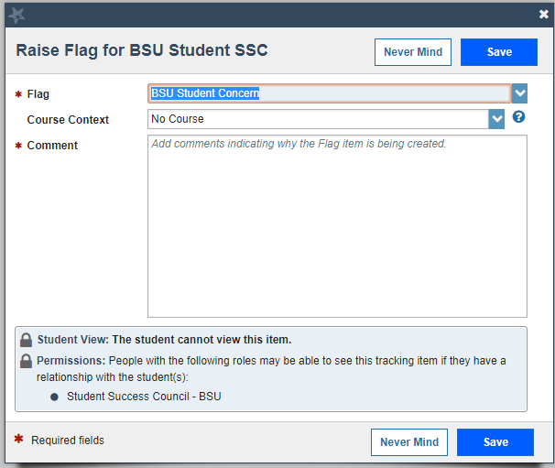

- There is no Course Context to select

- Enter the student’s first and last name and describe your concern about the student in the Comment box

- Click the Save button

Good to Know

- A student will not receive any notification or indication that a concern flag has been raised.

- Saving the flag sends a notification to Dr. Jesse Grant, Interim Dean of Students. Dr. Grant is the only person who will receive this notification and is the only person who can access and view the submitted flags.

- Employees submitting a flag cannot access it after it has been submitted. An employee who learns new information about a concern should submit a new flag.

- Dr. Grant will determine how to address the concern.

- Employees submitting flags will receive no notification regarding actions taken on it.

