TurnItIn Assignments Integration (KA #1668)

Published 2/26/2016 8:34 AM | Updated 10/3/2018 8:00 AM
Audience: Instructor

How do I use TurnItIn in my D2L Brightspace Assignments tool?

Summary 1
Installation 1
Requirements 1
Using the Integration 2
Enabling GradeMark 2
Enabling PeerMark 3
Additional Information 3
Additional Support 3

Summary
The TurnItIn Assignments integration allows an instructor to make use of the TurnItIn.com platform directly from within the D2L Brightspace Assignments tool. This allows the setup and use of Plagiarism detection, e-Rater, and GradeMark without leaving D2L. Students submit their assignment within D2L Brightspace and the paper is automatically submitted to TurnItIn.com.

Installation
The TurnItIn Assignments integration must be setup at the Organization level within your D2L Brightspace site. To have this step completed, Campus Admins should complete the steps in Article 1700 TurnItIn Administrator Configuration prior to submitting a request to the D2L Support team via the Minnesota State IT Service Desk customer portal (servicedesk.minnstate.edu).

Requirements
- A school must have a license for TurnItIn.com to make use of this integration.
- All D2L user accounts must have an email address in order for the TII integration to be able to submit/upload files from the Assignments tool to TII.

Using the Integration

Enabling GradeMark
- Navigate to the Assignments tool within your D2L Brightspace course.
- From the New/Edit folder page for an assignment, click on the TurnItIn tab.
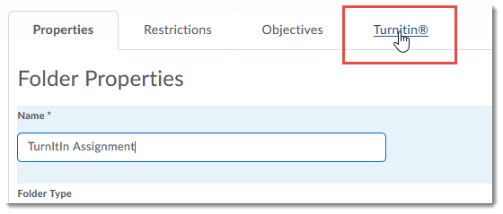
- Select the Enable GradeMark for this folder checkbox.
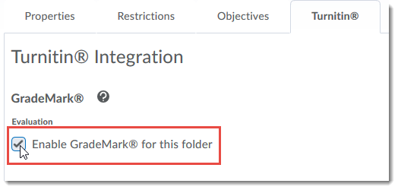
- Wait while TurnItIn is contacted.
- Once the TurnItIn dropbox is ready, the More Options in TurnItIn button will be available.
- Click More Options in Turnitin for additional configuration items. (This will launch a popup box).
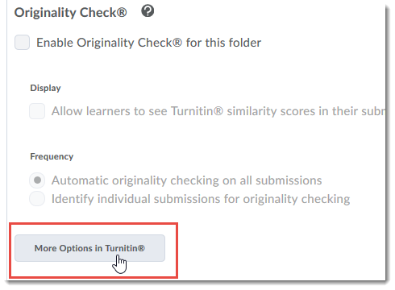
- After choosing any additional TurnItIn options, click Submit.
- Click Save.

Enabling PeerMark
The PeerMark tool cannot be used from within the Brightspace Assignments tool integration. In order to use PeerMark without navigating directly to Turnitin, the assignment must be configured as a ‘direct’ integration. See Turnitin Direct Integration - PeerMark (KA# 1968).

Additional Information
If a D2L Brightspace course has previously been paired with a TurnItIn course, and the TurnItIn course has been deleted, the assignments integration will throw the following error: “Turnitin assignment could not be created. class - class does not exist.”

Additional Support
Additional support resources for TurnItIn can be found the TurnItIn support site (http://turnitin.com/en_us/support/help-center#main-content).
Back to top

