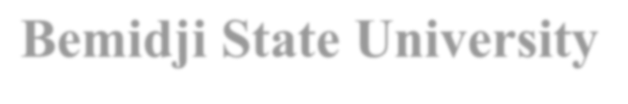
Bemidji State University
Clinical Experiences Program
Cooperating Teacher’s Recommendation

Student Professional: |  | Date:
City/School: |  | University Supervisor:
Subject/Grade: |  | Cooperating Teacher:
US Work Phone: |  | US Home/Cell Phone:
The following items reflect the goals for the Bemidji State Teacher Education Program. Please comment on the preparation reflected in each area: an appropriate image of a professional; adequate knowledge of basic skills and/or academic content areas; use of knowledge of child/adolescent development to accommodate diverse learner needs; ability to plan, facilitate, and evaluate effective cognitive/affective learning; ability to collaborate with parents and/or other professionals; and ability to grow through reflection on his/her own teaching. Comment on potential for performing the roles and functions of a professional teacher.
Please Type

Cooperating Teacher Original Signature (not typed)
Please be sure to sign form.
Save signed document as a PDF and send to student-teaching@bemidjistate.edu and Student Teacher

