Setting up StarID and Applying for Housing

- Go to http://starid.mnscu.edu
- At the top, click on “StarID Self Service”
- Click on “Activate StarID”
- You will arrive at a page with these options:

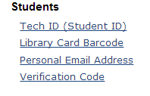
- In the Students section, click on “Personal Email Address”
- Enter the email address that you used when you applied to BSU and a verification code will be emailed to you.
- Check your email for the verification code and enter it in the box shown below:

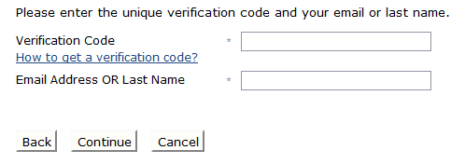
- It will display your StarID in yellow at the top of the page and will ask you to create a password. Please write down your StarID and your password. You will need them in the future.

Logging into MyBSU and E-Services

- Go to https://www.bemidjistate.edu/mybsu/
- Click on “Activate New Account”
- Complete steps 1-3 by providing your 8-digit Tech ID, last name as it appears on your I-20 or DS-2019, and date of birth in the YYYY/MM/DD format.
- Log in with the StarID and password you created above.

Reserving Housing
- Make sure you are logged into MyBSU.
- Click on “e-services” under your name
- Click on the blue “go to MnSCU e-Services”
- Select “Housing and Dining” on the left column
- Under “Your Selections”, click on “Apply for Housing.” Choose the correct academic year, (For example, Academic Year 2015-2016 includes Fall 2015 and Spring 2016 semesters).

***Please note that as a new international student your pre-payment of $150 is not required. You will make your payments during the week of orientation.

